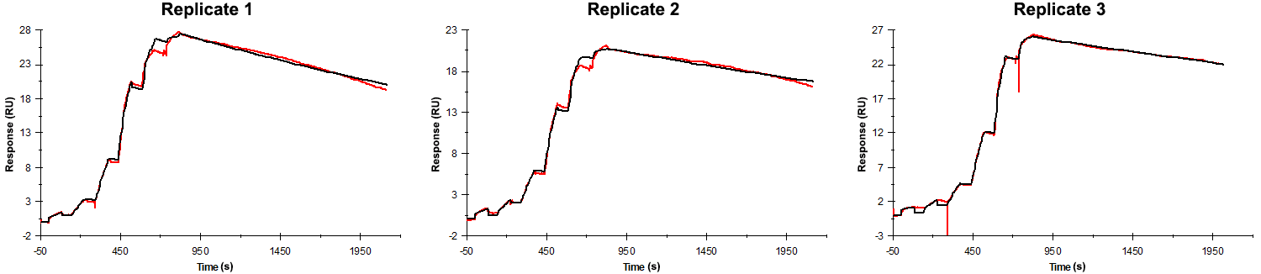
Sensorgrams obtained for each replicate of peptide 15 / Phd_{STm}⁵²⁻⁷³ R68A (analyte) binding to Doc_{STm} (ligand). Six concentrations of the analyte were flown over the surface in a single cycle, ranging from 50 nM to 0.206 nM (3-fold dilutions). In all replicates the association time was 80s. The dissociation times were 1300 s for replicate 1 and 2, and 1200 s for replicate 3.

Summary of the fitted parameters obtained from each SPR measurement of peptide 15.
Replicate | k_{on} (M⁻¹ s⁻¹) | k_{off} (s⁻¹) | K_{D} (pM) | R_{MAX} (RU) | t_{C} (RU M⁻¹ s⁻¹) | Chi² (RU²) | U-value
1 | 1.951 ± 0.003 × 10⁶ | 2.436 ± 0.005 × 10⁻⁴ | 124 | 27.6 ± 0.01 | 6.39 ± 22.00 × 10¹² | 0.245 | 1
2 | 1.566 ± 0.002 × 10⁶ | 1.662 ± 0.004 × 10⁻⁴ | 106 | 20.8 ± 0.01 | 8.020 ± 2.600 × 10¹² | 0.118 | 2
3 | 1.290 ± 0.004 × 10⁶ | 1.440 ± 0.003 × 10⁻⁴ | 112 | 26.1 ± 0.01 | 2.240 ± 0.024 × 10⁷ | 0.073 | 1

