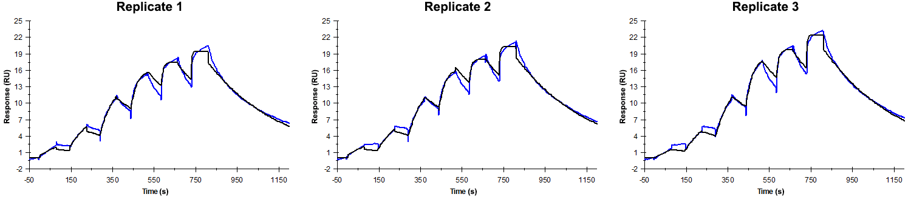
Sensorgrams obtained for each replicate of peptide 23 / Phd_{STm}⁵⁶⁻⁷⁰ (analyte) binding to Doc_{STm} (ligand). Six concentrations of the analyte were flown over the surface in a single cycle, ranging from 200 nM to 0.824 nM (3-fold dilutions). The association and dissociation times were 80 s and 400 s, respectively.

Summary of the fitted parameters obtained from each SPR measurement of peptide 23.
Replicate | k_{on} (M⁻¹ s⁻¹) | k_{off} (s⁻¹) | K_{D} (nM) | R_{MAX} (RU) | t_{C} (RU M⁻¹ s⁻¹) | Chi² (RU²) | U-value
1 | 1.534 ± 0.006 × 10⁶ | 2.840 ± 0.008 × 10⁻³ | 1.85 | 17.6 ± 0.01 | 2.425 ± 2.000 × 10¹² | 0.461 | 2
2 | 1.439 ± 0.006 × 10⁶ | 2.785 ± 0.008 × 10⁻³ | 1.94 | 18.5 ± 0.01 | 1.631 ± 3.300 × 10¹² | 0.455 | 2
3 | 1.265 ± 0.005 × 10⁶ | 2.758 ± 0.007 × 10⁻³ | 2.18 | 20.2 ± 0.01 | 4.966 ± 42.000 × 10¹¹ | 0.457 | 2

