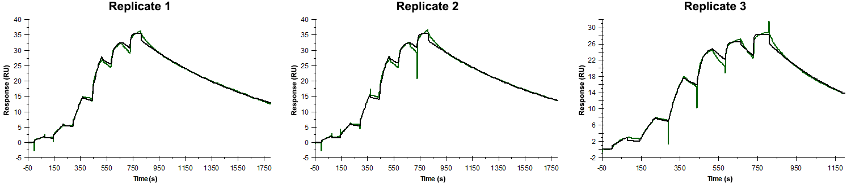
Sensorgrams obtained for each replicate of peptide 8 / Phd_{STm}⁵²⁻⁷³ M60A (analyte) binding to Doc_{STm} (ligand). Six concentrations of the analyte were flown over the surface in a single cycle, ranging from 100 nM to 0.412 nM (3-fold dilutions). The association and dissociation times were 80 s and 1000 s, respectively.

Summary of the fitted parameters obtained from each SPR measurement of peptide 8.
Replicate | k_{on} (M⁻¹ s⁻¹) | k_{off} (s⁻¹) | K_{D} (pM) | R_{MAX} (RU) | t_{C} (RU M⁻¹ s⁻¹) | Chi² (RU²) | U-value
1 | 1.442 ± 0.002 × 10⁶ | 9.658 ± 0.008 × 10⁻⁴ | 670 | 33.6 ± 0.01 | 1.566 ± 1.000 × 10¹³ | 0.275 | 1
2 | 1.490 ± 0.003 × 10⁶ | 9.101 ± 0.010 × 10⁻⁴ | 611 | 33.5 ± 0.01 | 3.717 ± 4.600 × 10¹³ | 0.418 | 1
3 | 3.730 ± 0.016 × 10⁶ | 18.10 ± 0.06 × 10⁻⁴ | 485 | 26.3 ± 0.01 | 8.970 ± 0.178 × 10⁷ | 0.248 | 1

