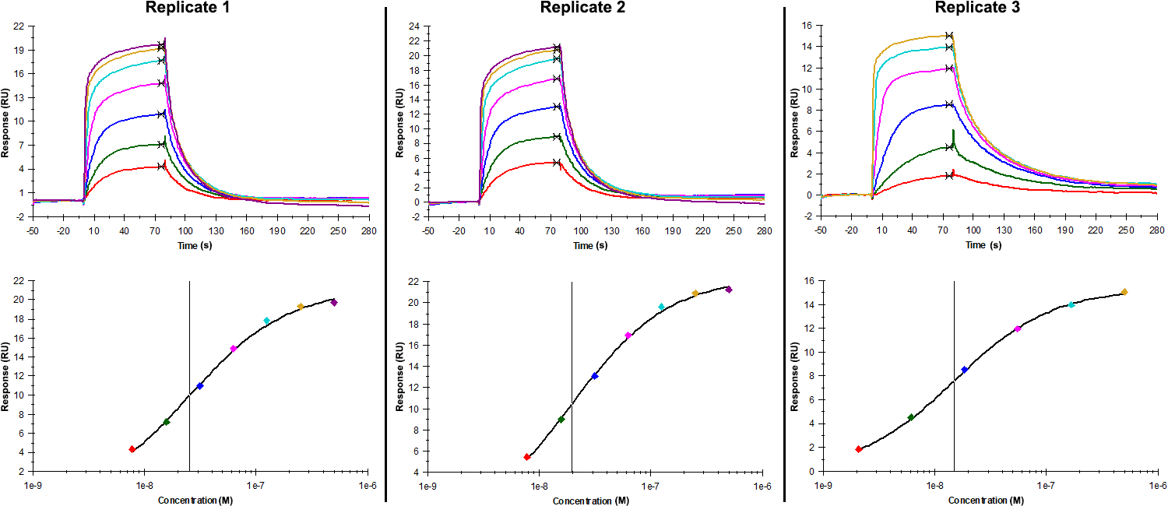
Sensorgrams (upper charts) and steady-state fit (lower charts) obtained for each replicate of peptide 7 / Phd_{STm}⁵²⁻⁷³ I59A (analyte) binding to Doc_{STm} (ligand). The analyte was flown in multiple individual cycles, ranging from 500 nM to 7.8125 nM (2-fold dilutions) for replicates 1 and 2 and from 500 nM to 2.06 nM (3-fold dilutions) for replicate 3. The association and dissociation times were 80 s and 200 s, respectively.

Summary of the fitted parameters obtained from each SPR measurement of peptide 7.
Replicate | K_{D} (nM) | R_{MAX} (RU) | Offset (RU) | Chi² (RU²)
1 | 25.40 ± 3.00 | 22.3 ± 0.7 | -1.20 ± 0.86 | 0.113
2 | 19.35 ± 2.20 | 24.1 ± 0.9 | -1.70 ± 1.00 | 0.099
3 | 15.10 ± 0.09 | 15.4 ± 0.2 | 0.00 ± 0.22 | 0.021

