Synthetic Approaches to Peptidomimetics
Sam Thompson
ªSchool of Chemistry, University of Southampton, Southampton, SO17 1QT
https://www.southampton.ac.uk/chemistry/about/staff/st3a15.page

The >650,000 protein-protein interactions (PPIs) that regulate human cellular processes represent a potential therapeutic goldmine, however the large and apparently featureless interfacial protein surfaces of these interactions make them highly demanding targets for small molecule inhibitor design.¹ From a synthetic chemistry perspective, the rational design of conformationally pre-organised scaffolds that mimic protein secondary structure is appealing.² These peptidomimetics are promising but, in common with many non–covalent protein inhibition strategies, they frequently suffer from low potency.

Here we describe a synthetic strategy to dramatically increase the affinity of mimetics for their target protein by forming a covalent bond between the two. Whilst such a covalent approach has been used to great effect for the inhibition of enzymes³ it has not been explored widely with PPIs.⁴ We focus on boronic acids, and their derivatives, as they have the potential to mediate covalent protein modification with a strong preference for (pairs of) N– and O–centered Lewis basic amino acid side-chains.

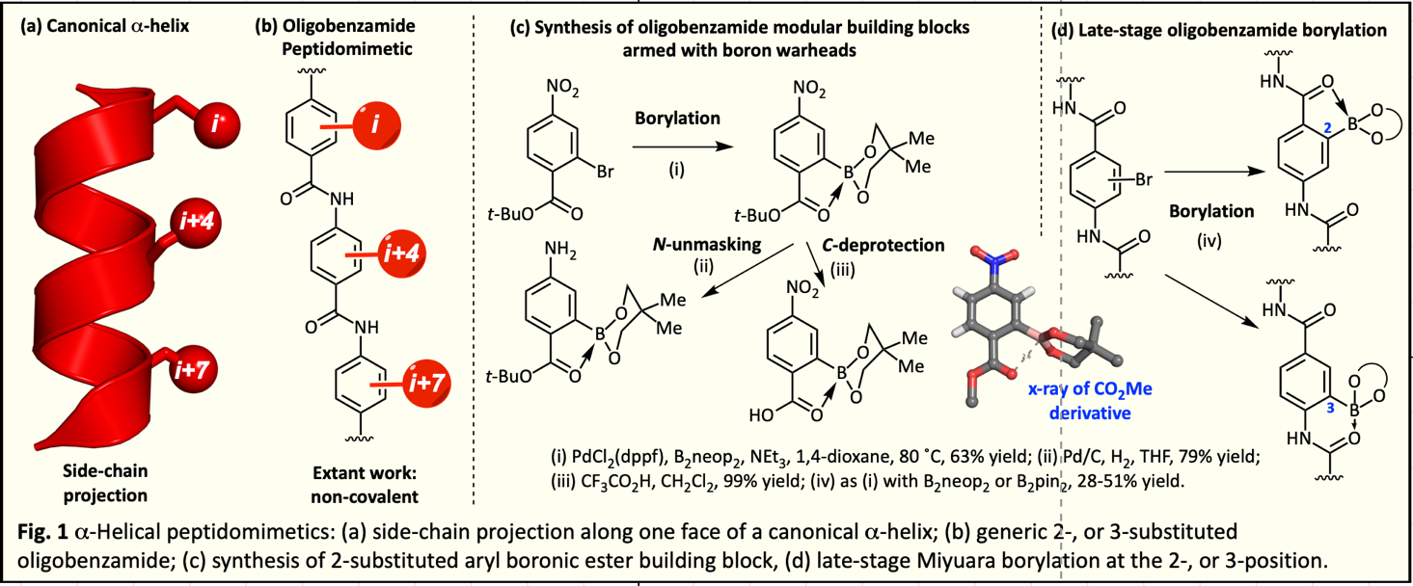

1 M. R. Arkin, Y. Tang and J. A. Wells, Chem. Biol., 2014, 21, 1102–1114.
2 V. Azzarito, K. Long, N. S. Murphy and A. J. Wilson, Nat. Chem., 2013, 5, 161–173.
3 E. E. Manasanch and R. Z. Orlowski, Nat. Rev. Clin. Oncol., 2017, 14, 417–433.
4 G. Akçay, M. A. Belmonte, B. Aquila, C. Chuaqui, A. W. Hird, M. L. Lamb, P. B. Rawlins, N. Su, S. Tentarelli, N. P. Grimster and Q. Su, Nat. Chem. Biol., 2016, 12, 931–936.

