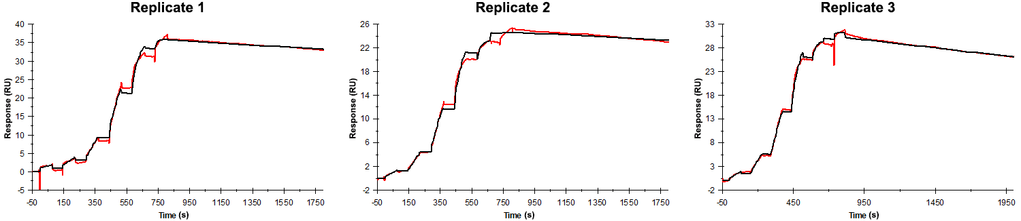
Sensorgrams obtained for each replicate of peptide 18 / Phd_{STm}⁵²⁻⁷³ D72A (analyte) binding to Doc_{STm} (ligand). Six concentrations of the analyte were flown over the surface in a single cycle, ranging from 50 nM to 0.206 nM (3-fold dilutions). In all replicates the association time was 80s. The dissociation times were 1000 s for replicates 1 and 2 and 1200 s for replicate 3.

Summary of the fitted parameters obtained from each SPR measurement of peptide 18.
Replicate | k_{on} (M⁻¹ s⁻¹) | k_{off} (s⁻¹) | K_{D} (pM) | R_{MAX} (RU) | t_{C} (RU M⁻¹ s⁻¹) | Chi² (RU²) | U-value
1 | 1.397 ± 0.002 × 10⁶ | 0.7430 ± 0.0069 × 10⁻⁴ | 53.2 | 35.7 ± 0.01 | 1.189 ± 1.800 × 10¹⁵ | 0.506 | 5
2 | 3.007 ± 0.005 × 10⁶ | 0.5670 ± 0.0066 × 10⁻⁴ | 18.9 | 24.7 ± 0.01 | 7.652 ± 15.000 × 10¹² | 0.245 | 7
3 | 3.120 ± 0.003 × 10⁶ | 1.200 ± 0.003 × 10⁻⁴ | 38.5 | 30.2 ± 0.01 | 5.850 ± 5.030 × 10¹³ | 0.142 | 2

