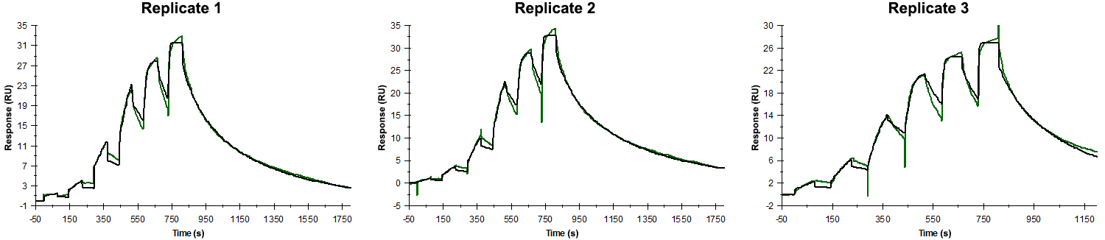
Sensorgrams obtained for each replicate of peptide 17 / Phd_{STm}⁵²⁻⁷³ L70A (analyte) binding to Doc_{STm} (ligand). Six concentrations of the analyte were flown over the surface in a single cycle, ranging from 100 nM to 0.412 nM (3-fold dilutions). In all replicates the association time was 80s. The dissociation times were 1000 s for replicates 1 and 2 and 400 s for replicate 3.

Summary of the fitted parameters obtained from each SPR measurement of peptide 17.
Replicate | k_{on} (M⁻¹ s⁻¹) | k_{off} (s⁻¹) | K_{D} (nM) | R_{MAX} (RU) | t_{C} (RU M⁻¹ s⁻¹) | Chi² (RU²) | U-value
1 | 2.873 ± 0.027 × 10⁶ | 6.019 ± 0.059 × 10⁻³ | 2.10 | 28.4 ± 0.04 | 1.078 ± 0.008 × 10⁷ | 0.464 | 2
2 | 3.197 ± 0.035 × 10⁶ | 6.343 ± 0.075 × 10⁻³ | 1.98 | 30.3 ± 0.04 | 1.034 ± 0.008 × 10⁷ | 0.584 | 2
3 | 5.440 ± 0.089 × 10⁶ | 5.540 ± 0.079 × 10⁻³ | 1.02 | 23.2 ± 0.04 | 2.390 ± 0.044 × 10⁷ | 0.730 | 3

