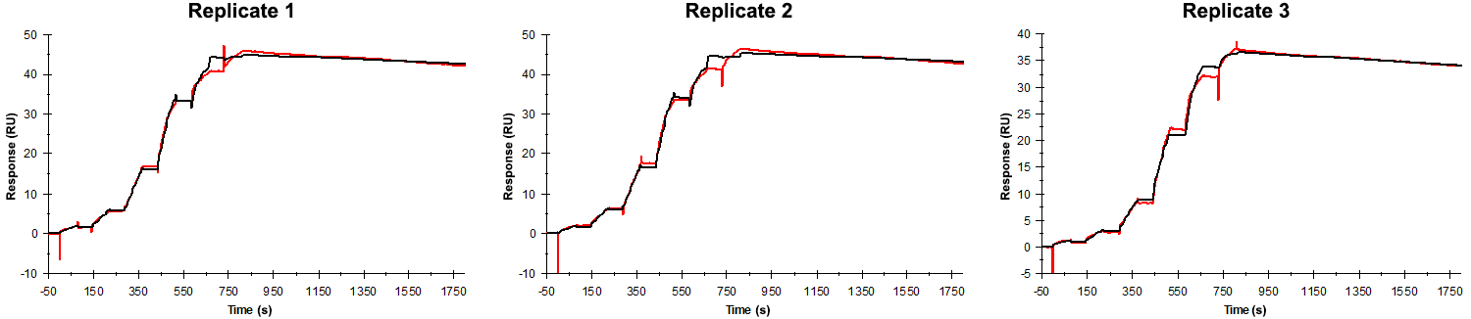
Sensorgrams obtained for each replicate of peptide 2 / Phd_{STm}⁵²⁻⁷³ M52A (analyte) binding to Doc_{STm} (ligand). Six concentrations of the analyte were flown over the surface in a single cycle, ranging from 100 nM to 0.412 nM (3-fold dilutions) for replicates 1 and 2, and 50 nM to 0.206 nM (3-fold dilutions) for replicate 3. The association and dissociation times were 80 s and 1000 s, respectively.

Summary of the fitted parameters obtained from each SPR measurement of peptide 2.
Replicate | k_{on} (M⁻¹ s⁻¹) | k_{off} (s⁻¹) | K_{D} (pM) | R_{MAX} (RU) | t_{C} (RU M⁻¹ s⁻¹) | Chi² (RU²) | U-value
1 | 1.039 ± 0.002 × 10⁶ | 5.437 ± 0.066 × 10⁻⁵ | 52.3 | 44.9 ± 0.02 | 1.311 ± 0.500 × 10¹² | 0.777 | 7
2 | 1.072 ± 0.002 × 10⁶ | 5.126 ± 0.065 × 10⁻⁵ | 47.8 | 45.3 ± 0.02 | 2.159 ± 0.850 × 10¹² | 0.792 | 7
3 | 1.297 ± 0.002 × 10⁶ | 7.143 ± 0.057 × 10⁻⁵ | 55.1 | 36.7 ± 0.01 | 1.249 ± 6.100 × 10¹³ | 0.367 | 5

