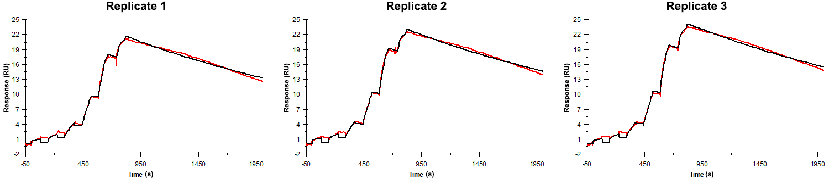
Sensorgrams obtained for each replicate of peptide 22 / Phd_{STm}⁵⁵⁻⁷¹ (analyte) binding to Doc_{STm} (ligand). Six concentrations of the analyte were flown over the surface in a single cycle, ranging from 100 nM to 0.412 nM (3-fold dilutions). The association and dissociation times were 80 s and 800 s, respectively.

Summary of the fitted parameters obtained from each SPR measurement of peptide 22.
Replicate | k_{on} (M⁻¹ s⁻¹) | k_{off} (s⁻¹) | K_{D} (pM) | R_{MAX} (RU) | t_{C} (RU M⁻¹ s⁻¹) | Chi² (RU²) | U-value
1 | 1.525 ± 0.004 × 10⁶ | 5.213 ± 0.016 × 10⁻⁴ | 342 | 20.5 ± 0.01 | 4.07 ± 120.00 × 10¹³ | 0.376 | 2
2 | 1.466 ± 0.004 × 10⁶ | 4.925 ± 0.015 × 10⁻⁴ | 336 | 21.8 ± 0.01 | 1.131 ± 2.100 × 10¹³ | 0.381 | 2
3 | 1.357 ± 0.003 × 10⁶ | 4.946 ± 0.015 × 10⁻⁴ | 365 | 22.6 ± 0.01 | 2.951 ± 2.200 × 10¹³ | 0.386 | 2

