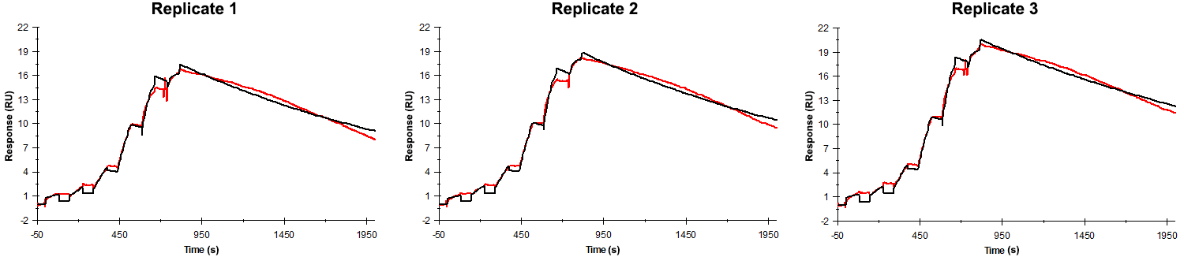
Sensorgrams obtained for each replicate of peptide 21 / Phd_{STm}⁵⁵⁻⁷³ (analyte) binding to Doc_{STm} (ligand). Six concentrations of the analyte were flown over the surface in a single cycle, ranging from 50 nM to 0.206 nM (3-fold dilutions). The association and dissociation times were 80 s and 1200 s, respectively.

Summary of the fitted parameters obtained from each SPR measurement of peptide 21.
Replicate | k_{on} (M⁻¹ s⁻¹) | k_{off} (s⁻¹) | K_{D} (pM) | R_{MAX} (RU) | t_{C} (RU M⁻¹ s⁻¹) | Chi² (RU²) | U-value
1 | 1.344 ± 0.004 × 10⁶ | 5.508 ± 0.011 × 10⁻⁴ | 410 | 17.6 ± 0.01 | 9.656 ± 17.000 × 10¹² | 0.292 | 2
2 | 1.218 ± 0.003 × 10⁶ | 5.013 ± 0.010 × 10⁻⁴ | 412 | 19.1 ± 0.01 | 2.095 ± 1.200 × 10¹² | 0.287 | 2
3 | 1.195 ± 0.003 × 10⁶ | 4.361 ± 0.009 × 10⁻⁴ | 365 | 20.7 ± 0.01 | 3.899 ± 5.500 × 10¹² | 0.298 | 2

