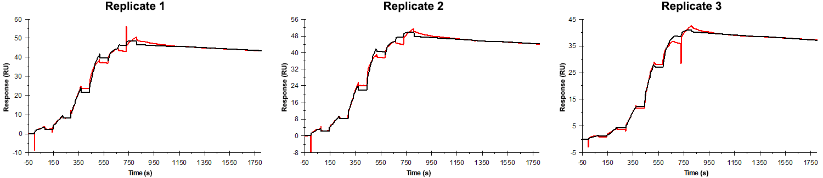
Sensorgrams obtained for each replicate of peptide 5 / Phd_{STm}⁵²⁻⁷³ E55A (analyte) binding to Doc_{STm} (ligand). Six concentrations of the analyte were flown over the surface in a single cycle, ranging from 100 nM to 0.412 nM (3-fold dilutions) for replicates 1 and 2, and 50 nM to 0.206 nM (3-fold dilutions) for replicate 3. The association and dissociation times were 80 s and 1000 s, respectively.

Summary of the fitted parameters obtained from each SPR measurement of peptide 5.
Replicate | k_{on} (M⁻¹ s⁻¹) | k_{off} (s⁻¹) | K_{D} (pM) | R_{MAX} (RU) | t_{C} (RU M⁻¹ s⁻¹) | Chi² (RU²) | U-value
1 | 1.453 ± 0.003 × 10⁶ | 7.105 ± 0.084 × 10⁻⁵ | 48.9 | 46.6 ± 0.02 | 1.410 ± 3.800 × 10¹³ | 1.390 | 7
2 | 1.461 ± 0.003 × 10⁶ | 7.493 ± 0.082 × 10⁻⁵ | 51.3 | 47.4 ± 0.02 | 7.999 ± 8.400 × 10¹² | 1.370 | 7
3 | 1.711 ± 0.003 × 10⁶ | 8.018 ± 0.068 × 10⁻⁵ | 46.9 | 40.1 ± 0.02 | 3.497 ± 88.00 × 10¹³ | 0.627 | 5

