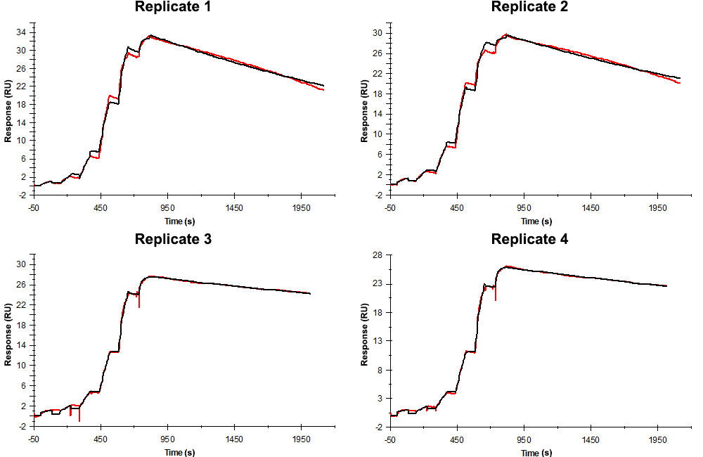
Sensorgrams obtained for each replicate of peptide 12 / Phd_{STm}⁵²⁻⁷³ N65A (analyte) binding to Doc_{STm} (ligand). Six concentrations of the analyte were flown over the surface in a single cycle, ranging from 50 nM to 0.206 nM (3-fold dilutions). In all replicates the association time was 80s. The dissociation times were 1300 s for replicates 1 and 2, and 1200 s for replicates 3 and 4.

Summary of the fitted parameters obtained from each SPR measurement of peptide 12.
Replicate | k_{on} (M⁻¹ s⁻¹) | k_{off} (s⁻¹) | K_{D} (pM) | R_{MAX} (RU) | t_{C} (RU M⁻¹ s⁻¹) | Chi² (RU²) | U-value
1 | 1.259 ± 0.002 × 10⁶ | 3.155 ± 0.005 × 10⁻⁴ | 251 | 33.5 ± 0.01 | 7.047 ± 1.700 × 10¹² | 0.338 | 1
2 | 1.595 ± 0.003 × 10⁶ | 2.643 ± 0.005 × 10⁻⁴ | 166 | 29.7 ± 0.01 | 4.890 ± 1.900 × 10¹² | 0.311 | 1
3 | 1.290 ± 0.004 × 10⁶ | 1.100 ± 0.003 × 10⁻⁴ | 85.3 | 27.6 ± 0.01 | 2.410 ± 0.026 × 10⁷ | 0.077 | 2
4 | 1.440 ± 0.004 × 10⁶ | 1.200 ± 0.002 × 10⁻⁴ | 83.3 | 25.9 ± 0.01 | 1.360 ± 0.006 × 10⁷ | 0.032 | 1

