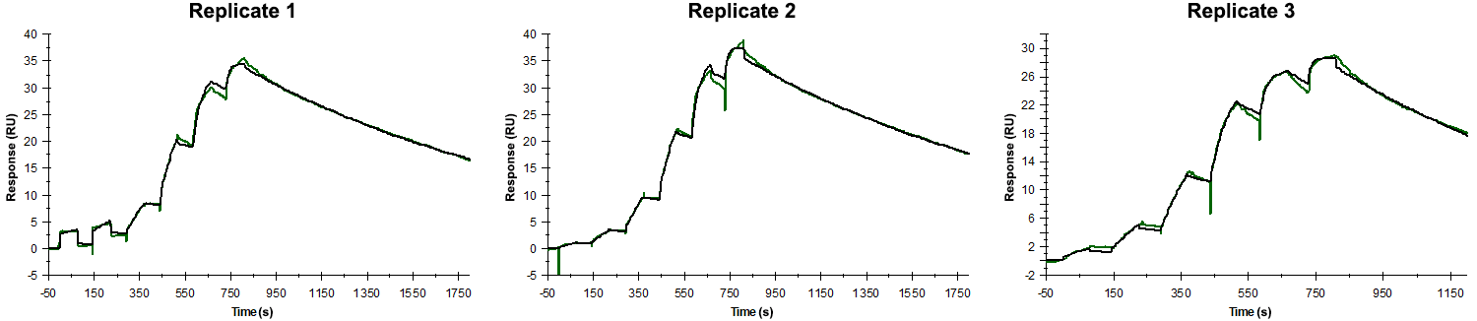
Sensorgrams obtained for each replicate of peptide 6 / Phd_{STm}⁵²⁻⁷³ F56A (analyte) binding to Doc_{STm} (ligand). Six concentrations of the analyte were flown over the surface in a single cycle, ranging from 100 nM to 0.412 nM (3-fold dilutions). In all replicates the association time was 80s. The dissociation times were 1000 s for replicates 1 and 2 and 400 s for replicate 3.

Summary of the fitted parameters obtained from each SPR measurement of peptide 6.
Replicate | k_{on} (M⁻¹ s⁻¹) | k_{off} (s⁻¹) | K_{D} (pM) | R_{MAX} (RU) | t_{C} (RU M⁻¹ s⁻¹) | Chi² (RU²) | U-value
1 | 7.135 ± 0.010 × 10⁵ | 7.167 ± 0.008 × 10⁻⁴ | 1000 | 34.1 ± 0.01 | 1.322 ± 0.850 × 10¹³ | 0.285 | 1
2 | 7.641 ± 0.010 × 10⁵ | 7.021 ± 0.007 × 10⁻⁴ | 919 | 35.8 ± 0.01 | 5.990 ± 3.730 × 10¹⁰ | 0.257 | 1
3 | 14.90 ± 0.03 × 10⁵ | 11.10 ± 0.03 × 10⁻⁴ | 745 | 27.6 ± 0.01 | 2.910 ± 2.760 × 10¹³ | 0.237 | 1

