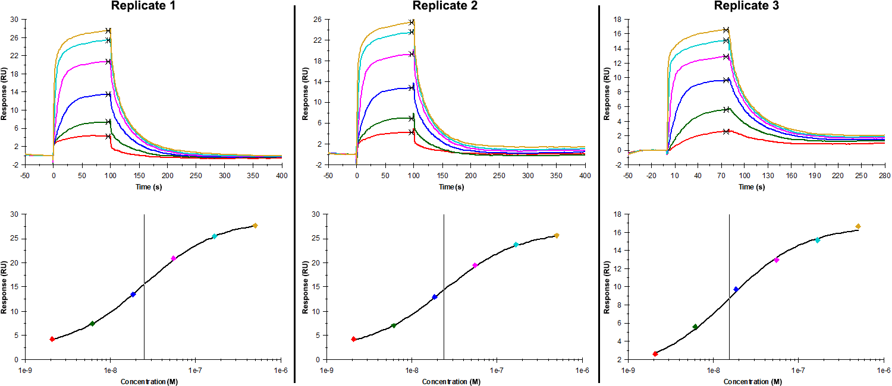
Sensorgrams (upper charts) and steady-state fit (lower charts) obtained for each replicate of peptide 14 / Phd_{STm}⁵²⁻⁷³ L67A (analyte) binding to Doc_{STm} (ligand). Six concentrations of the analyte were flown in multiple individual cycles, ranging from 500 nM to 2.06 nM (3-fold dilutions). The association and dissociation times were, respectively, 100 s and 300 s. For replicate 3 the association and dissociation times were, respectively, 80 s and 200 s

Summary of the fitted parameters obtained from each SPR measurement of peptide 14.
Replicate | K_{D} (nM) | R_{MAX} (RU) | Offset (RU) | Chi² (RU²)
1 | 24.96 ± 0.50 | 26.8 ± 0.1 | 2.10 ± 0.11 | 0.009
2 | 23.93 ± 0.94 | 24.5 ± 0.2 | 2.10 ± 0.20 | 0.028
3 | 15.4 ± 2.13 | 15.8 ± 0.5 | 0.90 ± 0.54 | 0.131

