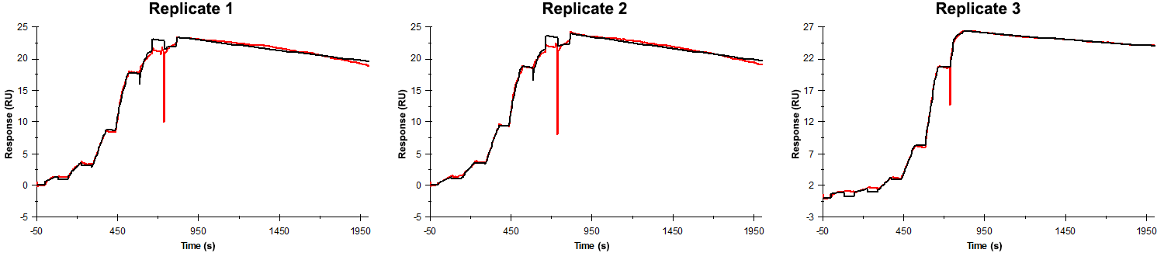
Sensorgrams obtained for each replicate of peptide 16 / Phd_{STm}⁵²⁻⁷³ E69A (analyte) binding to Doc_{STm} (ligand). Six concentrations of the analyte were flown over the surface in a single cycle, ranging from 50 nM to 0.206 nM (3-fold dilutions). The association and dissociation times were 80 s and 1200 s, respectively.

Summary of the fitted parameters obtained from each SPR measurement of peptide 16.
Replicate | k_{on} (M⁻¹ s⁻¹) | k_{off} (s⁻¹) | K_{D} (pM) | R_{MAX} (RU) | t_{C} (RU M⁻¹ s⁻¹) | Chi² (RU²) | U-value
1 | 2.199 ± 0.005 × 10⁶ | 1.511 ± 0.007 × 10⁻⁴ | 68.7 | 23.4 ± 0.01 | 2.47 ± 30.00 × 10¹⁴ | 0.310 | 3
2 | 2.373 ± 0.005 × 10⁶ | 1.688 ± 0.007 × 10⁻⁴ | 70.3 | 24.0 ± 0.01 | 9.908 ± 24.000 × 10¹⁴ | 0.348 | 2
3 | 1.730 ± 0.011 × 10⁶ | 0.8970 ± 0.0037 × 10⁻⁴ | 51.8 | 26.4 ± 0.01 | 6.090 ± 0.029 × 10⁶ | 0.079 | 2

