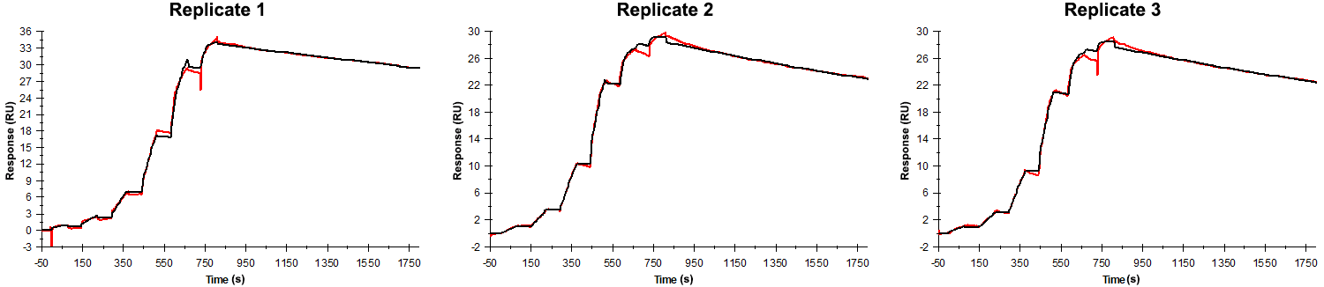
Sensorgrams obtained for each replicate of peptide 11 / Phd_{STm}⁵²⁻⁷³ G64A (analyte) binding to Doc_{STm} (ligand). Six concentrations of the analyte were flown over the surface in a single cycle, ranging from 50 nM to 0.206 nM (3-fold dilutions). The association and dissociation times were 80 s and 1000 s, respectively.

Summary of the fitted parameters obtained from each SPR measurement of peptide 11.
Replicate | k_{on} (M⁻¹ s⁻¹) | k_{off} (s⁻¹) | K_{D} (pM) | R_{MAX} (RU) | t_{C} (RU M⁻¹ s⁻¹) | Chi² (RU²) | U-value
1 | 1.081 ± 0.001 × 10⁶ | 1.420 ± 0.004 × 10⁻⁵ | 130 | 33.8 ± 0.01 | 4.702 ± 3.400 × 10¹¹ | 0.156 | 2
2 | 3.070 ± 0.014 × 10⁶ | 2.280 ± 0.005 × 10⁻⁵ | 74.3 | 28.4 ± 0.01 | 5.270 ± 0.073 × 10⁷ | 0.125 | 1
3 | 2.900 ± 0.016 × 10⁶ | 2.230 ± 0.006 × 10⁻⁵ | 76.9 | 27.7 ± 0.01 | 4.240 ± 0.062 × 10⁷ | 0.143 | 1

