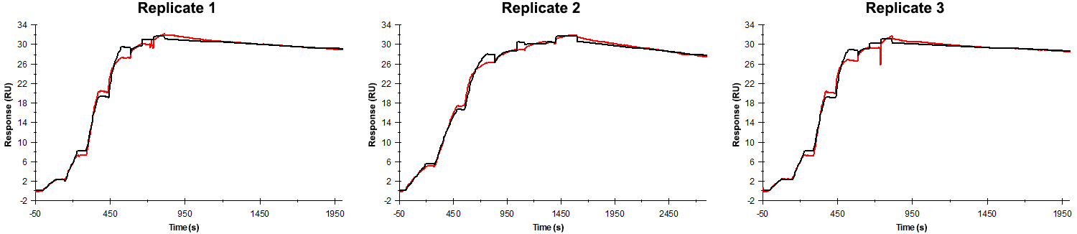
Sensorgrams obtained for each replicate of peptide 4 / Phd_{STm}⁵²⁻⁷³ D54A (analyte) binding to Doc_{STm} (ligand). Six concentrations of the analyte were flown over the surface in a single cycle, ranging from 50 nM to 0.206 nM (3-fold dilutions). The association times were 80s for replicates 1 and 2 and 200 s for replicate 3. In all replicates the dissociation time was 1200 s.

Summary of the fitted parameters obtained from each SPR measurement of peptide 4.
Replicate | k_{on} (M⁻¹ s⁻¹) | k_{off} (s⁻¹) | K_{D} (pM) | R_{MAX} (RU) | t_{C} (RU M⁻¹ s⁻¹) | Chi² (RU²) | U-value
1 | 4.580 ± 0.008 × 10⁶ | 5.840 ± 0.050 × 10⁻⁵ | 12.8 | 31.1 ± 0.01 | 3.560 ± 3.570 × 10¹⁴ | 0.388 | 5
2 | 4.890 ± 0.007 × 10⁶ | 8.120 ± 0.046 × 10⁻⁵ | 16.6 | 30.6 ± 0.01 | 2.390 ± 2.430 × 10¹³ | 0.347 | 5
3 | 4.730 ± 0.008 × 10⁶ | 4.760 ± 0.049 × 10⁻⁵ | 10.1 | 30.2 ± 0.01 | 4.950 ± 9.790 × 10¹² | 0.365 | 7

