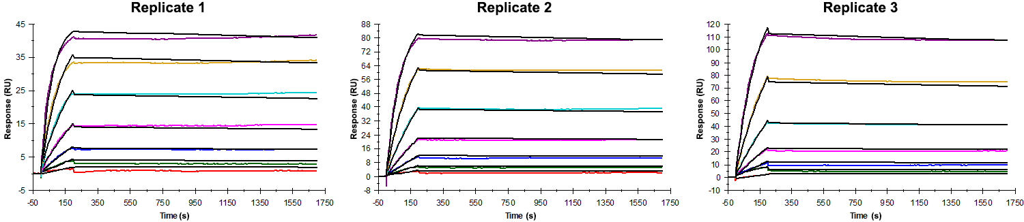
Sensorgrams obtained for each replicate of the Phd_{STm}¹⁻⁷³ protein (analyte) binding to Doc_{STm} (ligand). Due to struggles to fit the slow kinetic rate constants via single-cycle experiments, eight concentrations of the analyte were flown over the surface in multiple individual cycles to obtain more datapoints on the dissociation phase. Analyte concentrations ranged from 25 nM to 0.390625 nM (2-fold dilutions) and the association and dissociation times were 200 s and 1500 s, respectively. The surface was regenerated between each cycle and the ligand density on the surface varied between replicates (lowest and highest densities correspond to replicates 1 and 3, respectively) to verify the reproducibility of the results. Due to the slow association rate and mass-transport limitation at higher analyte concentrations, the data was fitted with a constant R_{MAX}, which was calculated based on the R_{MAX} of a positive control (peptide 1).

Summary of the fitted parameters obtained from each SPR measurement of the Phd_{STm}¹⁻⁷³ protein.
Replicate | k_{on} (M⁻¹ s⁻¹) | k_{off} (s⁻¹) | K_{D} (pM) | R_{MAX} (RU) | t_{C} (RU M⁻¹ s⁻¹) | Chi² (RU²) | U-value
1 | 5.958 ± 0.001 × 10⁵ | 3.022 ± 0.008 × 10⁻⁵ | 50.7 | 45.0 | 5.224 ± 0.020 × 10¹⁰ | 0.923 | 15
2 | 4.357 ± 0.001 × 10⁵ | 2.200 ± 0.008 × 10⁻⁵ | 50.5 | 91.8 | 2.354 ± 2.900 × 10¹² | 1.300 | 12
3 | 3.873 ± 0.001 × 10⁵ | 3.421 ± 0.002 × 10⁻⁵ | 88.3 | 139.9 | 4.360 ± 0.003 × 10⁷ | 2.530 | 9

