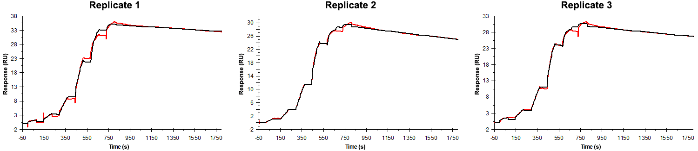
Sensorgrams obtained for each replicate of peptide 13 / Phd_{STm}⁵²⁻⁷³ E66A (analyte) binding to Doc_{STm} (ligand). Six concentrations of the analyte were flown over the surface in a single cycle, ranging from 50 nM to 0.206 nM (3-fold dilutions). The association and dissociation times were 80 s and 1000 s, respectively.

Summary of the fitted parameters obtained from each SPR measurement of peptide 13.
Replicate | k_{on} (M⁻¹ s⁻¹) | k_{off} (s⁻¹) | K_{D} (pM) | R_{MAX} (RU) | t_{C} (RU M⁻¹ s⁻¹) | Chi² (RU²) | U-value
1 | 1.504 ± 0.002 × 10⁶ | 7.151 ± 0.063 × 10⁻⁵ | 47.5 | 35.0 ± 0.01 | 4.63 ± 12.00 × 10¹² | 0.406 | 5
2 | 3.260 ± 0.013 × 10⁶ | 14.70 ± 0.04 × 10⁻⁵ | 45.1 | 28.9 ± 0.01 | 6.760 ± 0.094 × 10⁷ | 0.111 | 2
3 | 3.350 ± 0.017 × 10⁶ | 11.80 ± 0.05 × 10⁻⁵ | 35.2 | 29.9 ± 0.01 | 4.830 ± 0.058 × 10⁷ | 0.159 | 2

