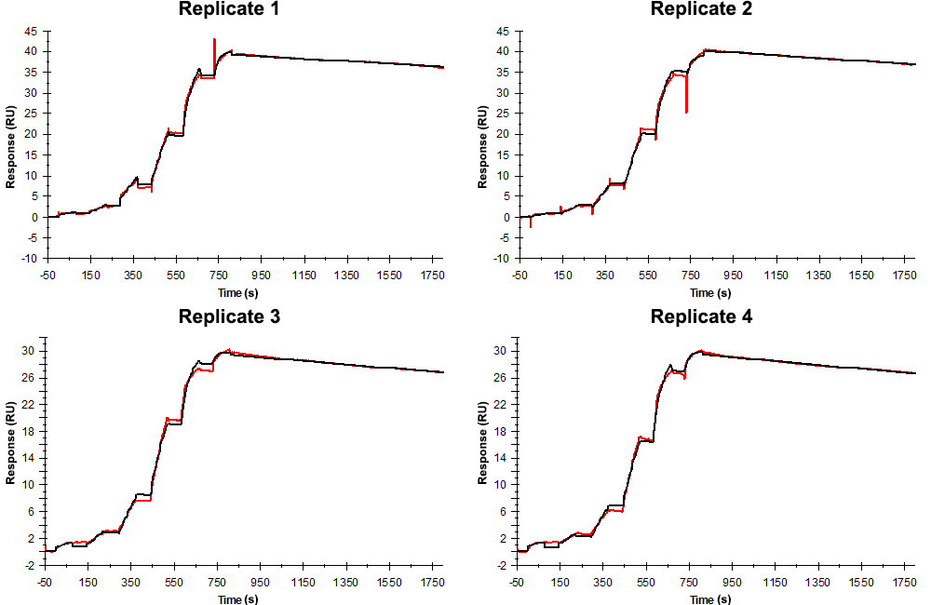
Sensorgrams obtained for each replicate of peptide 1 / Phd_{STm}⁵²⁻⁷³ (analyte) binding to Doc_{STm} (ligand). Six concentrations of the analyte were flown over the surface in a single cycle, ranging from 50 nM to 0.206 nM (3-fold dilutions). The association and dissociation times were 80 s and 1000 s, respectively.

Summary of the fitted parameters obtained from each SPR measurement of peptide 1.
Replicate | k_{on} (M⁻¹ s⁻¹) | k_{off} (s⁻¹) | K_{D} (pM) | R_{MAX} (RU) | t_{C} (RU M⁻¹ s⁻¹) | Chi² (RU²) | U-value
1 | 1.056 ± 0.001 × 10⁶ | 7.750 ± 0.040 × 10⁻⁵ | 73.4 | 39.20 ± 0.01 | 1.694 ± 15.000 × 10¹³ | 0.195 | 3
2 | 1.065 ± 0.001 × 10⁶ | 8.926 ± 0.054 × 10⁻⁵ | 83.8 | 40.20 ± 0.01 | 2.540 ± 1.100 × 10¹¹ | 0.371 | 3
3 | 1.610 ± 0.002 × 10⁶ | 9.520 ± 0.047 × 10⁻⁵ | 59.1 | 29.40 ± 0.01 | 1.670 ± 11.200 × 10¹³ | 0.157 | 3
4 | 1.270 ± 0.002 × 10⁶ | 10.40 ± 0.040 × 10⁻⁵ | 81.9 | 29.50 ± 0.01 | 2.430 ± 0.986 × 10⁹ | 0.113 | 2

