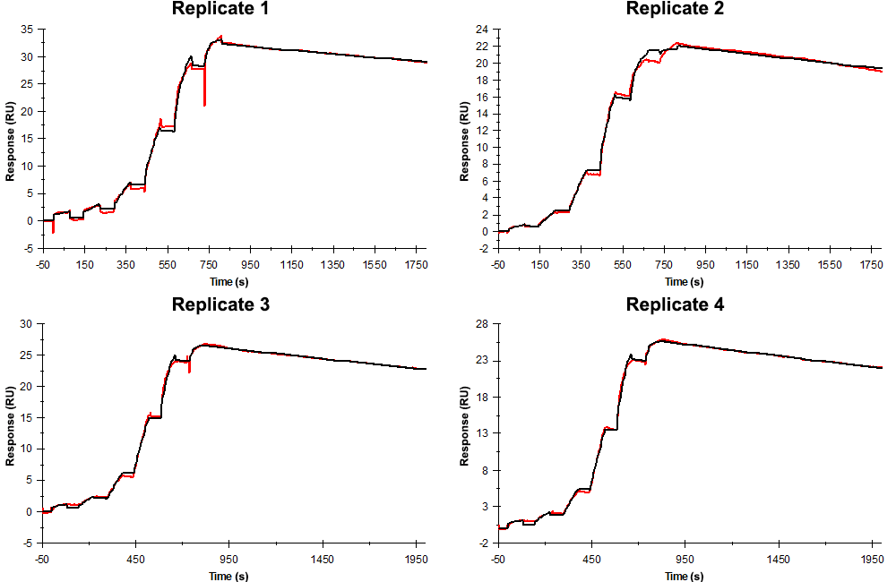
Sensorgrams obtained for each replicate of peptide 19 / Phd_{STm}⁵²⁻⁷³ K73A (analyte) binding to Doc_{STm} (ligand). Six concentrations of the analyte were flown over the surface in a single cycle, ranging from 50 nM to 0.206 nM (3-fold dilutions). In all replicates the association time was 80s. The dissociation times were 1000 s for replicates 1 and 2, and 1200 s for replicates 3 and 4.

Summary of the fitted parameters obtained from each SPR measurement of peptide 19.
Replicate | k_{on} (M⁻¹ s⁻¹) | k_{off} (s⁻¹) | K_{D} (pM) | R_{MAX} (RU) | t_{C} (RU M⁻¹ s⁻¹) | Chi² (RU²) | U-value
1 | 1.085 ± 0.001 × 10⁶ | 1.092 ± 0.005 × 10⁻⁴ | 101 | 32.4 ± 0.01 | 4.165 ± 25.000 × 10¹² | 0.211 | 3
2 | 2.120 ± 0.013 × 10⁶ | 1.344 ± 0.006 × 10⁻⁴ | 63.4 | 22.1 ± 0.01 | 9.656 ± 0.560 × 10⁷ | 0.127 | 2
3 | 1.280 ± 0.002 × 10⁶ | 1.280 ± 0.003 × 10⁻⁴ | 100 | 26.5 ± 0.01 | 2.260 ± 8.360 × 10¹⁰ | 0.092 | 1
4 | 1.280 ± 0.004 × 10⁶ | 1.320 ± 0.002 × 10⁻⁴ | 103 | 25.7 ± 0.01 | 6.870 ± 0.184 × 10⁷ | 0.049 | 1

