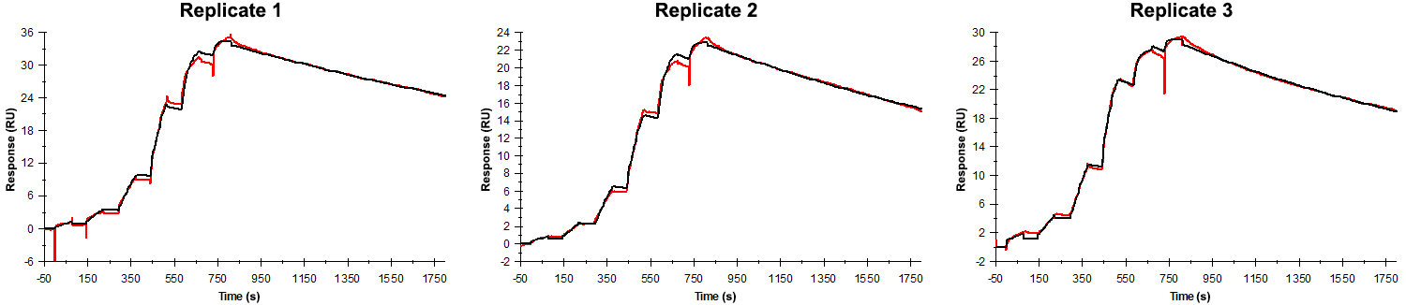
Sensorgrams obtained for each replicate of peptide 9 / Phd_{STm}⁵²⁻⁷³ V62A (analyte) binding to Doc_{STm} (ligand). Six concentrations of the analyte were flown over the surface in a single cycle, ranging from 50 nM to 0.206 nM (3-fold dilutions). The association and dissociation times were 80 s and 1000 s, respectively.

Summary of the fitted parameters obtained from each SPR measurement of peptide 9.
Replicate | k_{on} (M⁻¹ s⁻¹) | k_{off} (s⁻¹) | K_{D} (pM) | R_{MAX} (RU) | t_{C} (RU M⁻¹ s⁻¹) | Chi² (RU²) | U-value
1 | 1.798 ± 0.011 × 10⁶ | 3.293 ± 0.008 × 10⁻⁴ | 183 | 33.8 ± 0.01 | 2.110 ± 0.220 × 10⁸ | 0.365 | 1
2 | 1.649 ± 0.002 × 10⁶ | 3.936 ± 0.006 × 10⁻⁴ | 239 | 22.7 ± 0.01 | 1.087 ± 0.230 × 10¹³ | 0.102 | 1
3 | 3.350 ± 0.015 × 10⁶ | 4.420 ± 0.008 × 10⁻⁴ | 132 | 28.4 ± 0.01 | 6.920 ± 0.112 × 10⁷ | 0.151 | 1

