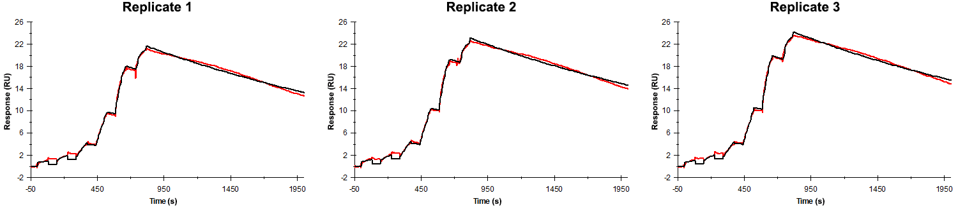
Sensorgrams obtained for each replicate of peptide 20 / Phd_{STm}⁵²⁻⁷¹ (analyte) binding to Doc_{STm} (ligand). Six concentrations of the analyte were flown over the surface in a single cycle, ranging from 50 nM to 0.206 nM (3-fold dilutions). The association and dissociation times were 80 s and 1200 s, respectively.

Summary of the fitted parameters obtained from each SPR measurement of peptide 20.
Replicate | k_{on} (M⁻¹ s⁻¹) | k_{off} (s⁻¹) | K_{D} (pM) | R_{MAX} (RU) | t_{C} (RU M⁻¹ s⁻¹) | Chi² (RU²) | U-value
1 | 9.247 ± 0.016 × 10⁵ | 4.132 ± 0.006 × 10⁻⁴ | 447 | 22.0 ± 0.01 | 4.539 ± 8.000 × 10¹² | 0.166 | 1
2 | 9.339 ± 0.014 × 10⁵ | 3.870 ± 0.006 × 10⁻⁴ | 414 | 23.4 ± 0.01 | 5.672 ± 2.800 × 10¹¹ | 0.165 | 1
3 | 8.910 ± 0.014 × 10⁵ | 3.778 ± 0.006 × 10⁻⁴ | 424 | 24.5 ± 0.01 | 8.001 ± 11.000 × 10¹² | 0.164 | 1

