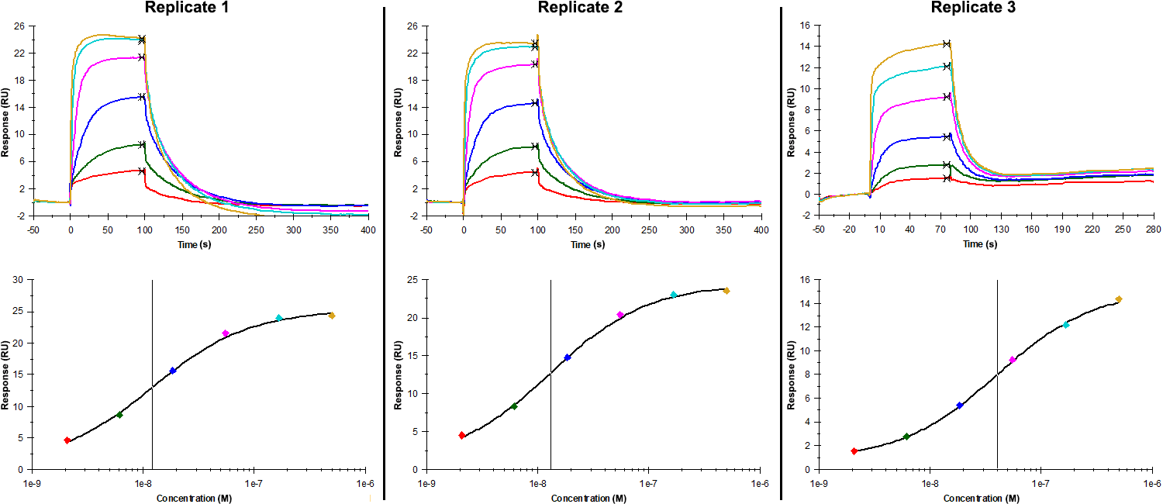
Sensorgrams (upper charts) and steady-state fit (lower charts) obtained for each replicate of peptide 10 / Phd_{STm}⁵²⁻⁷³ H63A (analyte) binding to Doc_{STm} (ligand). Six concentrations of the analyte were flown in multiple individual cycles, ranging from 500 nM to 2.06 nM (3-fold dilutions). The association and dissociation times were, respectively, 100 s and 300 s. For replicate 3 the association and dissociation times were, respectively, 80 s and 200 s

Summary of the fitted parameters obtained from each SPR measurement of peptide 10.
Replicate | K_{D} (nM) | R_{MAX} (RU) | Offset (RU) | Chi² (RU²)
1 | 12.17 ± 1.8 | 24.5 ± 0.9 | 0.80 ± 0.97 | 0.318
2 | 13.08 ± 1.40 | 23.4 ± 0.6 | 1.00 ± 0.67 | 0.168
3 | 40.00 ± 2.87 | 14.3 ± 0.2 | 0.80 ± 0.18 | 0.032

