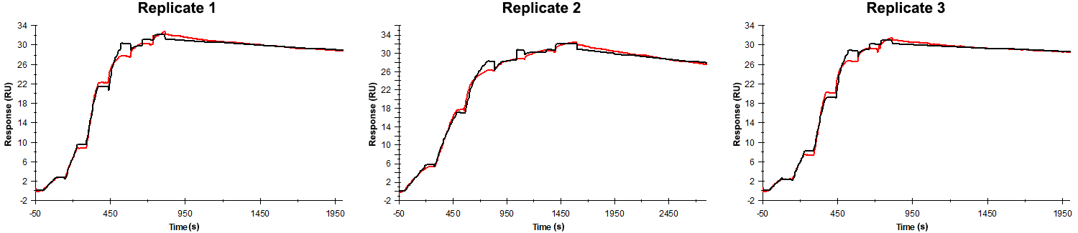
Sensorgrams obtained for each replicate of peptide 3 / Phd_{STm}⁵²⁻⁷³ D53A (analyte) binding to Doc_{STm} (ligand). Six concentrations of the analyte were flown over the surface in a single cycle, ranging from 50 nM to 0.206 nM (3-fold dilutions). The association times were 80s for replicates 1 and 2 and 200 s for replicate 3. In all replicates the dissociation time was 1200 s.

Summary of the fitted parameters obtained from each SPR measurement of peptide 3.
Replicate | k_{on} (M⁻¹ s⁻¹) | k_{off} (s⁻¹) | K_{D} (pM) | R_{MAX} (RU) | t_{C} (RU M⁻¹ s⁻¹) | Chi² (RU²) | U-value
1 | 5.480 ± 0.010 × 10⁶ | 6.650 ± 0.052 × 10⁻⁵ | 12.1 | 31.2 ± 0.01 | 4.970 ± 3.920 × 10¹² | 0.434 | 5
2 | 4.980 ± 0.009 × 10⁶ | 8.250 ± 0.052 × 10⁻⁵ | 16.6 | 30.8 ± 0.01 | 1.280 ± 3.230 × 10¹⁴ | 0.449 | 5
3 | 4.760 ± 0.008 × 10⁶ | 4.720 ± 0.049 × 10⁻⁵ | 9.92 | 30.2 ± 0.01 | 3.270 ± 9.670 × 10¹³ | 0.358 | 7

