Characterization of Cmp 341

Luis Montes1, Drako Covaks*2

1. UMC analytix
2. Spin Research

Further information

Supporting Information

Figure S1. 1H NMR spectrum of LS00027756.10.fid
Figure S2. 1H13C HSQC NMR spectrum of LS00027756.11.ser

Figure S1. 1H NMR spectrum of LS00027756.10.fid (700 MHz, DMSO, 303 K)

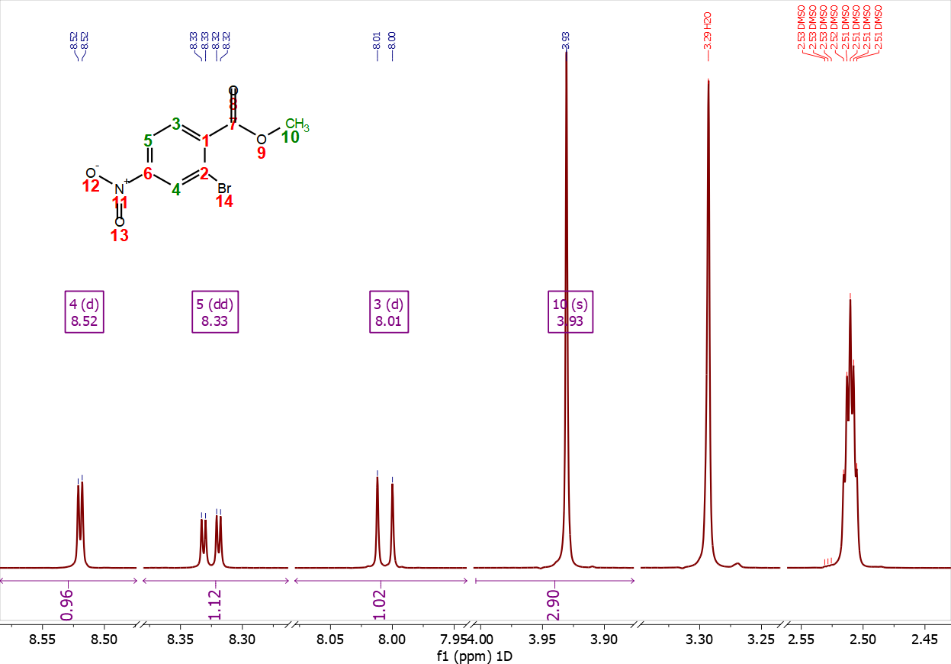
Figure S2. 1H13C HSQC NMR spectrum of LS00027756.11.ser ((176, 700) MHz, DMSO, 303 K)



