Borate-Catalysed Direct Amidation Reactions of Coordinating Substrates - Supporting Information
Richard J. Procter, Carla Alamillo-Ferrer, Usman Shabbir, Phyllida Britton, Dejan-Krešimir Bučar, Alexandre S. Dumon, Henry S. Rzepa, Jordi Bures,* Andrew Whiting,* and Tom D. Sheppard*
Raw data files can be found in an online data repository associated with this paper, DOI: 10.14469/hpc/12218
Contents
General Information 2
Preliminary time course experiments 2
Optimisation of Catalysis 4
Synthesis of Borates 6
Synthesis of Amides 9
In-Situ generation of catalyst 24
Varying the ratio of phenol to borane 25
Borane dimethylsulfide catalyst control reaction 25
Larger scale amidation reactions 26
Inhibition with 2 -amino pyridine 28
Adduct formation between 2-amino pyridine and phenylboroxine 28
Interaction of 2-amino pyridine with 2-chlorophenylboroxine 30
Synthesis of 2-Chlorophenylboroxine 30
Reaction of 2-amino pyridine with 2-chlorophenylboroxine 30
Reaction of 2-amino pyridine with 2-chlorophenylboronic acid 31
Analysis of reaction mixtures for catalyst protodeborylation 33
Characterisation data 38
Chiral HPLC traces 83
Single crystal x-ray diffraction studies 88
Computational methods 89
References 89

General Information
All reagents were purchased from chemical suppliers and used as received unless otherwise stated. Reactions were carried out open to ambient air unless otherwise specified. ¹H, ¹³C, ¹¹B and ¹⁹F NMR spectra were recorded on Bruker Avance Neo 700, Avance III 600, Avance Neo 500 or Avance III 400 spectrometers. Chemical shifts are reported in parts per million (ppm) and referenced against residual solvent signals (CDCl₃ = 7.26 (¹H), 77.1 (¹³C); DMSO = 2.49 (¹H), 39.5 (¹³C); MeCN-d₃ = 1.97 (¹H), 1.32 (¹³C)), ¹¹B and ¹⁹F were referenced externally. Peaks are assigned as singlet(s), doublet(d), triplet(t), quartet(q), quintet(qn), septet(sept) or mulitplet(m). Infrared spectra were obtained on a Bruker Alpha II compact FTIR Spectrometer operating in ATR mode, all frequencies given in reciprocal centimetres (cm⁻¹). High resolution mass spectrometry was performed using a Thermo Vanquish LC
connected to Q Exactive Plus Hybrid Quadrupole-Orbitrap mass spectrometer operating in ESI mode. Melting points were measured on a Gallenkamp heating block and are uncorrected. Column chromatography was performed on a Biotage Isolera one system using pre-packed flashpure cartidges.

Preliminary time course experiments
Stock solutions, made up to the prescribed volume with TAME, were used in the preparation of this reaction.
SL | Component | Volume / mL | Mass / mg | Concentration / M
A | BzOH | 5.0 | 764.0 | 1.25
B | 4-Phenylbutylamine | 5.0 | 935.2 | 1.25
C | TMB | 2.0 | 360.2 | 1.07
D | o-ClPhB(OH)₂ | 2.0 | 39.4 | 0.12

To a 25 mL three-neck flask containing a magnetic stirrer and fitted with a Dean-Stark condenser side-arm filled with TAME and wrapped with a heating tape (grounded silicone rubber heating tape BS0-G, BS0102040LG), was charged with stock solutions A (4.0 mL, 5.00 mmol, 1.0 equiv), B (4.0 mL, 5.02 mmol, 1.0 equiv) and C (1.0 mL, 1.07 mmol). The reaction mixture was heated to reflux (86 °C) before the addition of the catalyst stock solution D (1.0 mL, 0.12 mmol, 2.5 mol%). The reaction was monitored by by quantitative ¹H NMR using TMB as the internal standard.
Stock solutions, made up to the prescribed volume with TAME, were used in the preparation of this reaction.
SL | Component | Volume / mL | Mass / mg | Concentration / M
A | BzOH | 5.0 | 694.7 | 1.14
B | 4-Phenylbutylamine | 5.0 | 812.3 | 1.09
C | TMB | 2.0 | 303.3 | 0.90

To a 25 mL three-neck flask containing a magnetic stirrer and fitted with a Dean-Stark condenser side-arm filled with TAME and wrapped with a heating tape (grounded silicone rubber heating tape BS0-G, BS0102040LG), was charged with stock solutions A (4.4 mL, 5.03 mmol, 1.0 equiv), B (4.6 mL, 5.02 mmol, 1.0 equiv) and C (1.0 mL, 0.90 mmol). The reaction mixture was heated to reflux (86 °C) before the addition of B(OCH₂CF₃)₃ (27 µL, 0.12 mmol, 2.5 mol%) in one portion due to low stability in open air of the catalyst at room temperature. The reaction was monitored by offline sampling and analysing the data by quantitative ¹H NMR using TMB as the internal standard.
Stock solutions, made up to the prescribed volume with TAME, were used in the preparation of this reaction.
SL | Component | Volume / mL | Mass / mg | Concentration / M
A | Phenyl acetic acid | 5.0 | 850.7 | 1.25
B | 2-aminopyridine | 5.0 | 590.8 | 1.26
C | TMB | 1.0 | 413.6 | 2.46
D | (p-ClPh)₂B(OH) | 2.0 | 140.3 | 0.28

To a 25 mL three-neck flask containing a magnetic stirrer and fitted with a Dean-Stark condenser side-arm filled with TAME and wrapped with a heating tape (grounded silicone rubber heating tape BS0-G, BS0102040LG), was charged with stock solutions A (4.0 mL, 5.00 mmol, 1.0 equiv), B (4.0 mL, 5.03 mmol, 1.0 equiv) and C (0.2 mL, 0.49 mmol). The reaction mixture was heated to reflux (86 °C) before the addition of the catalyst stock solution D (1.8 mL, 0.50 mmol, 10 mol%). The reaction was monitored by offline sampling and analysing the data by quantitative ¹H NMR using TMB as the internal standard.
Stock solutions, made up to the prescribed volume with TAME, were used in the preparation of this reaction.
SL | Component | Volume / mL | Mass / mg | Concentration / M
A | Phenyl acetic acid | 5.0 | 775.6 | 1.14
B | 2-aminopyridine | 5.0 | 537.9 | 1.14
C | TMB | 2.0 | 286.1 | 0.85

To a 25 mL three-neck flask containing a magnetic stirrer and fitted with a Dean-Stark condenser side-arm filled with TAME and wrapped with a heating tape (grounded silicone rubber heating tape BS0-G, BS0102040LG), was charged with stock solutions A (4.4 mL, 5.02 mmol, 1.0 equiv), B (4.4 mL, 5.04 mmol, 1.0 equiv) and C (1.1 mL, 0.94 mmol). The reaction mixture was heated to reflux (86 °C) before the addition of B(OCH₂CF₃)₃ (100 µL, 0.46 mmol, 10 mol%) in one portion due to low stability in open air of the catalyst at room temperature. The reaction was monitored by offline sampling and analysing the data by quantitative ¹H NMR using TMB as the internal standard.

Optimisation of Catalysis
General procedure
In a 50 ml round bottomed flask, benzoic acid (610 mg, 5 mmol) and 1,3,5-trimethoxybenzene (for use as internal standard, 84.1 mg, 0.5 mmol) were dissolved in 10 ml tert-Amyl methyl ether (TAME). Benzylamine (600 μl, 5.5 mmol) was added, and the reaction mixture was heated to 70 °C when the respective catalyst (0.5 mmol, either as neat liquid, solid or as a solution in TAME) was added. The flask was equipped with a Dean-Stark distillation apparatus with a filled side arm, and the reaction was brought to reflux for 18 hours. A sample of the homogenous reaction mixture was quenched with 1M HCl solution, extracted into DCM, dried under reduced pressure, redissolved in CDCl₃ and analysed by ¹H NMR spectroscopy.
Catalyst | Yieldª / %
B(OCH₂CF₃)₃ | 56
B(OMe)₃ | 36
[-B(OMe)O-]₃ | 38
B(OiPr)₃ | 27
B(OHFIP)₃ | 60
B(OC(CF₃)₃)₃ | 51
B(OCH₂CCl₃)₃ | 64
 | 65
B(OPh)₃ | 52
 | 71
B(OC₆Cl₅)₃ | 51
 | 0
CatBH | 34
Cl₄CatBH | 57
B(OH)₃ | 20
PinBH | 22
 | 62
 | 78
ªMeasured by ¹H NMR vs. trimethoxybenzene internal standard
In a 50 ml round bottomed flask, 3-fluorophenylacetic acid (771mg, 5 mmol) and 2-amino pyridine (518 mg, 5.5 mmol) were dissolved in 10 ml tert-Amyl methyl ether (TAME). The reaction mixture was heated to 70 °C, (becomes homogenous ~ 65°C) and the respective catalyst was added (0.5 mmol, either as neat liquid, solid or as a solution in TAME (0.25M)), the flask equipped with a Dean-Stark distillation apparatus with a filled side arm, and the reaction was brought to reflux for 18 hours. The reaction was quenched with saturated NaHCO₃, and acetanilide (135 mg, 1 mmol) was added to use as an internal standard. The mixture was extracted into DCM, dried under reduced pressure, redissolved in CDCl₃ and analysed by ¹H NMR spectroscopy.
Catalyst | Yield / %
B(OCH₂CF₃)₃ | 20
B(OiPr)₃ | 26
B(OHFIP)₃ | 27
B(OC(CF₃)₃)₃ | 22
B(OCH₂CCl₃)₃ | 16
 | 15
B(OPh)₃ | 27
 | 46
 | 29
B(OC₆Cl₅)₃ | 26
 | 29
 | 0
B(OC₆F₅)₃* | 26
*Generated in-situ from BH₃.SMe₂ + 3 C₆F₅OH, according to the general procedure described for B(OArF₃)₃ vide infra.

Synthesis of Borates
Commercially available borates, boranes, and boronic acids were purchased from chemical suppliers and used as received. B(OCH₂CF₃)₃,¹ B(OHFiP)₃,² and Chlorocatechol borane³ were synthesised according to literature procedures. 3,4,5 trifluorophenol was stored over 3Å molecular sieves prior to use in borate synthesis. Melting points for borates are not recorded due to their sensitivity to moisture in air leading to unreliable melting point measurements.
tris(3,4,5-trifluorophenyl) borate
Procedure A (from BCl₃): In a flame dried Schlenk flask, under an atmosphere of argon, 3,4,5-trifluorophenol (7.26 g, 49 mmol) was dissolved in 30 ml anhydrous dichloromethane and cooled to -40 °C (precipitates). Boron trichloride solution (0.82 M in DCM, 20 ml, 16.333 mmol) (care, HCl evolution) was added dropwise and the reaction became homogenous. After 30 minutes the reaction was warmed to 0 °C with an ice/water bath (HCl evolves on warming), stirred for 30 minutes and warmed to room temperature. After 1 hour the reaction was concentrated under vacuum and the residue redissolved by warming in a mix of anhydrous pentane (10 ml) and DCM (4 ml), then cooled to -20 °C overnight, producing a crop of white crystals. The crystals were washed with pentane (1 ml) and dried under reduced pressure. Yield = 4.8 g, 10.6 mmol, 65%.
Procedure B (from BH₃.SMe₂): Under an atmosphere of argon in a flame dried 2 neck round bottom flask equipped with a reflux condenser, 3,4,5-trifluorophenol (10 g, 68 mmol), was dissolved in 15 ml anhydrous diethyl ether. The solution was cooled to 0 °C, and borane dimethylsulfide (2.6 ml, 2.6 mmol) was added dropwise and stirred for 30 minutes, after which the reaction was heated to reflux overnight. The solution was transferred to a Schlenk flask and concentrated under reduced pressure. Recrystallisation of the residue is typically more difficult than using procedure A, presumably due to residual dimethyl sulfide or borane species, and works most effectively using pentane/ether mixes (2:1). Yield 5.5g, 12.2 mmol, 47%.
¹H NMR (500 MHz, CDCl₃) δ (ppm) = 6.77 (m, 6H)
¹³C{¹H}NMR (126 MHz, CDCl₃) δ (ppm) = 151.3 (ddd, J_{C-F} = 250.1, 10.5, 5.5 Hz), 146.9 (td, J_{C-F} = 4.0, 11.9 Hz), 137.4 (dt, J_{C-F} = 248.6, 15.3, Hz), 105.3 (m)
¹¹B NMR (128 MHz, CDCl₃) δ (ppm) = 15.6 (s)
¹⁹F NMR (376 MHz, CDCl₃) δ (ppm) = -132.66 (d, J = 21 Hz), -165.51 (t, J = 21 Hz).
HRMS: [C₁₈H₆BO₃F₉ + OMe]⁻ : Expect 483.05 observe 483.05
ν_{max} (solid/cm⁻¹): 3090, 1625, 1520, 1453
tris(2,2,3,3,4,4,5,5-octafluoropentyl) borate
A flame dried two neck round bottomed flask was charged with borane dimethylsulfide (2.1 ml, 21 mmol), and cooled to 0 °C. 1H,1H,5H-octafluoro-1-pentanol (9 ml, 15.1g, 65 mmol) was added dropwise, and the reaction stirred overnight. The solution was then transferred to a distillation apparatus with the aid of 5 ml anhydrous pentane and volatiles were removed under reduced pressure. The product was distilled (111-115 °C, 2 mbar) to give a colourless oil. Yield = 13.27g, 18.85 mmol, 87%.
¹H NMR (400 MHz, CDCl₃) δ (ppm) = 6.01 (tt, J = 52.0, 5.4 Hz, 3H), 4.34 (t, J = 13.3 Hz, 6H).
¹³C{¹H} NMR (176 MHz, CDCl₃) δ (ppm) = 114.6 (tt, J = 256.5, 30.6 Hz), 111.0 (tddd, J = 264.4, 33.8, 30.9, 2.5 Hz), 110.2 (tddd, J = 263.7, 31.3, 26.8, 4.8 Hz), 107.7 (tt, J = 253.9, 30.9 Hz).
¹¹B NMR (128 MHz, CDCl₃) δ (ppm) = 17.7
¹⁹F{¹H} NMR (376 MHz, CDCl₃) δ (ppm) = -122.04 (m, 6F), -125.83 (m, 6F), -130.63 (m, 6F), -137.75 (m, 6F).
HRMS [C₁₅H₉BF₂₄O₃]⁻ : Calculated 704.0267, observed 704.0273
tris(2,2,2-trichloroethyl) borate
A flame dried two neck round bottomed flask was charged with borane dimethylsulfide (2 ml, 20 mmol), and cooled to 0 °C. Trichloroethanol (5.75 ml, 60 mmol) was added dropwise, and after 30 minutes the reaction was allowed to warm to room temperature. After stirring at this temperature for 30 minutes, the reaction was heated to 40 °C, and over a period of 1 hour a white solid formed. The reaction was allowed to stir at 40 °C overnight. The solid was recrystallised from hot anhydrous dichloromethane, producing 5.2 g white crystals (11.4 mmol, 57 %).
¹H NMR (500 MHz, CDCl₃) δ (ppm) = 4.52 (s, 6H)
¹³C{¹H} NMR (126 MHz, CDCl₃) δ (ppm) = 97.0, 75.9.
¹¹B NMR (160 MHz, CDCl₃) δ (ppm) = 17.7.
HRMS [C₆H₆BCl₉O₃+C₂H₅O]⁻ : Calculated 500.7889, experimental 500.7893
tris(2,4,6-trichlorophenyl) borate
Tris(2,4,6-trichlorophenyl) borate was prepared by a modified literature procedure⁴. In a flame dried Schlenk tube, 2,4,6-trichlorophenol (5.33 g, 27 mmol) was dissolved in anhydrous dichloromethane (40 ml). The solution was cooled with a dry ice/acetonitrile bath (-41 °C), causing the phenol to precipitate, and neat boron tribromide (690 μl, 9 mmol) was added dropwise (HBr is evolved, and should be trapped by bubbling through NaOH solution. A homogenous solution was formed on addition of the BBr₃). After 45 minutes reaction, the cold bath was replaced with an ice/water bath (further HBr evolution on warming), and after a further 45 minutes reaction this was removed and the flask allowed to warm to room temperature. After 45 minutes at room temperature, the solvent was removed under reduced pressure, and the product was isolated by recrystallisation from a saturated solution in DCM. Yield = 2.02 g white crystals, 37%.
¹H NMR (500 MHz, CDCl₃) δ (ppm) = 7.35 (s, 6H)
¹³C{¹H} NMR (126 MHz, CDCl₃) δ (ppm) = 144.4, 130.1, 128.6, 127.9.
¹¹B NMR (160 MHz, CDCl₃) δ (ppm) = 15.5
HRMS [C₁₈H₆BCl₉O₃]⁻ : Calculated 599.7542, observed 599.7542
Tris(pentachlorophenyl) borate
In a Schlenk flask under argon, pentachlorophenol (7.99 g, 30 mmol, 2.72 eq) was suspended in 20 ml anhydrous dichloromethane. The mixture was cooled to -78 °C and boron trichloride (1M in DCM, 1.1 ml, 11 mmol, 1 eq.) was added dropwise (care HCl evolution). After 30 minutes the cold bath was removed and the reaction was stirred at room temperature overnight. A further 20 ml anhydrous dichloromethane was added and the suspension filtered by cannula filtration, and the solid was washed with anhydrous THF (2 * 20ml). Due to poor solubility in standard NMR solvents, the product was characterised by mass spec only.
HRMS [C₁₈BCl₁₅O₃]⁻ : Expected 805.5185, observed 805.5187
Tris(perfluoro-tertbutyl) borate
Under an atmosphere of argon, a flame dried 2-necked round bottom flask equipped with a condenser was charged with perfluorotertbutanol (7.5 ml, 12.75g, 54 mmol, 3.15 eq.) and cooled to 0 °C. Borane dimethylsulfide (1.7 ml, 17 mmol, 1 eq) was added dropwise, and after 30 minutes the cold bath was removed and the reaction heated to reflux overnight. After this time 1 ml further perfluorobutanol was added and reflux was continued for 2 hours. After this time the borate was purified by distillation (100 °C, 40 mbar) and collected as a white solid. The solid was melted by gentle heating and solid impurities were removed by filtration. Yield = 5.75 g colourless liquid, 47%. Due to poor solubility in typical NMR solvents, analysis was carried out in anhydrous diethyl ether.
¹³C{¹H}NMR (126 MHz, (C₂H₅)₂O) δ (ppm) = 119.7 (q, J_{C-F} = 290.3 Hz). Quaternary carbon not visible.
¹¹B NMR (160 MHz, (C₂H₅)₂O) δ (ppm) = 14.1 ppm
¹⁹F NMR (376 MHz, (C₂H₅)₂O) δ (ppm) = -72.3 ppm

Synthesis of Amides
General Procedure
A 50 ml round bottomed flask was charged with carboxylic acid (5 mmol), amine (5.5 mmol), and tert-butyl acetate (4 ml), and heated to 80 °C. B(OArF₃)₃ (0.5 mmol, in solution in 1 ml tBuOAc) was added once this temperature was reached, the flask equipped with a Dean-Stark distillation apparatus with a filled side arm, and the reaction was brought to reflux for the indicated time. Reactions were quenched with a saturated NaHCO₃ solution, extracted into DCM, and washed with 1M NaOH followed by 1M HCl (for basic substrates this step was omitted). The organic phase was dried over Na₂SO₄, filtered, dried under reduced pressure and purified by column chromatography.
N-Benzylbenzamide
Synthesised according to the general procedure, using 5 mol% or 2 mol% catalyst loading. Purified by flash column chromatography (EtOAc:Cyclohexane 30% à 60%). Analytical data in accordance with literature reports.⁵ Yield = 923 mg white solid, 4.37 mmol, 87%
¹H NMR (700 MHz, CDCl₃): δ (ppm) = 7.79 (d, J = 7.6 Hz, 2H), 7.50 (t, J = 7.3 Hz, 1H), 7.43 (t, J = 7.6 Hz, 2H), 7.36 (m, 4H), 7.33-7.28 (m, 1H), 6.46 (s, 1H), 4.65 (d, J = 5.6 Hz, 2H).
¹³C NMR (176 MHz, CDCl₃): δ (ppm) = 167.48, 138.31, 134.52, 131.70, 128.94, 128.74, 128.07, 127.78, 127.09, 44.28.
HRMS [C₁₄H₁₃NO+H]⁺ Expected 212.1081 Observed 212.1068
Melting point: 92-93 °C
2-(3-fluorophenyl)-N-(pyridin-2-yl)acetamide
Synthesised according to the general procedure, purified by flash column Chromatography (EtOAc : cyclohexane, 15% à 50%). Yield = 940 mg white solid, 82%.
¹H NMR (700 MHz, CDCl₃) δ (ppm) = 8.43 (s, 1H), 8.22 (m, 2H), 7.71 (ddd, J = 8.4, 7.4, 1.9, Hz, 1H), 7.32 (td, J = 8.0, 6.0 Hz, 1H), 7.09 (d, J = 7.6 Hz, 1H), 7.04 (m, 2H), 7.00 (td, J = 8.5, 2.5 Hz, 1H), 3.74 (s, 1H).
¹³C NMR (176 MHz, CDCl₃) δ (ppm) = 169.0 163.2 (d, J(¹CF) = 247.0 Hz), 151.3, 147.6, 138.8, 136.4 (d, J(³CF) = 7.6 Hz), 130.7 (d, J(³CF) = 8.3 Hz), 125.2 (d, J(⁴CF) = 2.9 Hz), 120.2, 116.6 (d, J(²CF) = 21.6 Hz), 114.8 (d, J(²CF) = 21.0 Hz), 114.4), 44.5.
¹⁹F NMR (659 MHz, CDCl₃) δ (ppm) = −112.1 (m, 1F).
HRMS [C₁₃H₁₁FN₂O+H]⁺; Expected: 231.0928, observed: 231.0924
ν_{max} (solid/cm⁻¹): 3241, 3188, 3114, 3081, 3033, 1687, 1615, 1578, 1524, 1487, 1460, 1436
Melting Point: 108 – 111 °C
N-(2-(dimethylamino)-5-(trifluoromethyl)phenyl)-2-phenylacetamide
Synthesised according to the general procedure, purified by flash column chromatography (EtOAc:Cyclohexane 5% à 50%). Yield = 1.32 g pale pink solid, 4.09 mmol, 82%
¹H NMR (700 MHz, CDCl₃): δ (ppm) = 8.69 (d, J = 1.6 Hz, 1H), 8.34 (s, 1H), 7.41 (m, 2H), 7.35 (m, 3 H), 7.25 (dd, J = 7.9, 1.3 Hz, 1H), 7.10 (d, J = 8.2 Hz, 1H), 3.79 (s, 2H), 2.35 (s, 6H).
¹³C NMR (176MHz, CDCl₃): δ (ppm) = 169.3, 145.8, 134.6, 133.5, 129.8, 129.3, 127.8, 126.8 (q, J_{C-F} = 32.5 Hz), 124.3 (q, J_{C-F} = 271.8 Hz), 120.7 (q, J_{C-F} = 3.8 Hz), 120.0, 116.2 (q, J_{C-F} = 3.8 Hz), 45.5, 44.0.
¹⁹F NMR (659 MHz, CDCl₃) δ (ppm) = −62.15 (s).
HRMS [C₁₇H₁₇F₃N₂O + H]⁺ : Expect 323.1371 observe 323.1360
ν_{max} (solid/cm⁻¹): 3285, 3075, 3038, 2985, 2945, 2870, 2840, 2795, 1664, 1614, 1585, 1531, 1481, 1468, 1425.
Melting point: 86 – 88 °C
2-phenyl-N-(quinolin-8-yl)acetamide
Synthesised according to the general procedure. Purified by flash column chromatography (EtOAc : Cyclohexane 10% à 30%). Yield = 1.16g off-white solid, 4.42 mmol, 88%. Analytical data is in accordance with literature reports.⁶
¹H NMR (700 MHz, CDCl₃) δ (ppm) = 9.92 (s, 1H), 8.76 (d, J = 7.5 Hz, 1H), 8.69 (dd, J = 4.2, 1.5 Hz, 1H), 8.11 (dd, J = 8.2, 1.4 Hz, 1H), 7.51 (t, J = 7.9 Hz, 1H), 7.47 (dd, J = 8.1, 1 Hz, 1H), 7.45 (d, J = 7.5 Hz, 2H), 7.40 (m, 3H), 7.33 (t, J = 7.3 Hz, 1H), 3.90 (s, 2H).
¹³C NMR (176 MHz, CDCl₃) δ (ppm) = 169.7, 148.2, 138.5, 136.5, 134.8, 134.59, 129.7, 129.1, 128.0, 127.5, 127.5, 121.75, 121.7, 116.6, 45.5
HRMS [C₁₇H₁₄N₂O+H]⁺ : Expected 263.1179, Observed 263.1178
Melting point : 71 - 73 °C

N-benzyl-1H-indazole-3-carboxamide
Synthesised according to the general procedure, reaction time 44 hrs. Purified by flash column chromatography (MeOH in DCM, 0% à 4%), isolated as a white solid. Yield = 1.11 g, 4.4 mmol, 88%.
¹H NMR (700 MHz, DMSO) δ (ppm) = 13.59 (s, 1H), 8.96 (t, J = 6.3 Hz, 1H), 8.17 (d, J = 8.1 Hz, 1H), 7.61 (d, J = 8.5 Hz, 1H), 7.40 (t, J = 7.3 Hz, 1H), 7.35 (d, J = 7.5 Hz, 2H), 7.31 (t, J = 7.6 Hz, 2H), 7.22 (m, 2H), 4.49 (d, J = 6.3 Hz, 2H)
¹³C NMR (176 MHz, DMSO) δ (ppm) = 162.4, 141.1, 140.0, 138.2, 128.3, 127.3, 126.7, 126.5, 122.1, 121.6, 121.6, 110.7, 41.9.
HRMS [C₁₅H₁₃N₃O+H]⁺ : Expected 252.1131, observed 252.1135
ν_{max} (solid/cm⁻¹): 3406, 3160, 3125, 3083, 3053, 3026, 2916, 1644, 1535, 1505, 1469, 1452, 1429
Melting point : 169 – 170 °C
tert-butyl 4-(quinolin-8-ylcarbamoyl)piperidine-1-carboxylate
Synthesised according to the general procedure. Purified by flash column chromatography (EtOAc : Cyclohexane 10% à 50%). Yield = 1.38g brown solid, 3.88 mmol, 78%. Analytical data is in accordance with literature reports.⁷
¹H NMR (700 MHz, CDCl₃) δ (ppm) = 9.94 (s, 1H), 8.80 (dd, J = 4.2, 1.4 Hz, 1H), 8.77 (dd, J = 7.4, 0.9 Hz, 1H), 8.16 (dd, J = 8.2, 1.4 Hz, 1H), 7.53 (t, J = 7.8 Hz, 1H), 7.50 (dd, J = 8.1, 1.2 Hz, 1H), 7.46 (dd, J = 8.3, 4.2 Hz, 1H), 4.22 (br s, 2H), 2.86 (br s, 2H), 2.62 (tt, J = 11.5, 3.7 Hz, 1H), 2.03 (d, J = 11.3 Hz, 2H), 1.83 (qd, J = 12.2, 3.6 Hz, 2H), 1.48 (s, 9H)
¹³C NMR (176 MHz, CDCl₃) δ (ppm) = 173.1, 154.9, 148.3, 138.6, 136.6, 134.5, 128.1, 127.6, 121.8, 121.7, 116.7, 79.8, 44.9, 43.8, 43.1, 28.9, 28.6.
HRMS [C₂₀H₂₅N₃O₃+H]⁺: Calculated 356.1969, Observed 356.1964
Melting point: 103 – 105 °C

N-(2-(dimethylamino)ethyl)-2-phenylacetamide
Synthesised according to the general procedure. Purified by flash column chromatography (MeOH in DCM, 5 à 25 %, plus 1% NEt₃). Yield = 926 mg cream coloured hygroscopic solid, 4.49 mmol, 90%.
¹H NMR (600 MHz, CDCl₃) δ (ppm) = 7.33 (m, 2H), 7.27 (m, 3 H), 6.03 (s, 1H), 3.55 (s, 2H), 3.28 (q, J = 5.8 Hz, 2H), 2.33 (t, J = 6.0 Hz, 2H), 2.15 (s, 6 H).
¹³C NMR (151 MHz, CDCl₃) δ (ppm) = 171.1, 135.2, 129.4, 128.9, 127.2, 57.5, 45.2, 43.8, 37.1.
HRMS [C₁₂H₁₈N₂O + H]⁺ ; Calculated 207.1492, observed 207.1488
ν_{max} (solid/cm⁻¹): 3921, 3080, 3060, 3027, 2982, 2976, 2941, 2815, 2761, 1636, 1550, 1493, 1466, 1452, 1446
2-phenyl-N-(1H-pyrazol-3-yl)acetamide
Synthesised according to the general procedure. Purified by recrystallisation from hot methanol/water (2:1, 21 ml). Yield = 753 mg white needle crystals, 3.75 mmol, 75%. Analytical data is in accordance with literature reports.⁸
¹H NMR (700 MHz, DMSO) δ(ppm) = 12.30 (s, 1H), 10.59 (s, 1H), 7.56 (s, 1H), 7.30 (m, 4H), 7.22 (t, J = 6.7 Hz, 1H), 6.46 (s, 1H), 3.59 (s, 2H).
¹³C NMR (176 MHz, DMSO) δ(ppm) = 168.2, 147.4, 136.2, 129.1, 128.6, 128.3, 126.5, 95.9, 42.5.
HRMS [C₁₁H₁₁N₃O+H]⁺ : Expected 202.0975 Observed 202.0971
Melting point: 150 – 152 °C
N-Phenylpicolinamide
Synthesised according to the general procedure. After aqueous work-up, the crude oil was triturated with pentane and dried under vacuum to yield an orange/brown crystalline solid. Yield = 427 mg, 43%. Analytical data is in accordance with literature reports.⁹
¹H NMR (700 MHz, CDCl₃) δ(ppm) = 10.04 (s, 1H), 8.61 (d, J = 4.1 Hz, 1H), 8.31 (d, J = 7.8 Hz, 1H), 7.91 (t, J = 7.6 Hz, 1H), 7.79 (d, J = 7.9 Hz, 2H), 7.48 (dd, J = 7.7, 5.1 Hz, 1H), 7.39 (t, J = 7.7 Hz, 2H), 7.15 (t, J = 7.4 Hz, 1H).
¹³C NMR (176 MHz, CDCl₃) δ(ppm) = 162.1, 149.9, 148.0, 137.9, 137.9, 129.2, 126.6, 124.5, 122.6, 119.8.
HRMS [C₁₂H₁₀N₂O+H]⁺ : Expected 199.0866 Observed 199.0866
Melting point: 71 – 73 °C
N-(3-bromophenyl)-1H-pyrazole-3-carboxamide
Synthesised according to the general procedure, using toluene as the reaction solvent with 24 hours reaction time. Purified by recrystallisation on cooling of the reaction mixture, followed by washing with toluene (2 x 10 ml) and trituration with Et₂O (2 x 10 ml). Further pure material is isolated from the mother liquor by recrystallisation from hot toluene. Yield = 857 mg white solid, 3.22 mmol, 64%.
¹H NMR (700 MHz, DMSO-d₆) (major component) δ(ppm) = 13.45 (s, 1H), 10.24 (s, 1H), 8.15 (s, 1H), 7.90 (s, 1H), 7.81 (d, J = 7.5 Hz, 1H), 7.25 (m, 2H), 6.77 (s, 1H).
¹³C NMR (176 MHz, DMSO-d₆) δ(ppm) = 160.8, 146.4, 140.6, 130.6 (2C, overlapping peaks), 125.9, 122.4, 121.4, 119.0, 105.9
HRMS [C₁₀H₉ON₃Br + H]⁺ : Expect 265.9924, Observed 265.9927
ν_{max} (solid/cm⁻¹): 3368, 3283, 1676, 1585, 1532, 1478, 1450, 1433
Melting Point : 146 – 149 °C
N-benzylpicolinamide
Synthesised according to the general procedure using 5 mol % borate catalyst. Purified by flash column chromatography (EtOAc : Cyclohexane 20% à 40%). Yield = 1.022g white solid 4.82 mmol, 96%. Analytical data is in accordance with literature reports.¹⁰
¹H NMR (700 MHz, CDCl₃) δ (ppm) = 8.52 (d, J = 4.7 Hz, 1H), 8.40 (s, 1H), 8.24 (d, J = 7.8 Hz, 1H), 7.85 (td, J = 7.7, 1.7 Hz, 1H), 7.42 (ddd, J = 7.6, 4.7, 1.1 Hz, 1H), 7.35 (m, 4H), 7.28 (tt, J = 7.2, 1.4 Hz, 1H), 4.67 (d, J = 6.2 Hz, 2H).
¹³C NMR (176 MHz, CDCl₃) δ (ppm) = 164.3, 149.9, 148.2, 138.4, 137.6, 128.8, 128.0, 127.6, 126.4, 122.5, 43.6.
HRMS [C₁₃H₁₂N₂O+H]⁺ ; expected : 213.1022, observed : 213.1021
Melting point : 75 – 76 °C

N-benzyl-2-(2-chlorophenyl)-2-hydroxyacetamide
Synthesised according to the general procedure, with 40 hours reaction time. Purified by flash column chromatography (EtOAc : Hexanes 30 à 70 %). Yield = 638 mg white solid, 2.32 mmol, 46%. Analytical data is in accordance with literature values.¹¹
¹H NMR (700 MHz, CDCl₃): δ (ppm) = 7.47 (dd, J = 7.7, 1.8 Hz, 1H), 7.38 (dd, J = 7.8, 1.3 Hz, 1H), 7.30 (m, 3H), 7.26 (m, 2H), 7.17 (d, J = 7.8 Hz, 2H), 6.55 (br s, 1H), 5.55 (d, J = 4.6 Hz, 1H), 4.51 (dd, J = 14.9, 5.9 Hz, 1H), 4.42 (dd, J = 14.9, 5.8 Hz, 1H), 4.10 (d, J = 4.6 Hz, 1H).
¹³C NMR (176 MHz, DMSO-d₆): δ (ppm) = 171.3, 139.6, 139.1, 132.7, 129.3, 129.2, 129.0, 128.2, 127.3, 127.1, 126.7, 70.5, 42.0.
HRMS [C₁₅H₁₄ClNO₂ + H⁺] : Calculated 276.0786, observed 276.0789
Melting point: 81 – 84 °C
N-cyclohexylpicolinamide
Synthesised according to the general procedure, reaction for 24 hours. Purified by flash column chromatography (EtOAc in Cyclohexane 30 à 60 %). Yield = 993 mg white solid, 4.86 mmol, 97%. Data is in accordance with reported values.¹²
¹H NMR (700 MHz, CDCl₃) δ (ppm) = 8.53 (d, J = 4.3 Hz, 1H), 8.19 (d, J = 7.8 Hz, 1H), 7.94 (br s, 1H), 7.82 (t, J = 7.6 Hz, 1H), 7.40 (dd, J = 6.8, 5.3 Hz, 1H), 3.96 (m, 1H), 2.00 (dd, J = 12.3, 2.6 Hz, 2H), 1.76 (dt, J = 13.4, 3.5 Hz, 2H), 1.64 (m, 1H), 1.42 (qt, J = 11.8, 3.5 Hz, 2H), 1.31 (m, 2H), 1.23 (m, 1H).
¹³C NMR (176 MHz, CDCl₃) δ (ppm) = 163.4, 150.4, 148.1, 137.5, 126.1, 122.3, 48.3, 33.2, 25.7, 25.0.
Melting point : 59 – 61 °C
N-benzyl-1H-pyrazole-3-carboxamide
Synthesised according to the general procedure, purified by flash column chromatography (Acetone : cyclohexane 20% à 80%). Yield 623 mg white powder, 62%. Data is in accordance with reported values.¹³
¹H NMR (400 MHz, DMSO) δ (ppm) = 13.30 (br s, 1H), 8.75 (br s, 1H), 7.78 (br s, 1H), 7.34 – 7.28 (m, 4H), 7.28 – 7.20 (m, 1H), 6.69 (br s, 1H), 4.43 (d, J = 6.3 Hz, 2H).
¹³C NMR (151 MHz, DMSO) δ (ppm) = 161.6, 146.5, 139.9, 130.1, 128.3 (2C, overlapping peaks), 127.3 (2C, overlapping peaks), 126.7, 105.1, 41.9.
HRMS [C₁₁H₁₁N₃O+H]⁺ : Expect 202.0975, Observe 202.0978
Melting point: 140 – 145 °C
N-(2-(dimethylamino)phenyl)-2-phenylacetamide
Synthesised according to the general procedure. Purified by flash column chromatography (EtOAc : cyclohexane 10 % à 30%). Yield = 1.16 g pale pink solid 4.46 mmol, 91%.
¹H NMR (700 MHz, CDCl₃) δ (ppm) = 8.48 (s, 1H), 8.35 (d, J = 8.1 Hz, 1H), 7.40 (t, J = 7.5 Hz, 2H), 7.35 (m, 3H), 7.07 (m, 2H), 6.99 (t, J = 7.5 Hz, 1H), 3.77 (s, 2H), 2.33 (s, 6H).
¹³C NMR (176 MHz, CDCl₃) δ (ppm) = 169.1, 142.9, 135.0, 133.5, 129.8, 129.2, 127.6, 125.1, 123.8, 120.0, 119.1, 45.6, 44.5.
HRMS [C₁₆H₁₈N₂O+H]⁺ ; Expected = 255.1492, Observed = 255.1496
ν_{max} (solid/cm⁻¹): 3266, 3029, 2977, 2940, 2854, 2825, 2785, 1665, 1591, 1509, 1492, 1474, 1452, 1416
Melting point: 46 – 48 °C
N-(3,5-bis(trifluoromethyl)phenyl)-5-bromofuran-2-carboxamide
Synthesised according to the general procedure using toluene as the reaction solvent, reaction for 24 hours. Purified by flash column chromatography (EtOAc 5% à 25% in cyclohexane) Yield = 1.62 g cream solid, 81%.
¹H NMR (700 MHz, CDCl₃) δ (ppm) = 8.25 (s, 1H), 8.18 (s, 2H), 7.65 (s, 1H), 7.25 (d, J = 3.6 Hz, 1H), 6.55 (d, J = 3.6 Hz, 1H).
¹³C NMR (176 MHz, CDCl₃) δ (ppm) = 155.1, 148.4, 138.7, 132.7 (q, J_{C-F} = 33.6 Hz), 126.0, 123.1 (q, J_{C-F} = 272.9 Hz), 119.8 (q, J_{C-F} = 3.7 Hz), 119.0, 118.1 (sept, J_{C-F} = 3.7 Hz), 115.2.
¹⁹F NMR (659 MHz, CDCl₃) δ (ppm) = −63.04 (s, 1F)
HRMS [C₁₃H₆F₆NO₂Br + H]⁺ : Expect 401.9559, observed 401.9570
ν_{max} (solid/cm⁻¹): 3297, 3095, 1657, 1628, 1586, 1547, 1467, 1439
Melting point: 121 – 122 °C
N-(3-bromophenyl)benzamide
Synthesised according to the general procedure, using toluene as the reaction solvent. Purified by flash column chromatography (EtOAc:Cyclohexane 5 à 30 %). Yield = 1.16g white solid, 84%. Analytical data is in accordance with literature reports.¹⁴
¹H NMR (700 MHz, CDCl₃) δ (ppm) = 7.99 (s, 1H), 7.90 (t, J = 1.9 Hz, 1H), 7.83 (m, 2H), 7.54 (m, 2H), 7.46 (t, J = 7.8 Hz, 2H), 7.26 (m, 1H), 7.20 (t, J = 8.0 Hz, 1H).
¹³C NMR (176 MHz, CDCl₃) δ (ppm) = 166.0, 139.3, 134.6, 132.2, 130.5, 129.0, 127.7, 127.2, 123.3, 122.8, 118.9.
HRMS [C₁₃H₁₀NOBr+H]⁺ : Expected 276.0024, Observed 276.0015
Melting point: 133 - 135 °C
N-(3,5-bis(trifluoromethyl)phenyl)-2-phenylacetamide
Synthesised according to the general procedure using toluene as reaction solvent, with 46 hours reaction time. Purified by flash column chromatography (EtOAc : Cyclohexane 5 à 50%). Yield = 1.625 g white solid, 94%. Analytical data is in accordance with literature reports.¹²
¹H NMR (700 MHz, CDCl₃) δ (ppm) = 7.93 (s, 2H), 7.58 (s, 1H), 7.43 (t, J = 7.4 Hz, 2H), 7.38 (m, 2H), 7.33 (d, J = 7.6 Hz, 2H), 3.78 (s, 2H).
¹³C NMR (176 MHz, CDCl₃) δ (ppm) = 169.6, 139.1, 133.6, 132.5 (q, J_{C-F} = 33.6 Hz), 129.6, 129.6, 128.3, 123.12 (q, J_{C-F} = 272.8 Hz), 119.6 (m), 117.9 (sept, J_{C-F} = 3.6 Hz), 44.9
¹⁹F NMR (659 MHz, CDCl₃) δ (ppm) = −63.04.
HRMS [C₁₆H₁₀NOF₆]⁻ : Expected 346.0672, observed 346.0668
Melting point: 126 – 127 °C
N-allyl-N-phenyl,2-phenylacetamide
Synthesised according to the general procedure, using toluene as the reaction solvent, at 0.5 M concentration. Purified by flash column chromatography (EtOAc : Cyclohexane 10 à 65%). Yield = 903 mg, yellow oil, 72%. Analytical data is in accordance with literature reports.¹
¹H NMR (700 MHz, CDCl₃) δ (ppm) = 7.37 (m, 3H), 7.23 (t, J = 7.3 Hz, 2H), 7.19 (t, J = 7.2 Hz, 1H), 7.08 (d, J = 7.3 Hz, 2H), 7.05 (d, J = 7.3 Hz, 2H), 5.86 (ddt, J = 17.2, 10.2, 6.4 Hz, 1H), 5.09 (d, J = 10.1 Hz, 1H), 5.04 (d, J = 17.1 Hz, 1H), 4.30 (d, J = 6.3 Hz, 2H), 3.45 (s, 2H).
¹³C NMR (176 MHz, CDCl₃) δ 170.7, 142.5, 135.5, 133.2, 129.6, 129.2, 128.8, 128.4, 128.2, 126.7, 118.1, 52.6, 41.4.
HRMS [C₁₇H₁₇NO+H]⁺: Expected 252.1383 Observed 252.1377
N-Methyl-N-phenylbenzamide
Synthesised according to the general procedure using toluene as reaction solvent for 23 hours. Purified by flash column chromatography (EtOAc 20% à 60% in cyclohexane) Yield = 440 mg brown oil, 42%. Analytical data is in accordance with reported literature values.¹⁵
¹H NMR (700 MHz, CDCl₃) δ (ppm) = 7.29 (d, J = 7.5 Hz, 2H), 7.24-7.20 (m, 3H), 7.16-7.12 (m, 3H), 7.03 (d, J = 7.9Hz, 2H), 3.50 (s, 3H).
¹³C NMR (176 MHz, CDCl₃) δ (ppm) = 170.8, 145.0, 136.0, 129.7, 129.3, 128.8, 127.9, 127.0, 126.6, 38.5.
N-cyclohexylcyclopropanecarboxamide
Synthesised according to the general procedure. Purified by flash column chromatography (EtOAc : cyclohexane, 25% à 85%). Yield = 812 mg white solid, 97%. Data in accordance with previous literature reports.¹⁶
¹H NMR (700 MHz, CDCl₃): δ (ppm) = 5.54 (s, 1H), 3.77 (tdt, J = 12 Hz, 11 Hz, 4 Hz, 1H), 1.91 (dddd, J = 12.5 Hz, 4 Hz, 3.9 Hz, 3.5 Hz, 2H), 1.69 (dtt, J = 13.5, 3.9, 3.9 Hz, 2H), 1.60 (dtt, J = 12.0, 3.9, 3.9 Hz, 1 H), 1.34 (qt, J = 12.1 Hz, 3.5 Hz, 2H), 1.27 (tt, J = 7.9 Hz, 4.4 Hz, 1H), 1.08-1.18 (m, 3H), 0.93 (dtd, J = 4.4 Hz, 3.9 Hz, 3.1 Hz, 2H), 0.69 (dtd, J = 7.9 Hz, 3.9 Hz, 3.1 Hz, 2H).
¹³C NMR (176 MHz, CDCl₃): δ (ppm) = 172.6, 48.4, 33.5, 25.7, 25.1, 15.0, 7.1
HRMS : [C₁₀H₁₇ON + H]⁺ : Expected = 168.1383, found 168.1388
Melting point : 137 – 138 °C

N-(adamantan-1-yl)-2-phenylacetamide
Synthesised according to the general procedure. Purified by flash column chromatography (EtOAc 10% à 50% in cyclohexane) Yield = 67 mg white solid, 5%. Data is in accordance with previous literature values.¹⁷
¹H NMR (700 MHz, CDCl₃) δ (ppm) = 7.34 (t, J = 7.4 Hz, 1H), 7.27 (t, J = 7.4 Hz, 2H), 7.24 (d, J = 7.5 Hz, 2H), 5.02 (s, 1H), 3.47 (s, 2H), 2.00 – 2.05 (m, 3H), 1.88 – 1.92 (m, 6H), 1.64 (t, J = 3.0 Hz, 6H).
¹³C NMR (176 MHz, CDCl₃) δ (ppm) = 170.2, 135.7, 129.4, 129.0, 127.2, 52.0, 45.2, 41.6, 36.4, 29.5.
HRMS : [C₁₈H₂₃ON + H]⁺ : Expected = 270.1852, found 270.1855
(S)-N-(1-phenylethyl)pivalamide
Synthesised according to the general procedure. Purified by flash column chromatography (EtOAc 15 % à 60 % in cyclohexane). Yield = 763 mg white solid, 74%. Analytical data is in accordance with literature reports.¹⁸
¹H NMR (700 MHz, CDCl₃) δ (ppm) = 7.33 (t, J = 7.6 Hz, 2H), 7.29 (d, J = 7.4 Hz, 2H), 7.25 (t, J = 7.2 Hz, 1H), 5.82 (s, 1H), 5.10 (qn, J = 7.1 Hz, 1H), 1.48 (d, J = 6.9 Hz, 3H), 1.20 (s, 9H).
¹³C NMR (176 MHz, CDCl₃) δ (ppm) = 177.6, 143.6, 128.8, 127.4, 126.16, 48.6, 38.7, 27.7, 21.9
HRMS [C₁₃H₁₉NO+H]⁺ : Expected 206.1539, observed 206.1535
Melting point: 118 – 119 °C
N-(pyridin-2-yl)-2-(thiophen-3-yl)acetamide
Synthesised according to the general procedure. Purified by flash column chromatography. Yield = 866 mg, off white solid, 79%. Data is in accordance with previous reports.¹⁹
¹H NMR (700 MHz, CDCl₃) δ (ppm) = 8.27 (s, 1H), 8.22 (m, 2H), 7.69 (ddd, J = 8.4 ,7.5, 1.9 Hz, 1H), 7.36 (dd, J = 4.9, 3.0 Hz, 1H), 7.20 (m, 1H), 7.06 (dd, J = 4.9, 1.3 Hz, 1H), 7.02 (ddd, J = 7.4, 4.9, 0.9 Hz, 1H), 3.78 (s, 2H).
¹³C NMR (176 MHz, CDCl₃) δ (ppm) = 169.3, 151.4, 147.9, 138.6, 133.9, 128.5, 127.2, 124.0, 120.1, 114.2, 39.4.
HRMS [C₁₁H₁₀N₂OS+H]⁺ ; expected : 219.0587, observed : 219.0585
Melting point: 108 – 109 °C
tert-butyl 4-(pyridin-2-ylcarbamoyl)piperidine-1-carboxylate
Synthesised according to the general procedure, reaction for 41 hours. Purified by flash column chromatography (EtOAc in cyclohexane, 15 à 85%). Yield = 1.20 g, white solid, 79%.
¹H NMR (700 MHz, CDCl₃) δ (ppm) = 8.72 (s, 1H), 8.24 (dd, J = 4.9, 1.0 Hz, 1H), 8.20 (d, J = 8.3 Hz, 1H), 7.69 (ddd, J = 8.3, 7.3, 1.9 Hz, 1H), 7.03 (ddd, J = 7.3, 4.9, 0.8 Hz, 1H), 4.14 (br s, 2H), 2.72 (br s, 2H), 2.38 (m, 1H), 1.84 (br d, J = 11.4 Hz, 2H), 1.72 (qd, J = 12.3, 4.1 Hz, 2H), 1.44 (s, 9H).
¹³C NMR (176 MHz, CDCl₃) δ (ppm) = 173.4, 154.8, 151.7, 147.7, 138.7, 120.0, 114.6, 79.8, 44.3, 43.6, 42.9, 28.6.
HRMS [C₁₇H₂₃N₃O₃+H]⁺ : Calculated 306.1812 Observed 306.1809
ν_{max} (solid/cm⁻¹): 3312, 2978, 2947, 2925, 2847, 1672, 1578, 1528, 1458, 1420.
Melting point: 156 – 157 °C
N-(pyridin-2-yl)pivalamide
Synthesised according to the general procedure, reaction for 45 hours. Purified by flash column chromatography, (EtOAc in cyclohexane, 10 à 50 %). Yield = 535 mg white solid, 60 %.
¹H NMR (700 MHz, CDCl₃) δ (ppm) = 8.26 – 8.24 (m, 1H), 8.24 – 8.22 (m, 1H), 8.02 (s, 1H), 7.69 (ddd, J = 8.3, 7.3, 1.9 Hz, 1H), 7.02 (ddd, J = 7.3, 4.9, 0.9 Hz, 1H), 1.32 (s, 9H).
¹³C NMR (176 MHz, CDCl₃) δ (ppm) = 177.2, 151.7, 147.8, 138.5 119.8, 114.0, 39.9, 27.6.
HRMS [C₁₀H₁₄N₂O + H]⁺ : Expected 179.1179, observed 179.1181
Melting point: 71 – 72 °C
N-(pyridin-2-yl)benzamide
Synthesised according to the general procedure, reaction for 44 hours. Purified by flash column chromatography (EtOAc in hexanes, 10% à 70%). Yield = 402 mg crystalline white solid, 40%. Analytical data is in accordance with literature reports.²⁰
¹H NMR (700 MHz, CDCl₃) δ (ppm) = 8.91 (s, 1H), 8.40 (dt, J = 8.4 Hz, 1 Hz, 1H), 8.20 (dd, J = 5 Hz, 1 Hz), 1 H), 7.91-7.93 (m, 2H), 7.75 (ddd, J = 8.4, 7.4, 1.9 Hz, 1H), 7.56 (tt, J = 7.4, 1.2 Hz, 1H), 7.48 (t, 7.8 Hz, 2H), 7.04 (ddd, J = 7.3, 4.9, 1 Hz, 1H).
¹³C NMR (176 MHz, CDCl₃) δ (ppm) = δ 166.1, 151.8, 147.9, 138.7, 134.5, 132.4, 128.9, 127.5, 120.0, 114.5.
HRMS [C₁₂H₁₀NO₂+H]⁺: Calculated = 199.0866, found 199.0865
Melting point: 78 – 82 °C
N-(pyridin-2-yl)picolinamide
Synthesised according to the general procedure, reaction time 42 hrs. Purified by flash column chromatography (EtOAc in hexanes, 10% à 100%). Yield = 200 mg white solid, 20%. Analytical data is in accordance with literature reports.²¹
¹H NMR (700 MHz, CDCl₃) δ (ppm) = 10.55 (s, 1H), 8.64 (ddd, J = 4.7, 1.6, 0.9 Hz, 1H), 8.42 (dt, J = 8.3, 0.8 Hz, 1H), 8.37 (ddd, J = 4.9, 1.9, 0.9 Hz, 1H), 8.30 (dt, J = 7.8, 1 Hz, 1H), 7.91 (td, J = 7.7, 1.7 Hz, 1H), 7.76 (m, 1H), 7.49 (ddd, J = 7.5, 4.7, 1.2 Hz, 1H), 7.08 (ddd, J = 7.3, 4.9, 1.0 Hz, 1H).
¹³C NMR (176 MHz, CDCl₃) δ (ppm) = 162.8, 151.3, 149.5, 148.4, 148.4, 138.4, 137.7, 126.9, 122.6, 120.0, 114.1.
HRMS [C₁₁H₉N₃O+H]⁺ : Expected 200.0818, observed 200.0817
Melting point : 101 – 104 °C
N-(pyridin-2-yl)-1H-indazole-3-carboxamide
Synthesised according to the general procedure, reaction for 72 hours. Purified by flash column chromatography (MeOH in DCM, 0 à 5%), and further recrystallised from hot methanol. Yield = 238 mg pale yellow/orange crystalline solid, 1 mmol, 20%.
¹H NMR (700 MHz, CDCl₃) δ (ppm) = 13.92 (s, 1H), 9.77 (s, 1H), 8.37 (ddd, J = 4.8 Hz, 1.7 Hz, 0.7 Hz, 1H), 8.26 (d, J = 8.3 Hz, 1H), 8.22 (d, J = 8.1 Hz, 1H), 7.87 (ddd, J = 8.3 Hz, 7.4 Hz, 1.7 Hz, 1 H), 7.67 (d, 8.4 Hz, 1H), 7.47 (ddd, J = 8.4 Hz, 6.9 Hz, 0.9 Hz, 1 H), 7.32 (t, J = 7.4 Hz, 1H), 7.17 (ddd, J = 7.4 Hz, 4.8 Hz, 0.8 Hz, 1H).
¹³C NMR (176 MHz, CDCl₃) δ (ppm) = 160.6, 151.1, 148.4, 141.5, 138.5, 137.3, 127.0, 122.9, 121.5, 121.2, 119.9, 113.5, 111.2.
HRMS [C₁₃H₁₀N₄O+H]⁺ : Expect 239.0927 observe 239.0921
ν_{max} (solid/cm⁻¹): 3336, 2726, 1678, 1595, 1574, 1538, 1512, 1488, 1454, 1433
Melting point > 250 °C

2-(3-fluorophenyl)-N-(pyridin-3-yl)acetamide
Synthesised according to the general procedure, reaction for 24 hours. Purified by flash column chromatography (EtOAc in cyclohexane, 60 à 100%). Yield = 791mg, white solid, 69%.
¹H NMR (600 MHz, CDCl₃) δ (ppm) = 8.46 (d, J = 2.5 Hz, 1H), 8.34 (d, J = 4.6 Hz, 1H), 8.13 (d, J = 8.3 Hz, 1H), 7.38 (dd, J = 13.8, 7.9 Hz, 2H), 7.27 (dd, J = 7.2, 3.4 Hz, 1H), 7.13 (d, J = 7.6 Hz, 1H), 7.09 – 7.02 (m, 2H), 3.76 (s, 2H).
¹³C NMR (151 MHz, CDCl₃) δ (ppm) = 168.9, 163.1 (d, J(¹CF) = 247.7 Hz), 145.6, 141.1, 136.2 (d, J(³CF) = 7.5 Hz), 134.4, 130.9 (d, J(³CF) = 8.4 Hz), 127.4, 125.2 (d, J(³CF) = 2.9 Hz), 123.8, 116.6 (d, J(²CF) = 21.6 Hz), 114.9 (d, J(²CF) = 20.9 Hz), 44.4.
¹⁹F NMR (659 MHz, CDCl₃) δ (ppm) = −111.7 (m, 1F).
HRMS [C₁₃H₁₁FN₂O+H]⁺: Expected 231.0928, observed 231.0921.
ν_{max} (solid/cm⁻¹): 3102, 3051, 1658, 1604, 1581, 1502, 1485, 1449, 1417.
Melting point: 105 – 107 °C.
tert-Butyl 4-(pyridin-3-ylcarbamoyl)piperidine-1-carboxylate
Synthesised according to the general procedure, reaction for 24 hours. Purified by flash column chromatography (EtOAc in cyclohexane, 0 à 20%). Yield = 784 mg, off-white solid, 51%. Data is in accordance with literature reports.²²
¹H NMR (700 MHz, CDCl₃) δ (ppm) = 8.54 (d, J = 2.2 Hz, 1H), 8.35 (d, J = 4.5 Hz, 1H), 8.19 (d, J = 8.2 Hz, 1H), 7.32 (br s, 1H), 7.28 (dd, J = 8.3, 4.7 Hz, 1H), 4.21 (br s, 2H), 2.79 (br s, 2H), 2.43 (tt, J = 11.6, 3.6 Hz, 1H), 1.91 (d, J = 12.3 Hz, 2H), 1.75 (qd, J = 12.4, 4.3 Hz, 2H), 1.46 (s, 9H).
¹³C NMR (176 MHz, CDCl₃) δ (ppm) = 173.2, 154.8, 145.6, 141.2, 134.7, 127.4, 123.9, 79.9, 44.4, 28.7, 28.6.
HRMS [C₁₆H₂₃N₃O₃+H]⁺: Expected 306.1812, observed 306.1808
ν_{max} (solid/cm⁻¹): 3243, 3178, 2961, 2847, 1688, 1611, 1581, 1550, 1477, 1450, 1424.
Melting point: 164 – 166 °C.

tert-butyl-(R)-2-(benzylcarbamoyl)pyrrolidine-1-carboxylate
Synthesised according to the general procedure, from Boc-D-proline and benzylamine, reaction for 24 hours. Purified by flash column chromatography (EtOAc in cyclohexane, 0 à 30%). Yield = 1.19 g, white solid, 78%. Data is in accordance with previous reports.²³
Enantiopurity >99:1 measured by HPLC Chiralpak AD-H column, 10% IPA in hexane, 1 ml/min, 40 mbar, 30 °C. Retention time = 6.6 minutes
¹H NMR (600 MHz, DMSO) δ (ppm) = 8.40 (t, J = 5.9 Hz, NH, 0.6H, major), 8.36 (t, J = 5.8 Hz, NH, 0.4H, minor), 7.33 – 7.19 (m, 5H), 4.37 – 4.30 (m, 1H), 4.24 – 4.16 (m, 1H), 4.12 (dd, J = 8.6, 2.8 Hz, 0.4H, minor), 4.07 (dd, J = 8.5, 3.1 Hz, 1H, 0.6H, major), 3.44 – 3.37 (m, 1H), 3.32 – 3.25 (m, 1H), 2.17 – 2.03 (m, 1H), 1.89 – 1.71 (m, 3H), 1.41 (s, 3.3H, minor), 1.28 (s, 5.7H, major).
¹³C NMR (151 MHz, DMSO) δ (ppm) = 172.5, 172.3, 153.7, 153.4, 139.7, 139.6, 128.2, 127.3, 126.9, 126.8, 126.6, 78.6, 78.5, 59.9, 59.8, 46.7, 46.5, 42.0, 41.8, 31.1, 30.1, 28.2, 27.9, 24.0, 23.2.
HRMS [C₁₇H₂₄N₂O₃+H]⁺: Expected 305.1859, observed 305.1853.
ν_{max} (solid/cm⁻¹): 3331, 3052, 2977, 2911, 2872, 1738, 1682, 1527, 1478, 1453, 1423.
Melting point: 131 – 133 °C
tert-butyl (S)-2-(benzylcarbamoyl)pyrrolidine-1-carboxylate
Synthesised according to the general procedure, from Boc-L -proline and benzylamine, reaction for 17 hours. Purified by flash column chromatography (EtOAc in cyclohexane, 25 à 100%). Yield = 1.37 g, white solid, 90%. NMR data identical to R enantiomer.
Enantiopurity >99:1 measured by HPLC Chiralpak AD-H column, 10% IPA in hexane, 1 ml/min 40 mbar, 30 °C. Retention time = 10.7 minutes
Melting point: >250 °C
tert-butyl (S)-2-(naphthalen-1-ylcarbamoyl)pyrrolidine-1-carboxylate
Synthesised according to the general procedure from Boc-L-proline and 8-amino quinoline, reaction time 44 hours. Purified by flash column chromatography (EtOAc in hexane 15à 35 %) Yield = 351 mg white solid, 21%. Data is in accordance with previous reports.²⁴
¹H NMR (700 MHz, CDCl₃) δ (ppm) = 10.61 (s, 0.4 H minor), 10.36 (s, 0.6 H major), 8.83 – 8.75 (m, 2H), 8.18 – 8.11 (m, 1H), 7.57 – 7.47 (m, 2H), 7.47 – 7.40 (m, 1H), 4.61 (s, 0.4H), 4.44 (s, 0.6H), 3.74-3.67 (m, 0.6H), 3.67-3.58 (m, 1H), 3.52 – 3.34 (m, 0.4H), 2.46 – 2.37 (m, 0.4H), 2.36 – 2.24 (m, 1.2H), 2.20-2.10 (m, 0.4H) 2.05-1.97 (m, 1H), 1.97-1.91 (m, 1H), 1.55 (s, 3.6H), 1.35 (s, 5.4H).
¹³C NMR (176 MHz, CDCl₃) δ (ppm) = 171.7, 171.2, 155.5, 154.8, 148.6, 148.3, 138.9, 138.7, 136.4, 134.6, 134.2, 128.1, 127.4, 121.9, 121.8, 121.6, 116.8, 116.6, 80.8, 80.4, 62.6, 61.7, 47.4, 47.1, 31.5, 29.6, 28.6, 28.4, 24.6, 24.0.
HRMS [C₁₉H₂₃O₃N₃ + H]⁺ : Expect 342.1812 Observe 342.1804
Melting point: 147- 148 °C
Enantiopurity >99:1 measured by HPLC Chiralpak AD-H column, 20% IPA in hexane, 1 ml/min, 40 mbar, 30 °C. Retention time = 12.6 minutes
tert-butyl-(R)-2-(quinolin-8-ylcarbamoyl)pyrrolidine-1-carboxylate
Synthesised according to the general procedure, from Boc-D-proline and 8-amino quinoline reaction for 40 hours. Purified by flash column chromatography (EtOAc in cyclohexane, 10 à 30%). Yield = 348 mg, white solid, 20%. Data is in accordance with previous reports²⁵. NMR data is identical to S enantiomer.
Enantiopurity >99:1 measured by HPLC Chiralpak AD-H column, 20% IPA in hexane, 1 ml/min, 40 mbar, 30 °C. Retention time = 10.2 minutes
HRMS [C₁₉H₂₃N₃O₃+H]⁺: Expected 342.1812, observed 342.1806.
ν_{max} (solid/cm⁻¹): 3285, 2973, 2928, 2870, 1702, 1673, 1524, 1484, 1414.
Melting point: 152 – 154 °C.

In-Situ generation of catalyst

Procedure A: Under an atmosphere of argon, 3,4,5-triflurophenol (222 mg, 1.5 mmol) was dissolved in 0.6 ml anhydrous diethyl ether and cooled to 0 °C. Borane dimethylsulfide (50 μl, 0.5 mmol) was added and the reaction stirred at 0 °C for 5 minutes before heating to reflux for 90 minutes. After this time, 3-fluorophenylacetic acid (771 mg, 5 mmol) was added (hydrogen evolution observed), followed by 2-amino pyridine (518 mg, 5.5 mmol) and 5 ml tert-butyl acetate. The reaction was heated to reflux under a Dean-Stark distillation apparatus for 18 hours when the reaction was cooled and quenched by addition of water. The aqueous layer was basified with 15 ml 1 M NaOH, extracted with DCM (3 * 15 ml), dried over Na₂SO₄, filtered and concentrated under reduced pressure. The pure product was isolated by flash column chromatography (EtOAc in cyclohexane, 15% à 40%), to give 929 mg of a white solid 4.03 mmol, 81%.
A similar procedure was followed for reactions using 2 equivalents of trifluorophenol:
Purified by column chromatography, yield = 80%
Purified by recrystallisation from MeOH/water (5:4), 861 mg, 86%
Procedure B: The reactions were carried out as for procedure A, however 3,4,5-trifluorophenol and borane dimethylsulfide were stirred in 5 ml tBuOAc at room temperature, and the carboxylic acid and amine were added directly to this mixture, before heating to reflux under a Dean-Stark trap.
2-phenyl-N-(quinolin-8-yl)acetamide
Synthesised according to the in situ catalyst generation procedure B, using 0.2 eq. of 3,4,5-trifluorophenol and stirring at rt for 2 h before adding the acid and amine. Yield = 996 mg, white solid, 76%. Analytical data is in accordance with compound 6 synthesised using general procedure.

N-(3-bromophenyl)-1H-pyrazole-3-carboxamide
Synthesised according to the in situ catalyst generation procedure B, using 0.2 eq. of 3,4,5-trifluorophenol and stirring at rt for 2 h before adding the acid and amine. Yield = 891 mg, white solid, 67%. Analytical data is in accordance with compound 12 synthesised using general procedure.

Varying the ratio of phenol to borane
Reactions were carried out according to the in-situ generation procedure, using varying amounts of trifluorophenol. For the reaction with no added phenol, the acid and amine were mixed in 5 ml tert-butyl acetate, heated to reflux and borane dimethylsulfide was added under a flow of argon, before the reaction was heated in a Dean-Stark apparatus.
Phenol Equivalents | Yield / %
3 | 81
2 | 80
1 | 71
0 | 70
B(OH)₃ | 48

Borane dimethylsulfide catalyst control reaction
As the in-situ generation reaction showed high reactivity with borane dimethylsulfide we investigated whether this would be a more general catalyst. We hypothesised that a part of the reactivity was derived from stoichiometric activation of the carboxylic acid through 3 B-H bonds on the catalyst, so tested the reaction using picolinic acid and benzylamine, which gave 96% yield with only 5% of the B(OArF₃)₃ catalyst, and offered a possibly chelating substrate. The reaction was carried out as described above, and provided only 6% isolated yield of amide.

Larger scale amidation reactions

N-(pyridin-2-yl)-2-(thiophen-3-yl)acetamide
3-thiopheneacetic acid (14.2g, 100 mmol) and 2-aminopyridine (10.4g, 110 mmol) were suspended in 70 ml tert-butyl acetate and heated to 85 °C. A solution of B(OArF₃)₃ (2.26g, 5 mmol, in 10 ml ^{t}BuOAc) was added, followed by a further 20 ml tert-butyl acetate totalling 100 ml reaction solvent. The suspension did not fully dissolve and was heated to reflux under a Dean-Stark apparatus for 40 hours then filtered whilst hot and washed with 10 ml hot tBuOAc. A precipitate formed in the collection flask and was redissolved by heating and addition of 1 ml EtOH, then cooled slowly, resulting in a crop of 10.28 g large brown crystals. The mother liquor was concentrated to approx. 30 ml, the resulting precipitate was warmed back into solution and on cooling produced a second crop of crystals, which were collected and washed with 10 ml cold tBuOAc giving 2.70 g for a total yield of 12. 98g (59.5 mmol, 60 %).
PMI = total mass of substances used (reagents, solvents)/mass of product
= (14.2 + 10.4 + 2.26 + ((100 + 10 + 10) * 0.866)) / 12.98
= 10.1

2-(3-fluorophenyl)-N-(pyridin-2-yl)acetamide
Under an atmosphere of argon, 3,4,5-trifluorophenol (4.44 g, 30 mmol) was dissolved in anhydrous diethyl ether (10 ml) and cooled to 0 °C. Borane dimethylsulfide (950 μl, 10 mmol) was added dropwise (evolution of hydrogen observed), and the solution stirred at this temperature for 20 minutes before heating to reflux for 2 hours. After this time the ether was removed by distillation and the product redissolved in 10 ml tert-butyl acetate. In a separate flask (taking no precautions to exclude air) 3-fluorophenylacetic acid (15.4 g, 100 mmol) and 2-amino pyridine (10.4 g, 110 mmol) were suspended in 80 ml tert-butyl acetate and heated to reflux under a Dean-Stark condenser. The catalyst solution was added, followed by a further 10 ml tert-butyl acetate. The reaction remained heterogenous throughout. After 44 hours, the reaction was made homogenous by the addition of 15 ml EtOH (whilst still hot). On cooling a crop of colourless crystals formed, these were collected and washed twice with ^{t}BuOAc (10 ml then 5 ml) to yield 8.28 g. The mother liquor produced two further batches of crystals, each washed with 10 ml tBuOAc (2.7g). The mother liquor was concentrated and 2 ml EtOH was added to aid dissolution. The recrystallisation and washing cycle was repeated for a total of 6 crops of crystals, each washed with 10 ml tBuOAc, excluding the final two batches which were each washed with 10 ml diethyl ether. Final yield = 16.25g, 70.6 mmol, 71%.
PMI = (15.4+10.4+0.76+4.4+((10+10+10)*0.706) + ((100+10+5+10+10+10)*0.866)+ (17*0.789)) /16.25 = 11.8

Inhibition with 2 -amino pyridine
In order to explore the reactivity difference between boronic acid and borate catalysts for reactions involving 2-amino pyridine, we tested it as an additive in reactions between benzoic acid and benzylamine.
In a 50 ml round bottomed flask, benzoic acid (610 mg, 5 mmol) and 1,3,5-trimethoxybenzene (for use as internal standard, 84.1 mg, 0.5 mmol) were dissolved in 10 ml tert-Amyl methyl ether (TAME), with the addition of additives as listed in the table. Benzylamine (600 μl, 5.5 mmol) was added and the reaction mixture was heated to 70 °C. 2-chlorophenylboronic acid was added then the flask equipped with a Dean-Stark distillation apparatus with a filled side arm and the reaction was brought to reflux for 18 hours. The reaction was quenched with NaHCO₃ solution, extracted into DCM, washed with 1M HCl, dried over Na₂SO₄, filtered and concentrated in vacuo. The yield was determined by ¹H NMR analysis vs. the internal standard.
Additive | Amount (equivs.) | Yield
None |  | 79
2-amino pyridine | 0.1 | 67
 | 1 | 41
 | 2 | 21
 | 4 | 10
4-amino pyridine | 1 | 70
4-DMAP | 1 | 68
NBu₃ | 1 | 89

Additive | Amount (equivs.) | Yield
None |  | 71
2-amino pyridine | 1 | 55
 | 2 | 32
 | 4 | 23

Adduct formation between 2-amino pyridine and phenylboroxine
Triphenylboroxine (31 mg, 0.1 mmol) and 2-aminopyridine (9 mg, 0.1 mmol) were dissolved in 500 μl CDCl₃, and the resulting solution was analysed by ¹H and ¹¹B NMR spectroscopy.
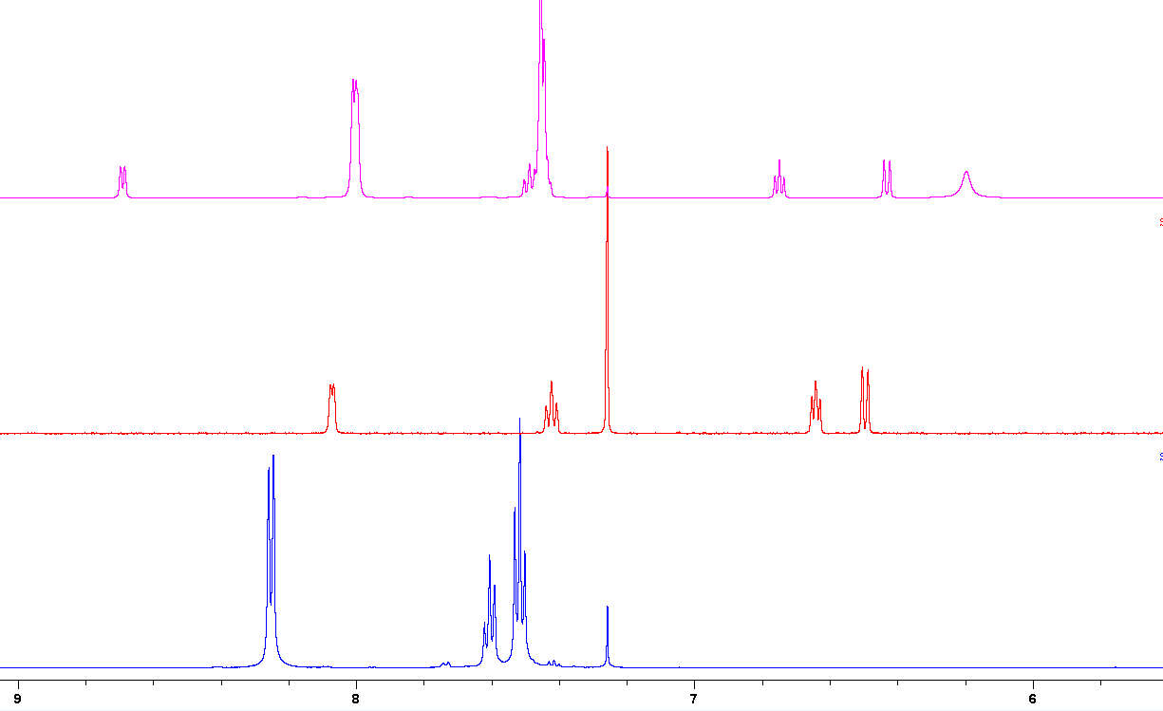
[PhBO]₃ + NH₂Py
NH₂Py
[PhBO]₃
Figure SX: Aromatic region of the NMR spectra of phenylboroxine, 2-amino pyridine, and a 1:1 mixture of each, in CDCl₃.
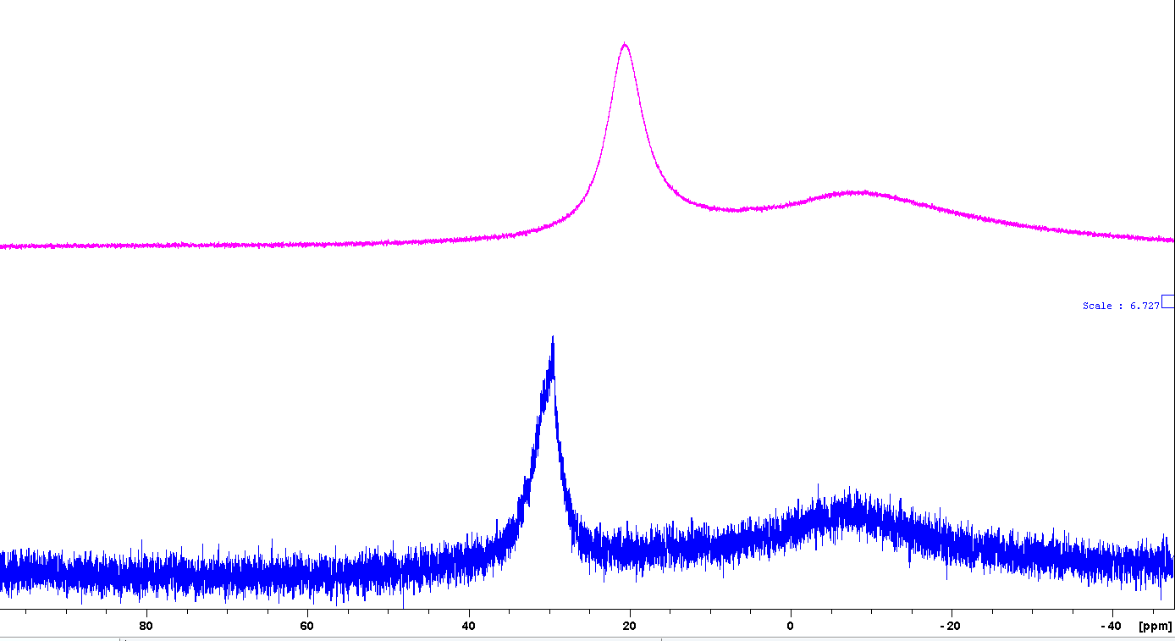
[PhBO]₃ + NH₂Py
[PhBO]₃
29.9
20.9
Figure SX: ¹¹B NMR spectra of triphenylboroxine and a mixture of triphenylboroxine with 2-amino pyridine, each in CDCl₃

Interaction of 2-amino pyridine with 2-chlorophenylboroxine

Synthesis of 2-Chlorophenylboroxine
Under an atmosphere of argon, 2-chlorophenyl boronic acid (3g, 19 mmol) was suspended in toluene (60 ml) and heated to reflux under a dean-stark apparatus for 4 hours. On cooling, a white precipitate formed. The reaction mixture was filtered under air and washed twice with toluene (10 ml), redissolving most of the solid. The solution was poured into ice cold hexane (150 ml) and a white precipitate formed, the solid was collected by filtration, washed with twice with hexane (20 ml), and dried under reduced pressure. Yield = 1.17 g white needle crystals, (2.8 mmol, 44 %)
¹H NMR (700 MHz, CDCl₃) δ (ppm) = 8.26 (d, J = 7.5 Hz, 3H), 7.49 – 7.45 (m, 6H), 7.39 – 7.35 (m, 3H).
¹³C NMR (176 MHz, CDCl₃) δ (ppm) = 141.5, 138.9, 133.6, 130.5, 128.9, 126.4.
¹¹B NMR (225 MHz, CDCl₃) δ (ppm) = 29.2.

Reaction of 2-amino pyridine with 2-chlorophenylboroxine
2-Chlorophenylboroxine (41.5 mg, 0.1 mmol) and 2-amino pyridine (9 mg, 0.1 mmol) were dissolved in 600 μl CDCl₃ and analysed by ¹H and ¹¹B NMR spectroscopy.

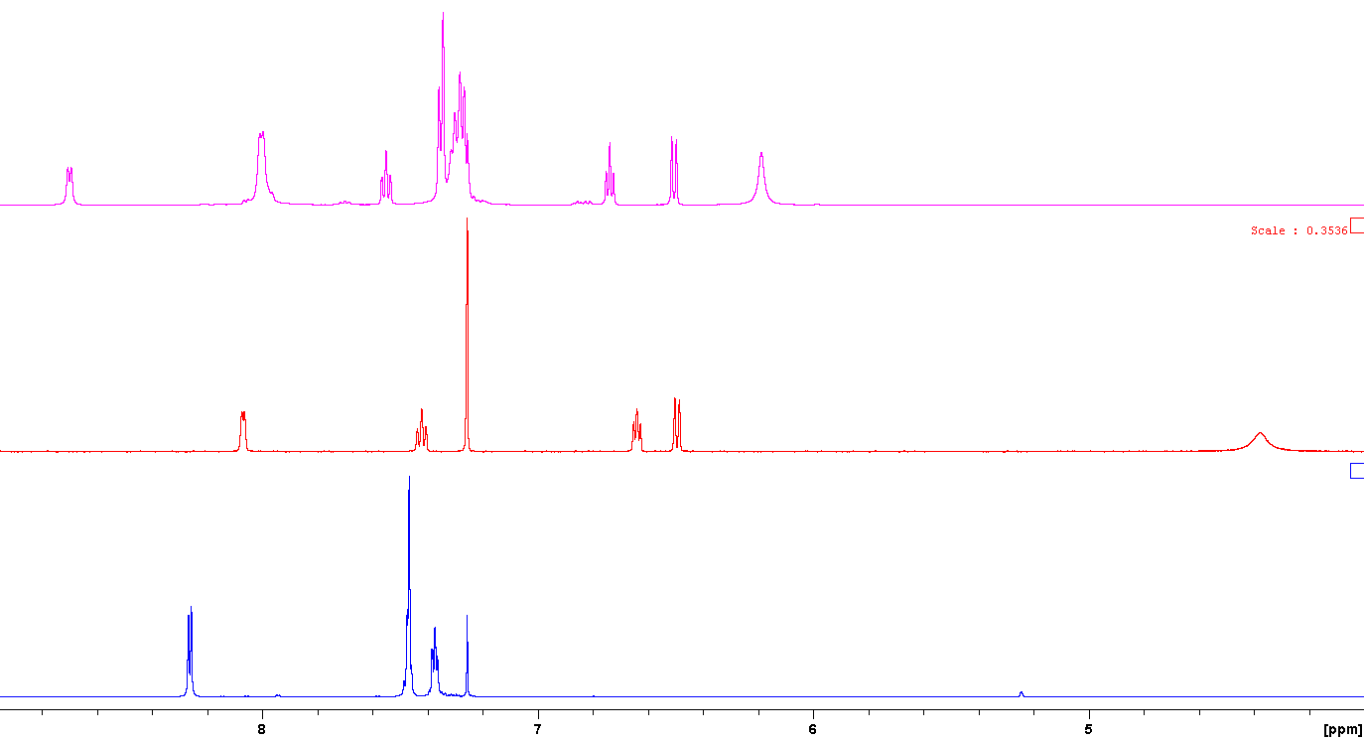
[(2-ClC₆H₄)BO]₃
[ArBO]₃ + NH₂Py
NH₂Py
Figure SX: Window of the ¹H NMR spectrum (CDCl₃) of the interaction of 2-chlorophenylboroxine with 2-aminopyridine
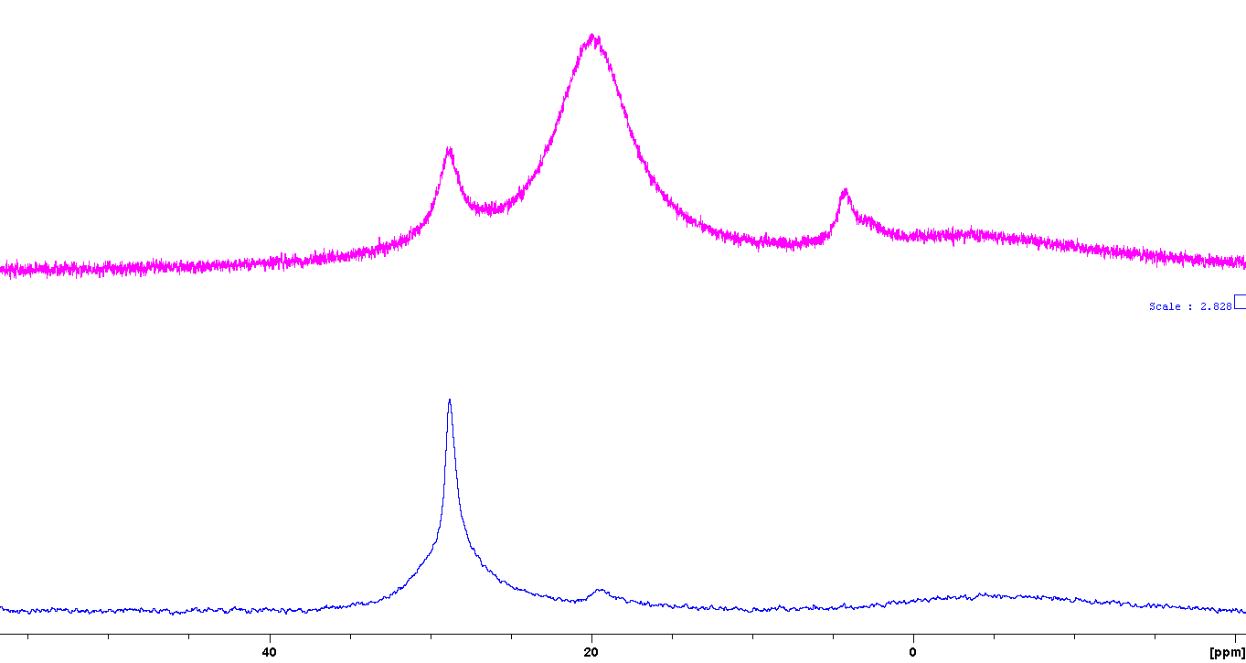
[(2-ClC₆H₄)BO]₃
[ArBO]₃ + NH₂Py
Figure SX: ¹¹B NMR spectrum (CDCl₃) of the interaction between 2-chlorophenylboroxine and 2-amino pyridine

Reaction of 2-amino pyridine with 2-chlorophenylboronic acid
Under an atmosphere of argon, 2-chlorophenyl boronic acid (47 mg, 0.3 mmol, 3 eq.) and 2-aminopyridine (10 mg, 0.1 mmol, 1 eq.) were suspended in CDCl₃ (1.2 ml), and activated 4Å molecular sieves (1.2 g) were added. The reaction was stirred for 3 days, after which time it was filtered and ¹H and ¹¹B NMR spectra were measured, revealing a product identical to that obtained using the pre-formed boroxine.
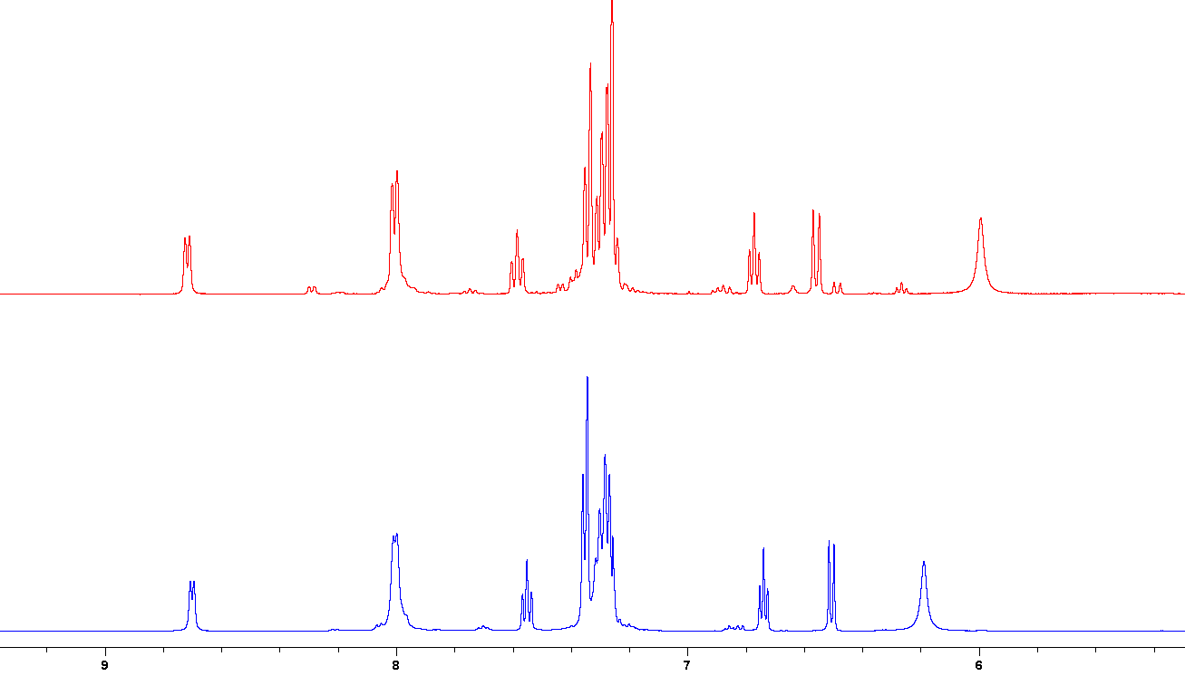
(2-ClC₆H₄)B(OH)₂ + (1/3)NH₂Py
[(2-ClC₆H₄)BO]₃ + NH₂Py
Figure SX: ¹H NMR spectrum of the reaction between 2-chlorophenylboronic acid and 2-amino pyridine in the presence of 4Å molecular sieves in CDCl₃.

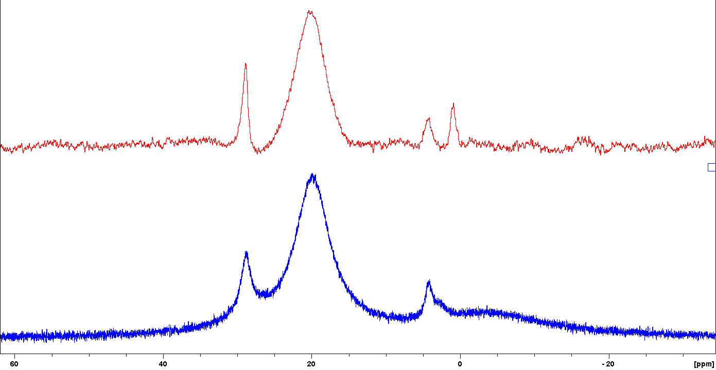
(2-ClC₆H₄)B(OH)₂ + (1/3)NH₂Py
[(2-ClC₆H₄)BO]₃ + NH₂Py
Figure SX: ¹¹B NMR spectrum (CDCl₃) of (top) the reaction between 2-chlorophenylboronic acid and 2-amino pyridine, and (bottom) the interaction between 2-chlorophenylboroxine and 2-amino pyridine.

Analysis of reaction mixtures for catalyst protodeborylation
A series of amidation experiments were performed using 2-chloro-4-fluorophenylboronic acid as catalyst to give a ¹⁹F NMR handle for reaction monitoring. In each case, no protodeborylation was observed, though no remaining boronic acid could be detected either. There is no single clear ¹⁹F containing species, and many are fairly broad. These are likely to be various adducts of (dehydrated) 2-chloro-4-fluorophenylboronic acid with the amines, carboxylates, and inhibitors present in the reaction.
Benzoic acid (610 mg, 5 mmol) and 1,3,5-trimethoxybenzene (84 mg, 0.5 mmol) were dissolved in TAME (10 ml). Benzylamine (600 μl, 5.5 mmol) was added and the reaction heated to 80 °C, at which point 2-chloro-4-fluorophenylboronic acid (87 mg, 0.5 mmol) was added, a filled Dean-Stark adapter was attached and the reaction heated to reflux. After 1 hour, two aliquots of 250 μl were withdrawn, and 4-fluorobromobenzene (2.5 μl) was added to each as an internal standard for NMR analysis. In one of the samples, 3-flurorochlorobenzene was added to aid identification of any protodeborylation of the catalyst. Each sample was diluted with 400 μl CDCl₃ and analysed by ¹⁹F NMR spectroscopy. After 18 hours, a second set of samples was taken for similar analysis.
A second reaction was performed in an analogous procedure with addition of 2-aminopyridine (471 mg, 5 mmol, 1 eq.) in the initial reaction mixture.
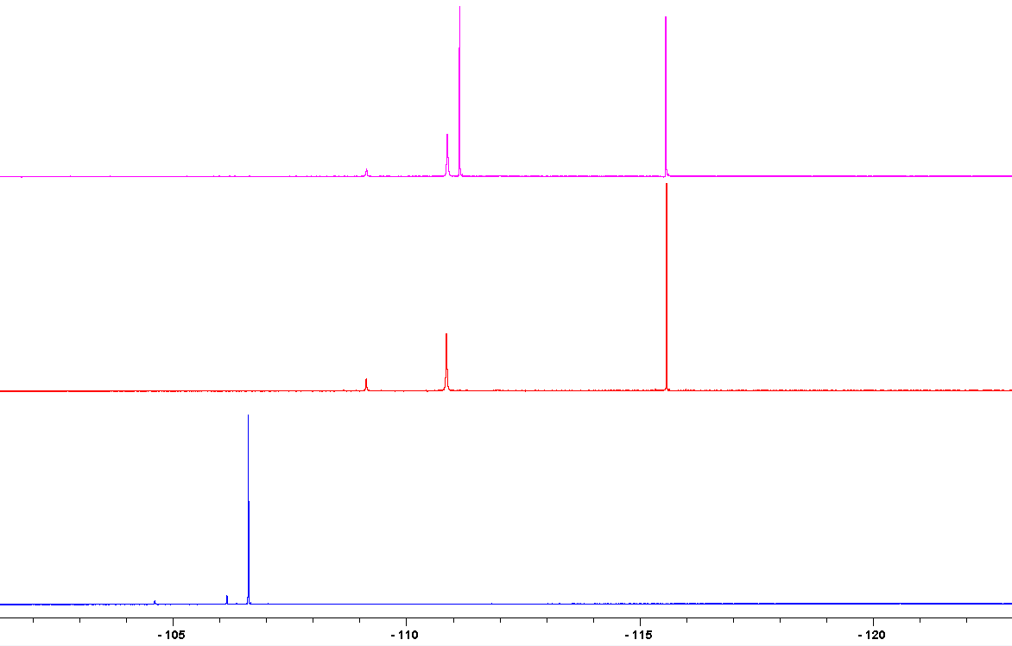
c)
b)
a)
¹⁹F NMR spectra of a) 2-chloro-4-fluorophenylboronic acid, b) the reaction mixture after 1 hour, c) the reaction mixture after 1 hour with 3-fluorochlorobenzene added
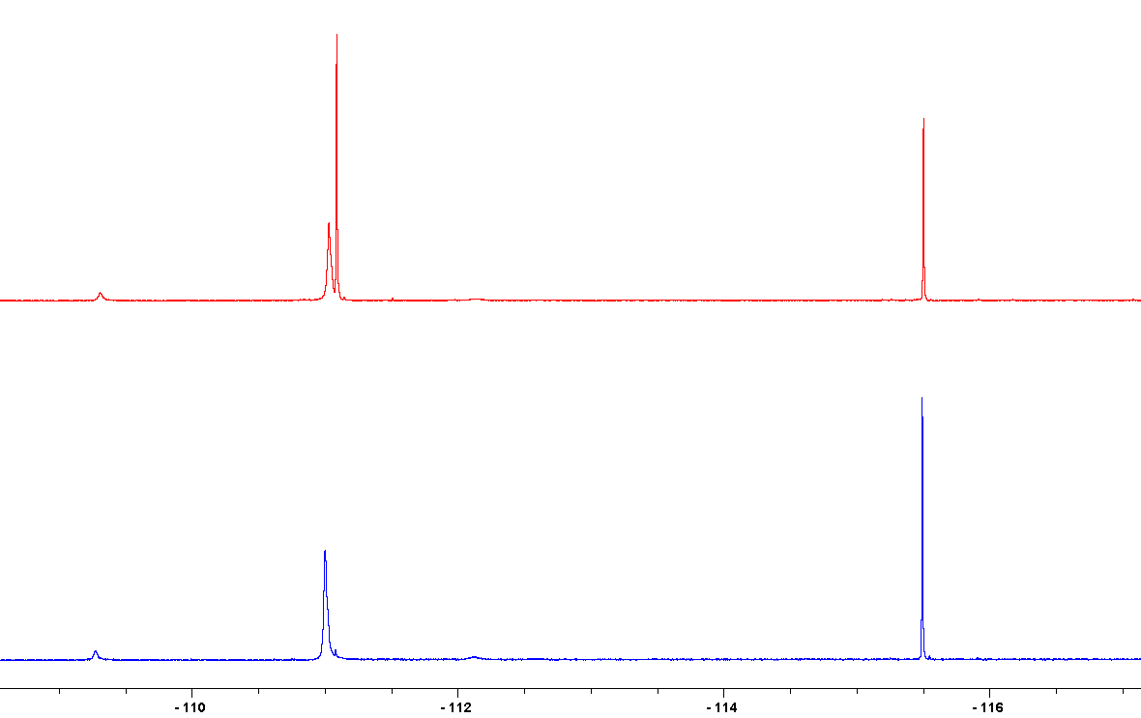
b)
a)
¹⁹F NMR spectra of a) the reaction mixture after 18 hours, b) with 3-fluorochlorobenzene added
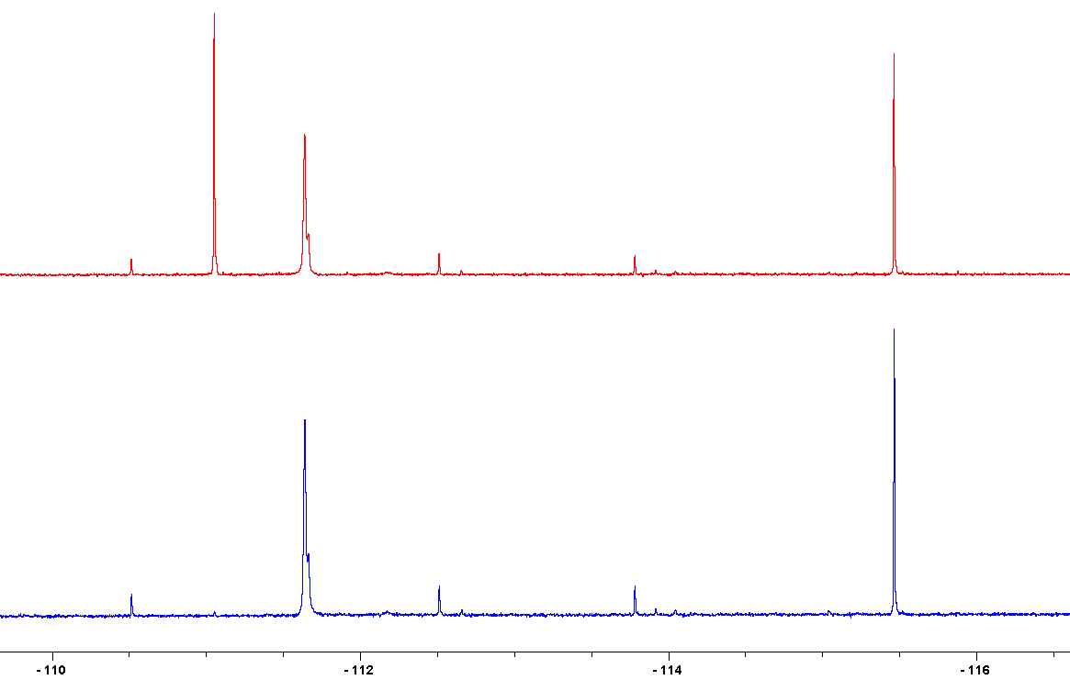
b)
a)
¹⁹F NMR spectra of the reaction with 2-amino pyridine as an inhibitor after 18 hours, a) without and b) with 3-fluorochlorobenzene

Phenylacetic acid (681 mg, 5 mmol) and 2-aminopyridine (518 mg, 5.5 mmol) were suspended in TAME (10 ml), heated to 80°C (dissolves on heating), and 2-chloro-4-fluorophenyl boronic acid (87 mg, 0.5 mmol) was added. A filled Dean-Stark adapter was attached and the reaction heated to reflux for 18 hours. After this time, 4-fluorobromobenzene (54.9 μl, 0.5 mmol) was added and an aliquot of 250 μl was taken from the reaction mixture. 3-fluorochlorobenzene (53.5 μl, 0.5 mmol) was added to the remaining reaction mixture, and a further 250 μl aliquot was taken. Each sample was diluted with 400 μl CDCl₃ and analysed by ¹⁹F NMR spectroscopy.

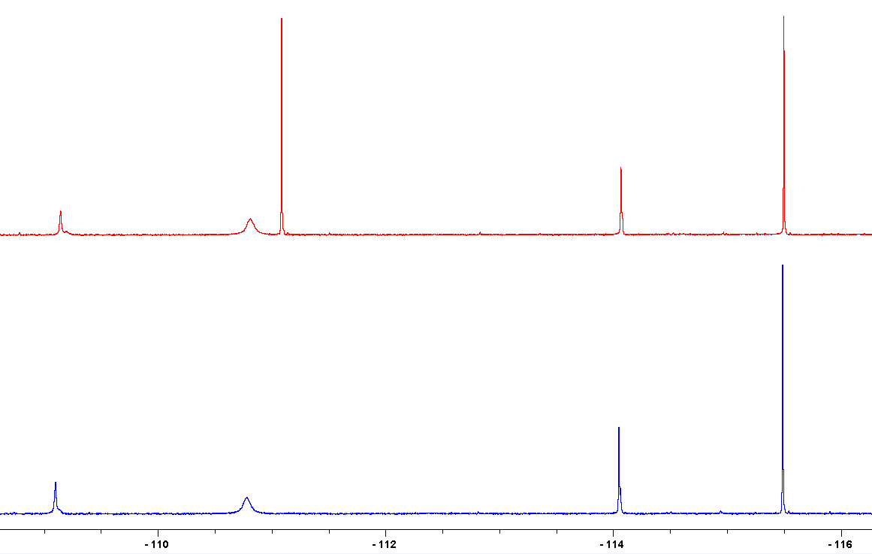
b)
a)
¹⁹F NMR spectra of the reaction mixture after 18 hours a) without and b) with 3-fluorochlorobenzene

2-aminopyridine (518 mg, 5.5 mmol) and 2-chloro-4-fluorophenylboronic acid (87 mg, 0.5 mmol) were dissolved in TAME (10 ml), and heated to reflux under a filled Dean-Stark apparatus for 18 hours. After this time, 4-fluorobromobenzene (54.9 μl, 0.5 mmol) was added and an aliquot of 250 μl was taken from the reaction mixture. 3-fluorochlorobenzene (53.5 μl, 0.5 mmol) was added to the remaining reaction mixture, and a further 250 μl aliquot was taken. Each sample was diluted with 400 μl CDCl₃ and analysed by ¹⁹F NMR spectroscopy. N.B. in this reaction there is significant solid precipitate.

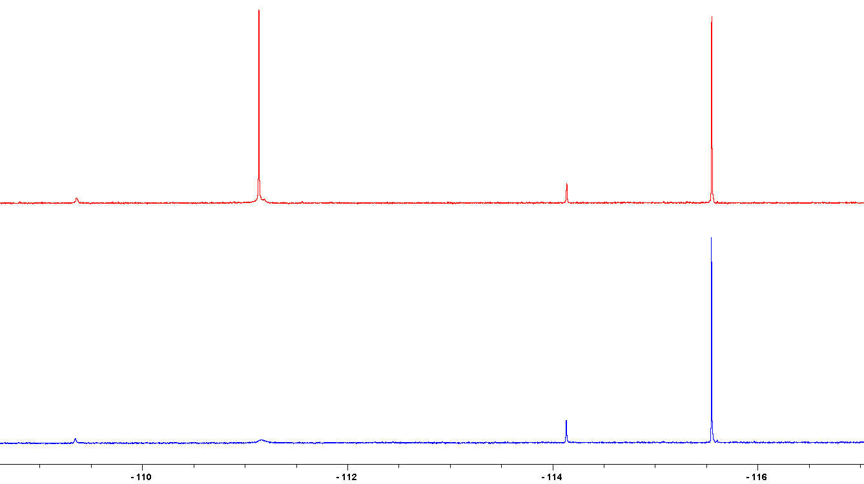
b)
a)
¹⁹F NMR spectra of the reaction between excess 2-amino pyridine and 2-chloro-4-fluorophenyl boronic acid, a) without and b) with 3-fluorochlorobenzene

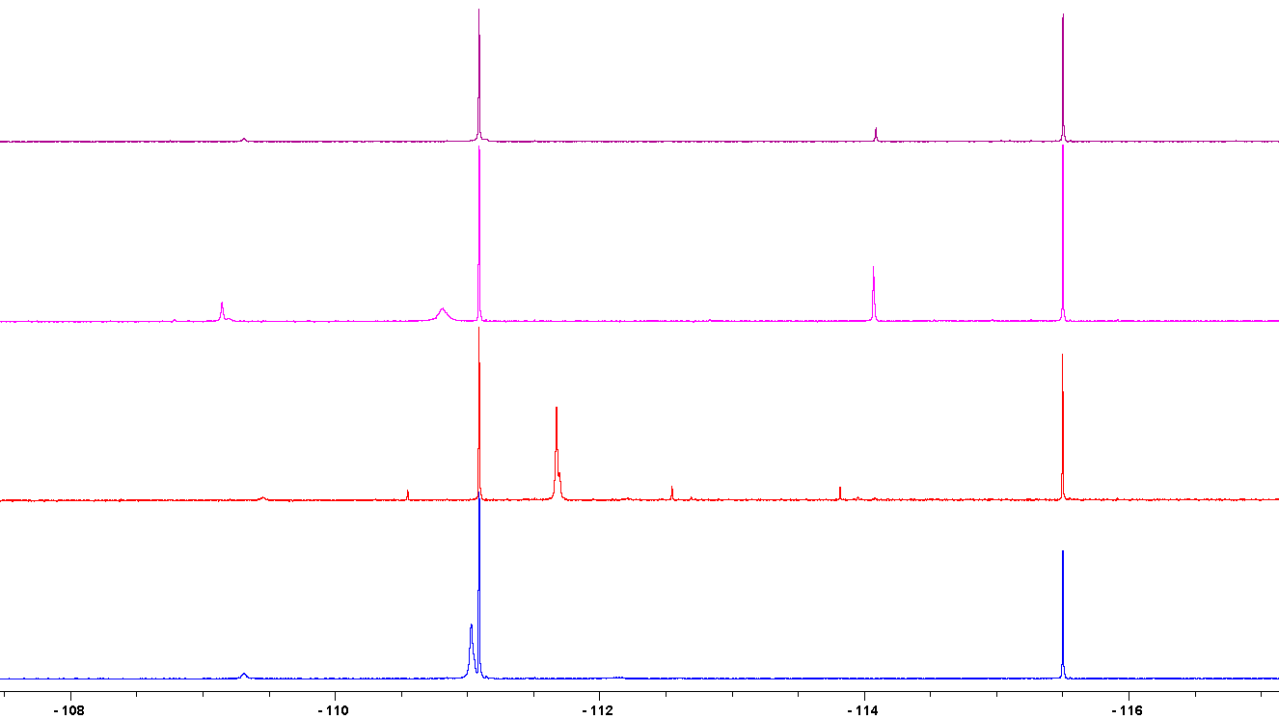
d)
c)
b)
a)
¹⁹F NMR spectra, with added 4-fluorobromobenzene and 3-fluorochlorobenzene, of the reactions catalysed by 2-chloro-4-fluorophenylboronic acid a) Benzoic acid + benzylamine, b) benzoic acid + benzylamine + 2-amino pyridine (inhibitor), c) phenylacetic acid + 2-aminopyridine, and d) the reaction of 2-chloro-4-fluorophenylboronic acid with excess 2-aminopyridine.

Characterisation data
tris(3,4,5-trifluorophenyl) borate
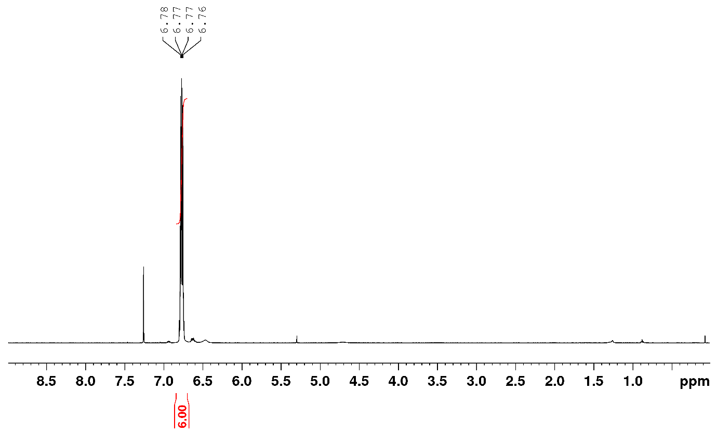
¹H NMR spectrum of B(OArF₃)₃ in CDCl₃
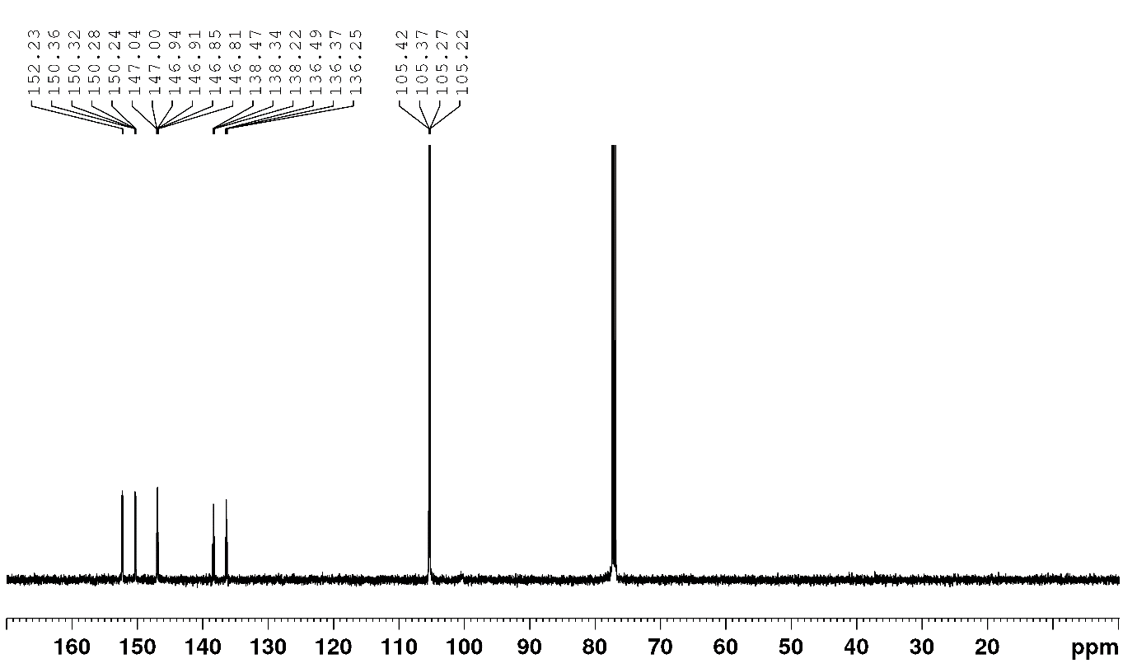
¹³C NMR spectrum of B(OArF₃)₃ in CDCl₃

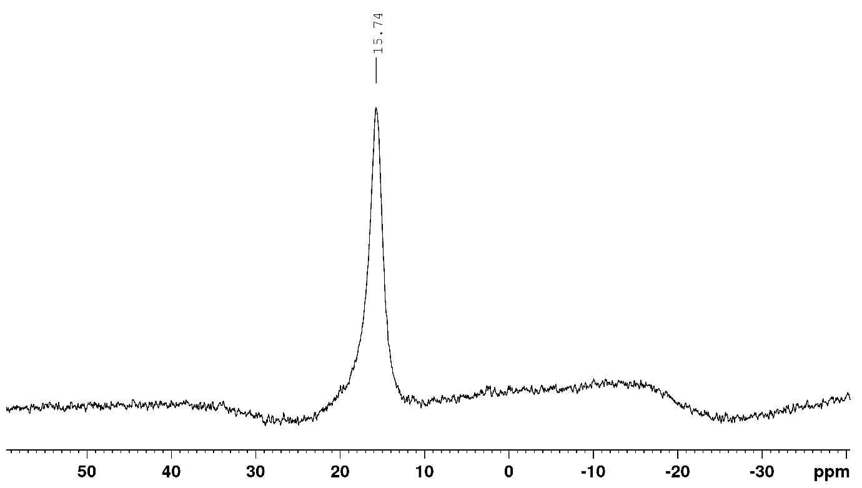
¹¹B NMR spectrum of B(OArF₃)₃ in CDCl₃

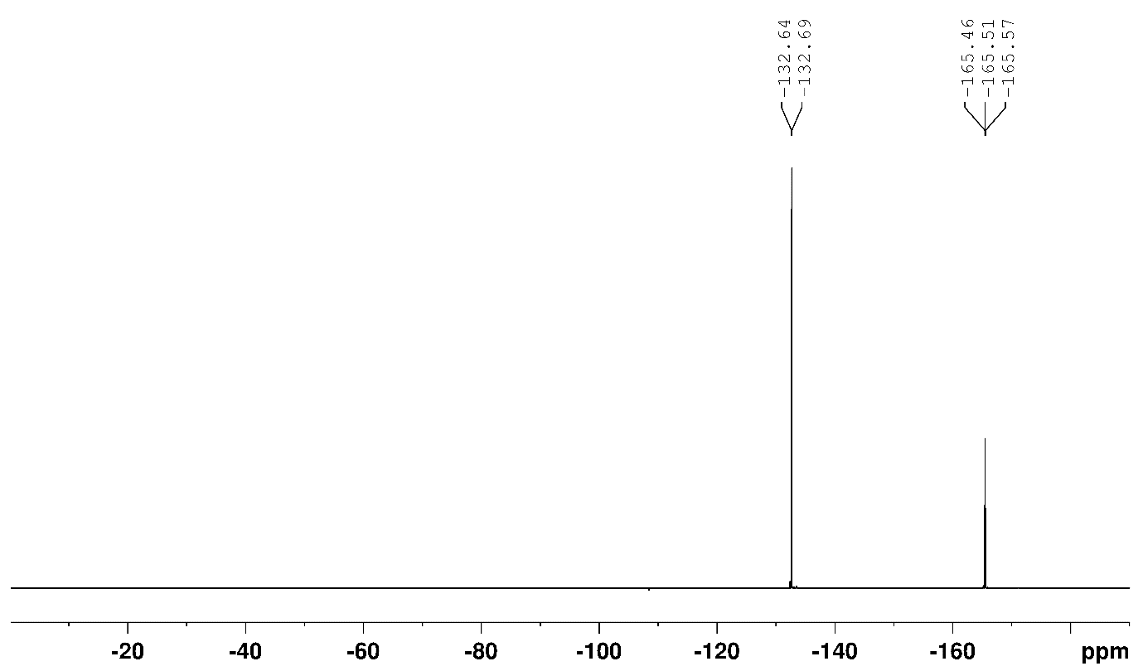
¹⁹F NMR spectrum of B(OArF₃)₃ in CDCl₃.

tris(2,2,3,3,4,4,5,5-octafluoropentyl) borate
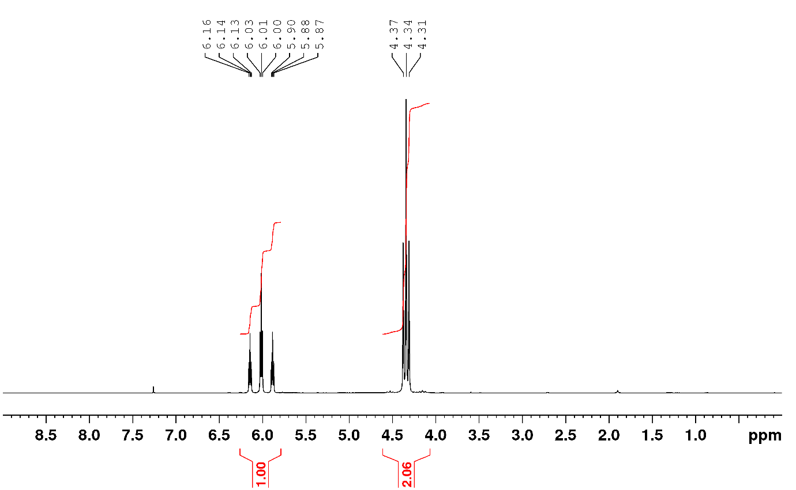
¹H NMR spectrum of B(OCH₂(CF₂)₃CF₂H)₃ in CDCl₃.
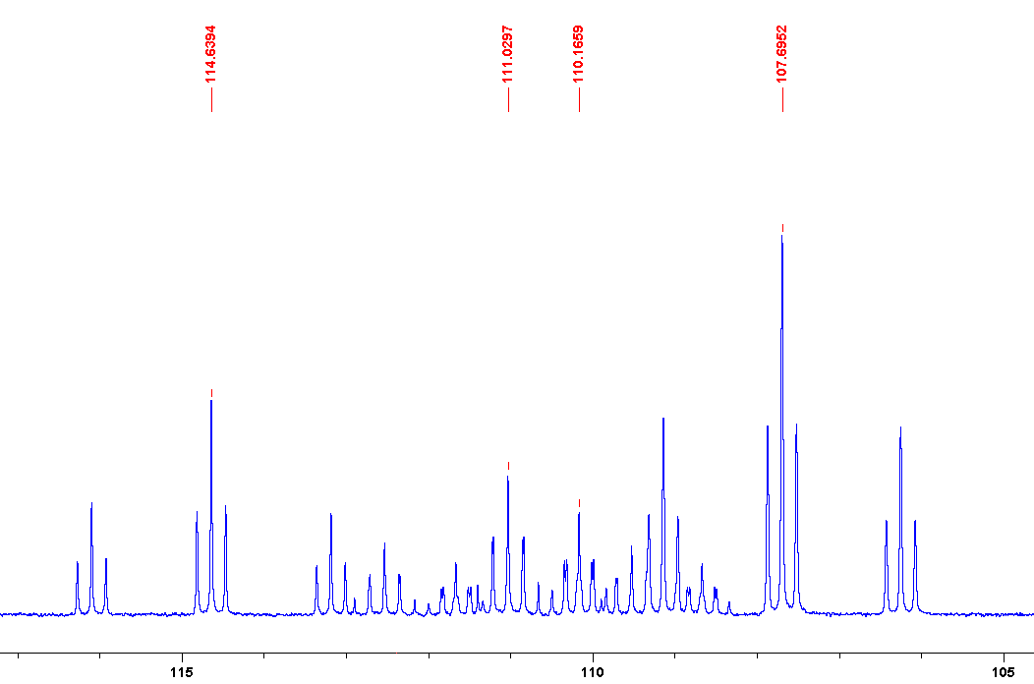
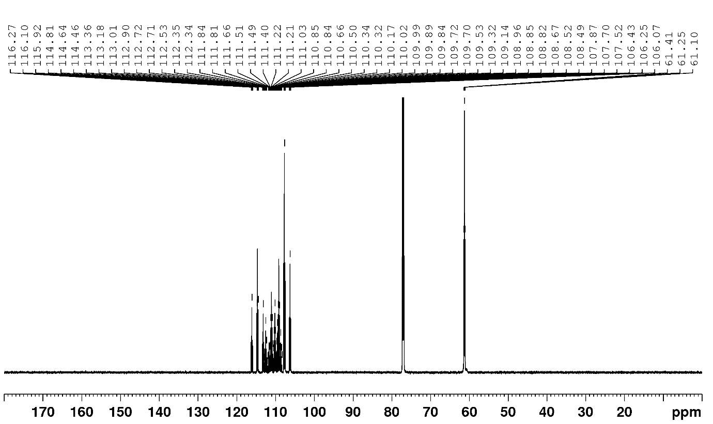
¹³C NMR spectrum of B(OCH₂(CF₂)₃CF₂H)₃ in CDCl_{3.}
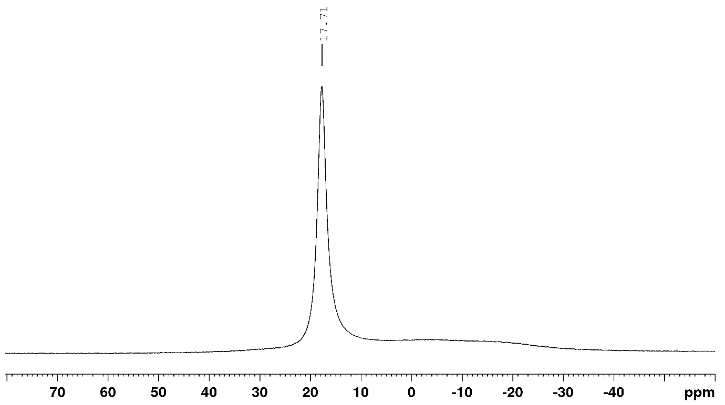
¹¹B NMR spectrum of B(OCH₂(CF₂)₃CF₂H)₃ in CDCl_{3.}
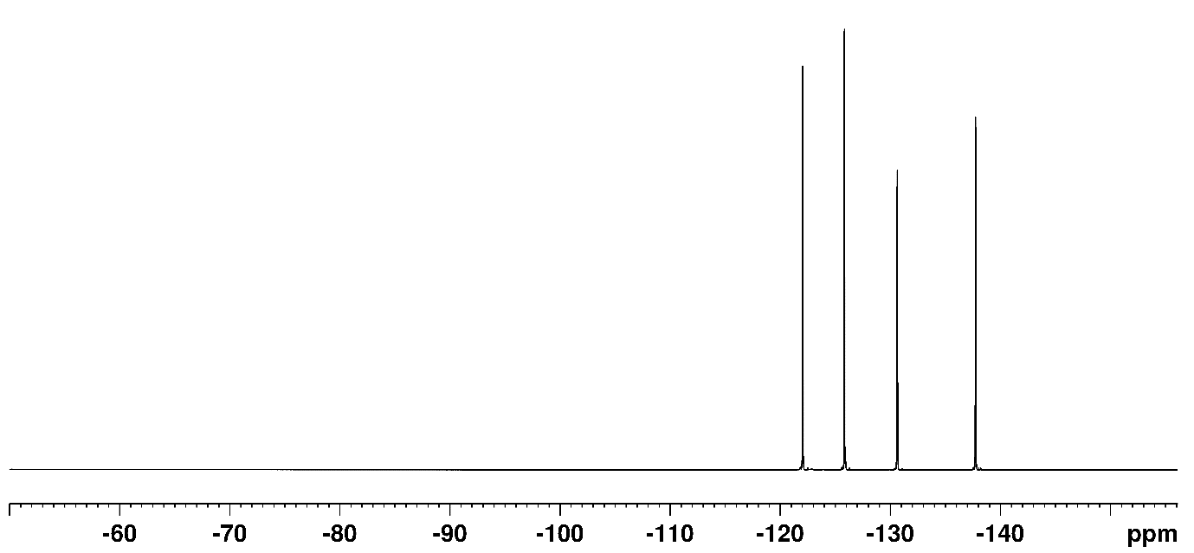
¹⁹F NMR spectrum of B(OCH₂(CF₂)₃CF₂H)₃ in CDCl_{3.}

tris(2,2,2-trichloroethyl) borate
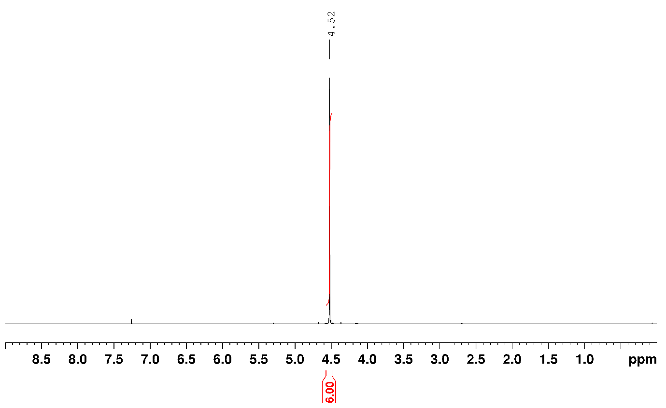
¹H NMR spectrum of trichloroethylborate in CDCl₃.
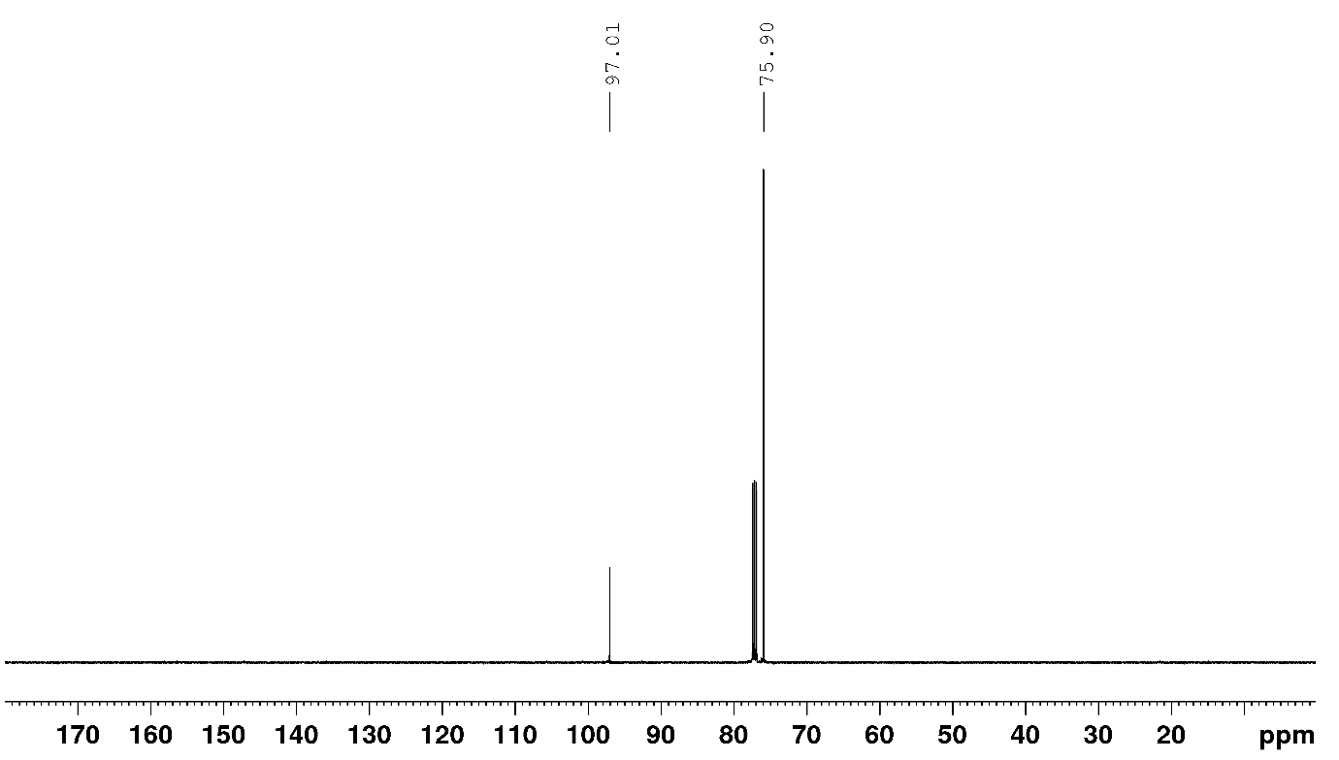
¹³C NMR spectrum of trichloroethylborate in CDCl₃.
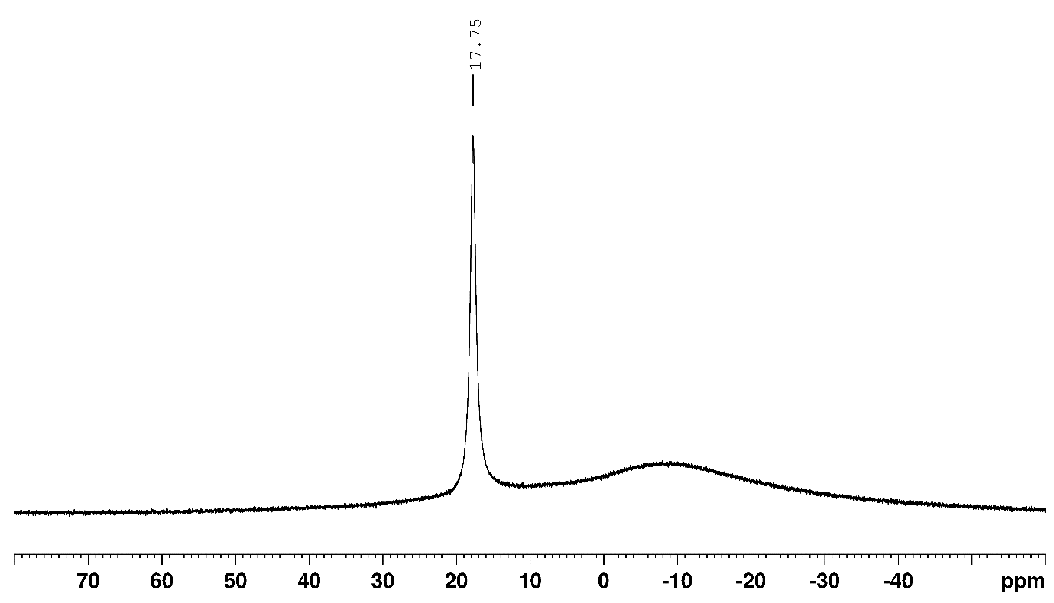
¹¹B NMR spectrum of trichloroethylborate in CDCl₃.

tris(2,4,6-trichlorophenyl) borate
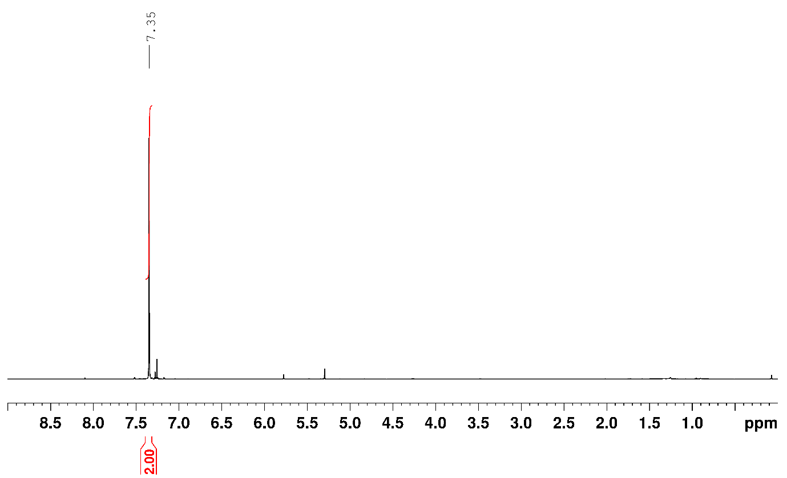
¹H NMR spectrum of D in CDCl₃
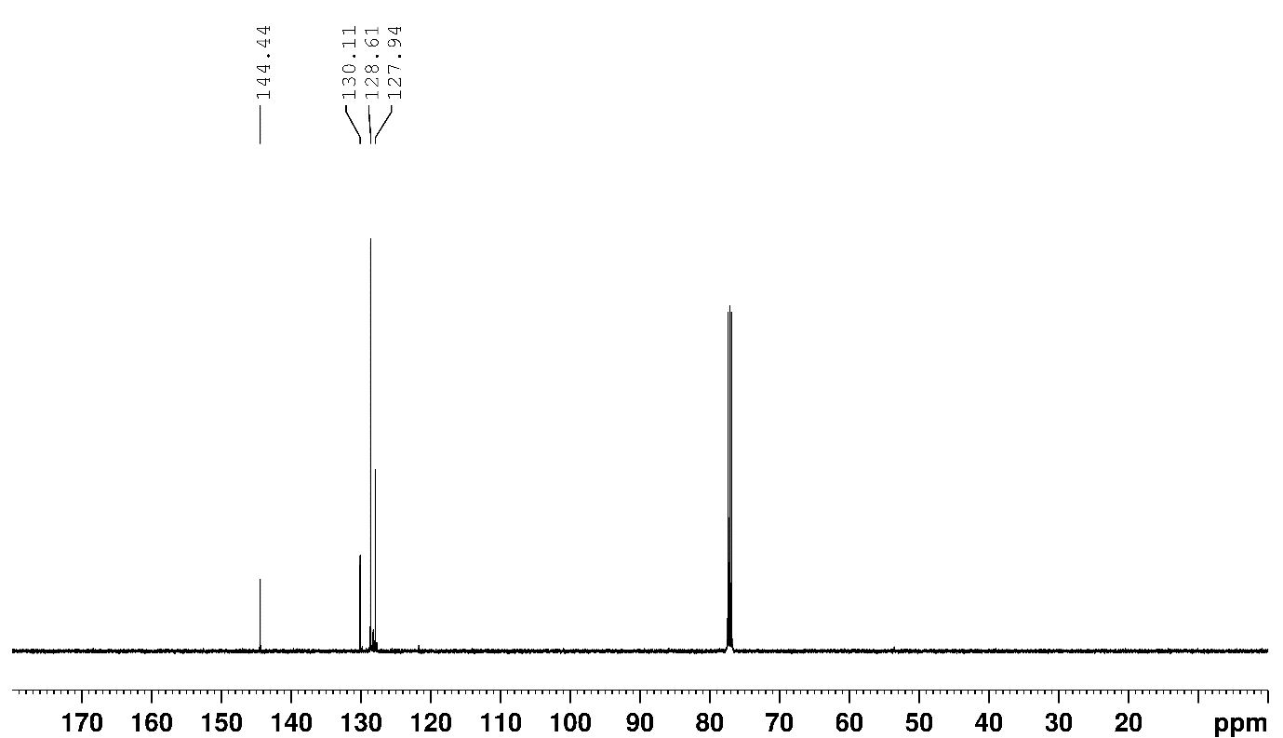
¹³C NMR spectrum of D in CDCl₃
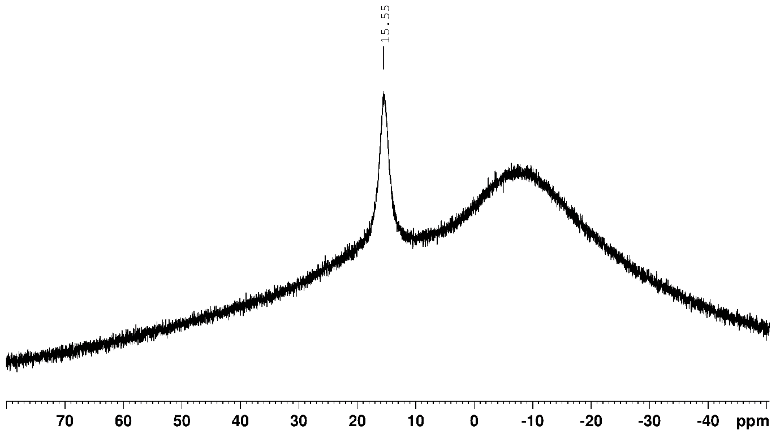
¹¹B NMR spectrum of D in CDCl₃

N-Benzylbenzamide
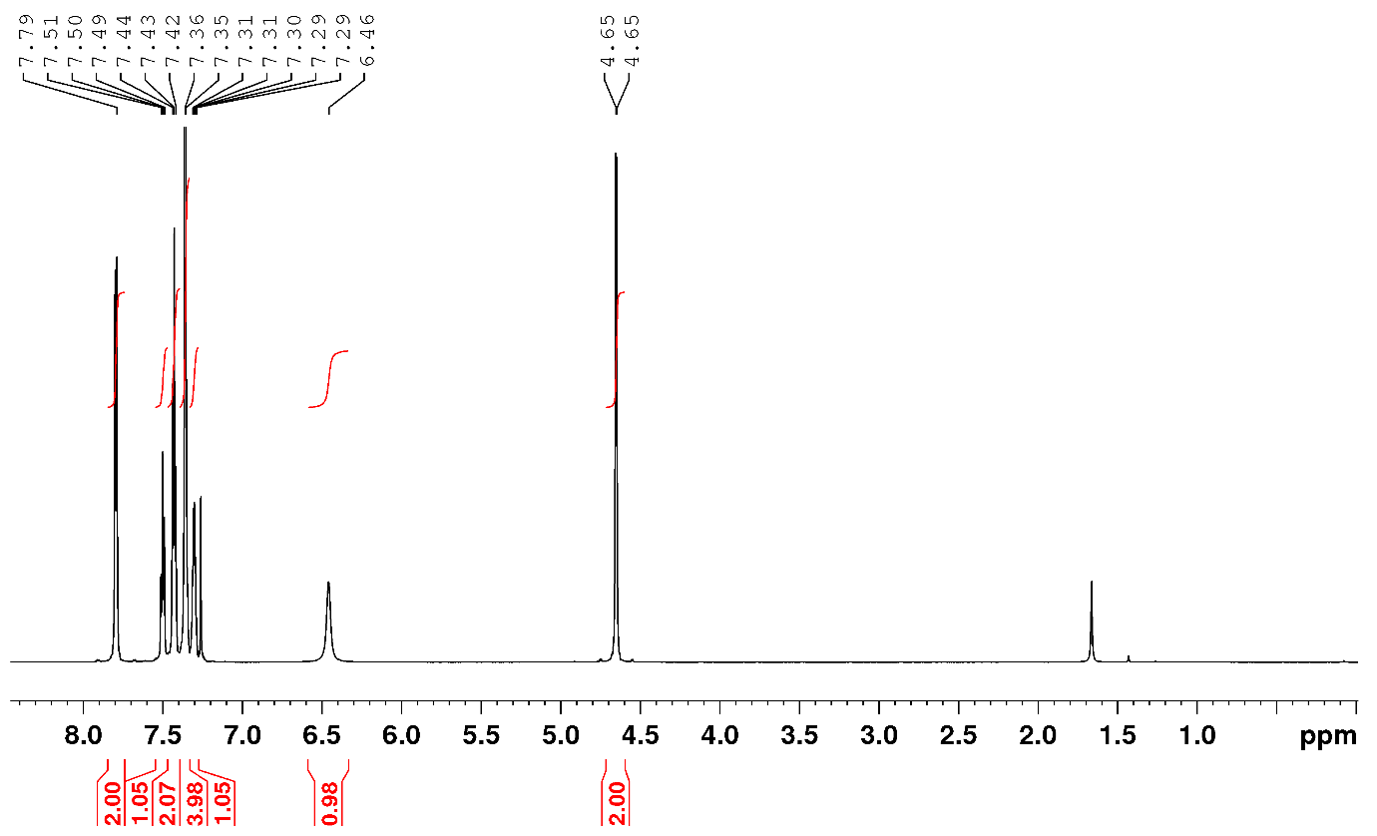
¹H NMR spectrum of 3 in CDCl₃
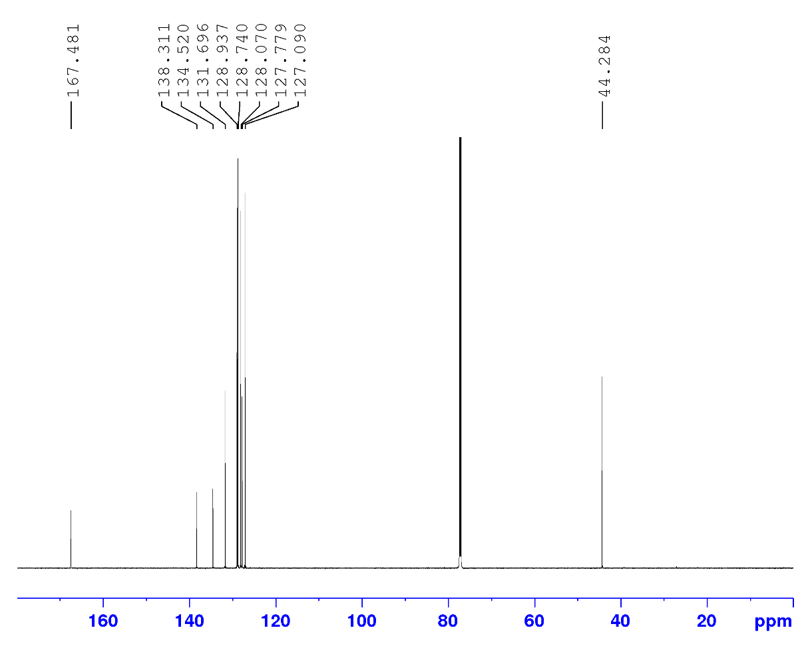
Figure SX: ¹³C NMR spectrum of 3 in CDCl₃

2-(3-fluorophenyl)-N-(pyridin-2-yl)acetamide
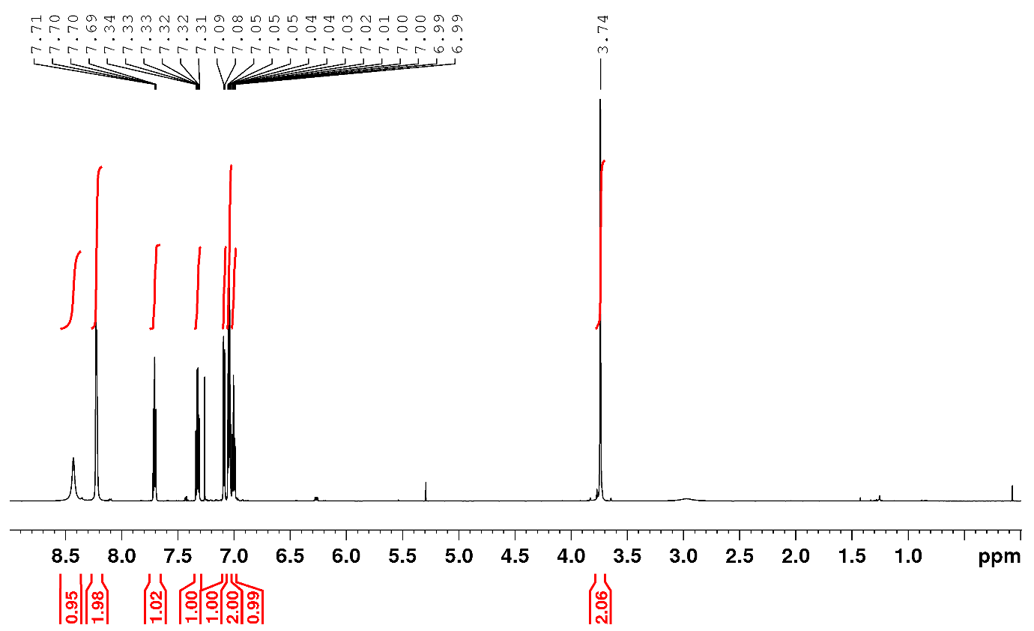
Figure SX: ¹H NMR spectrum of 4 in CDCl₃
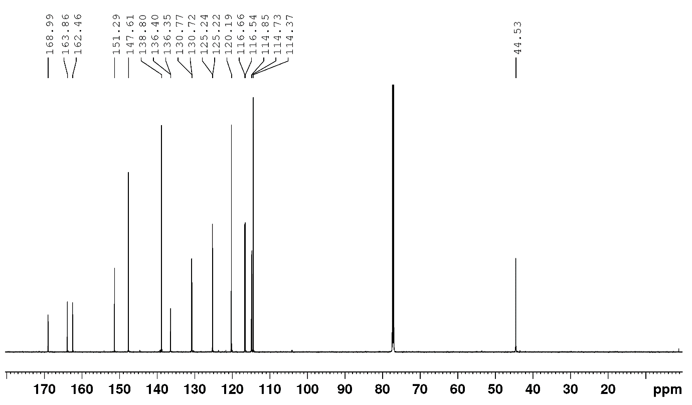
Figure SX: ¹³C NMR spectrum of 4 in CDCl₃
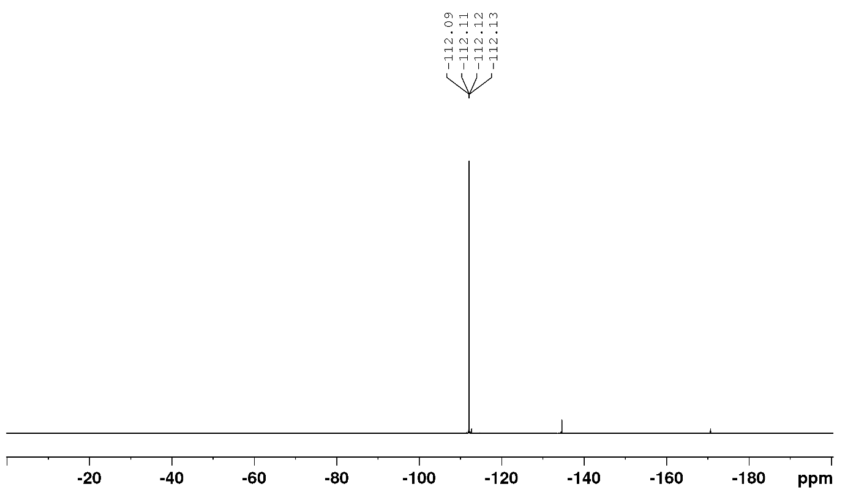
Figure SX: ¹⁹F NMR spectrum of 4 in CDCl₃

N-(2-(dimethylamino)-5-(trifluoromethyl)phenyl)-2-phenylacetamide
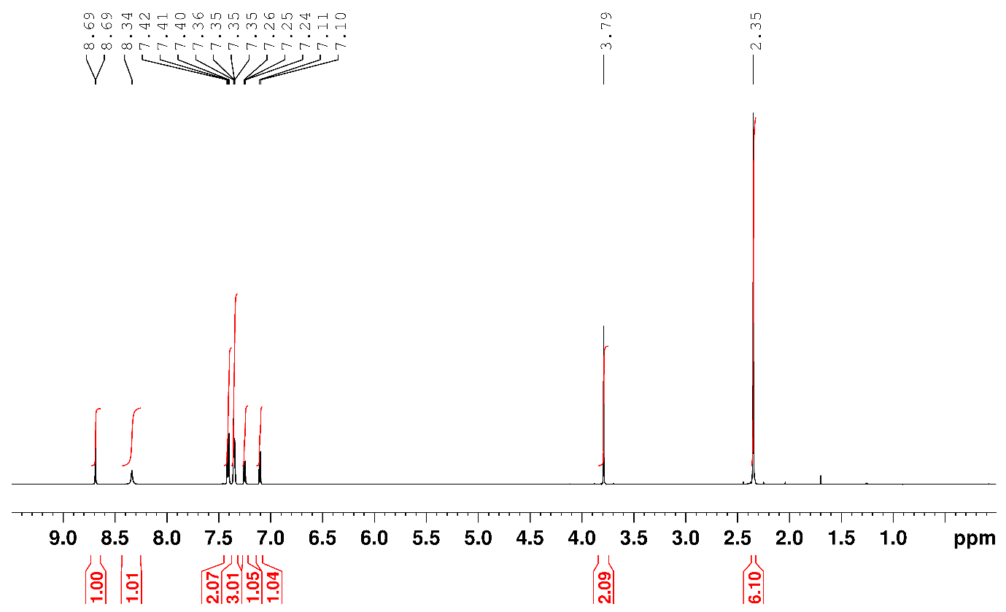
¹H NMR spectrum of 5 in CDCl₃
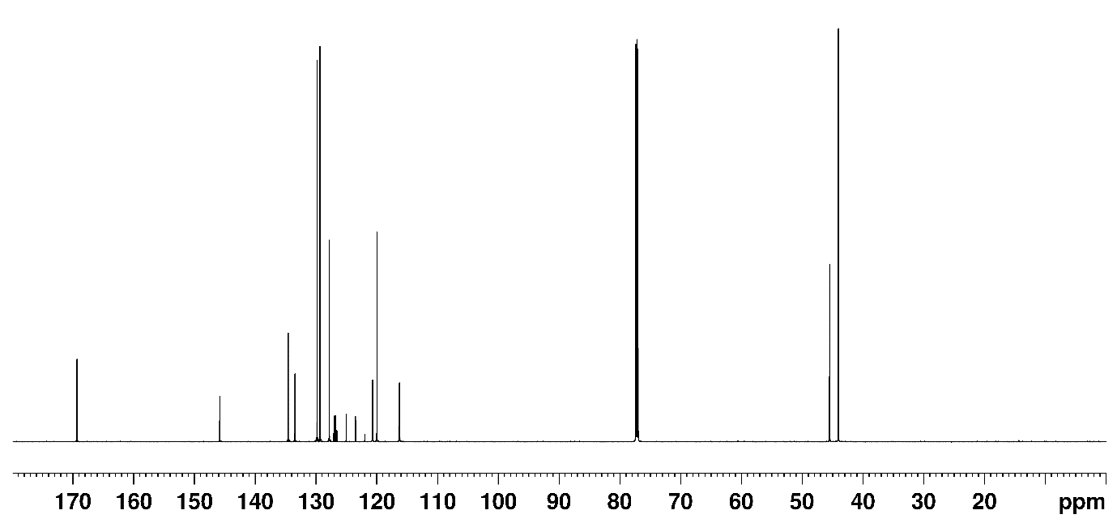
¹³C NMR spectrum of 5 in CDCl₃
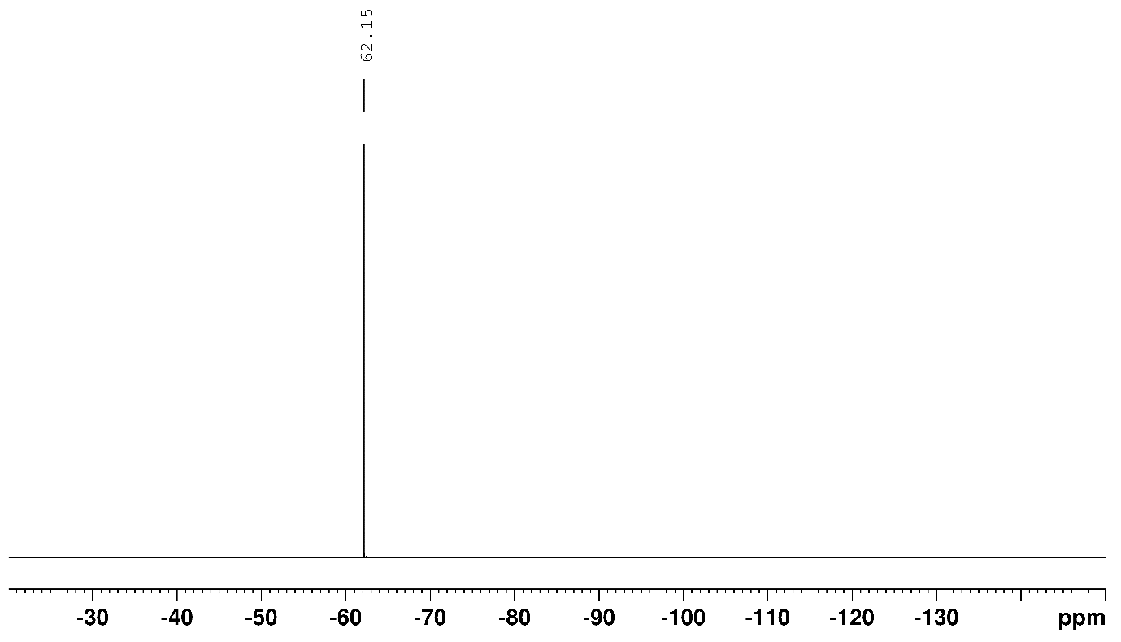
¹⁹F NMR spectrum of 5 in CDCl₃

2-phenyl-N-(quinolin-8-yl)acetamide
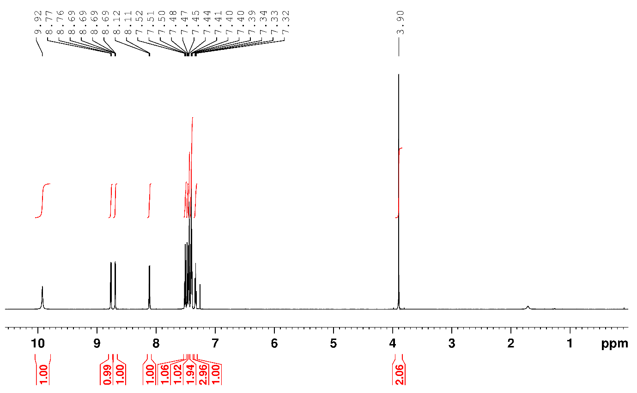
¹H NMR spectrum of 6 in CDCl₃
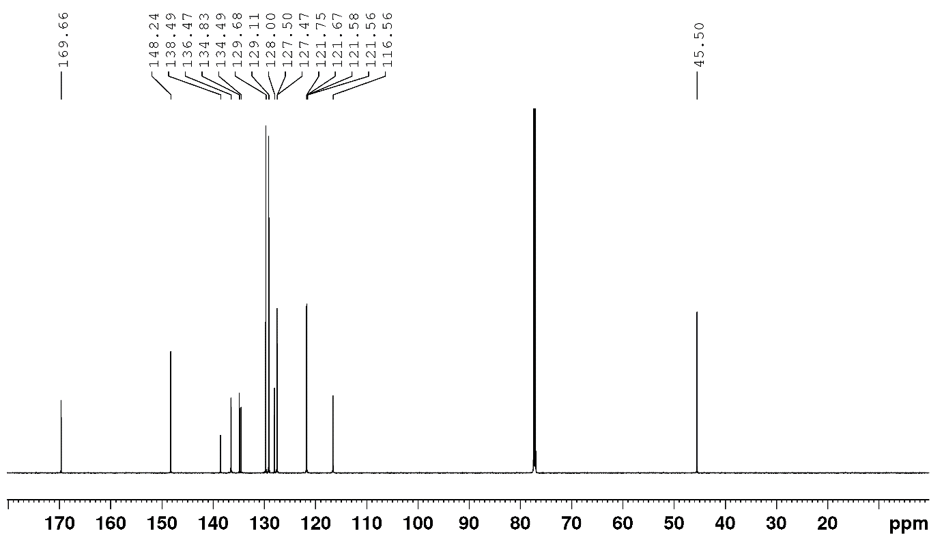
¹³C NMR spectrum of 6 in CDCl₃
N-benzyl-1H-indazole-3-carboxamide
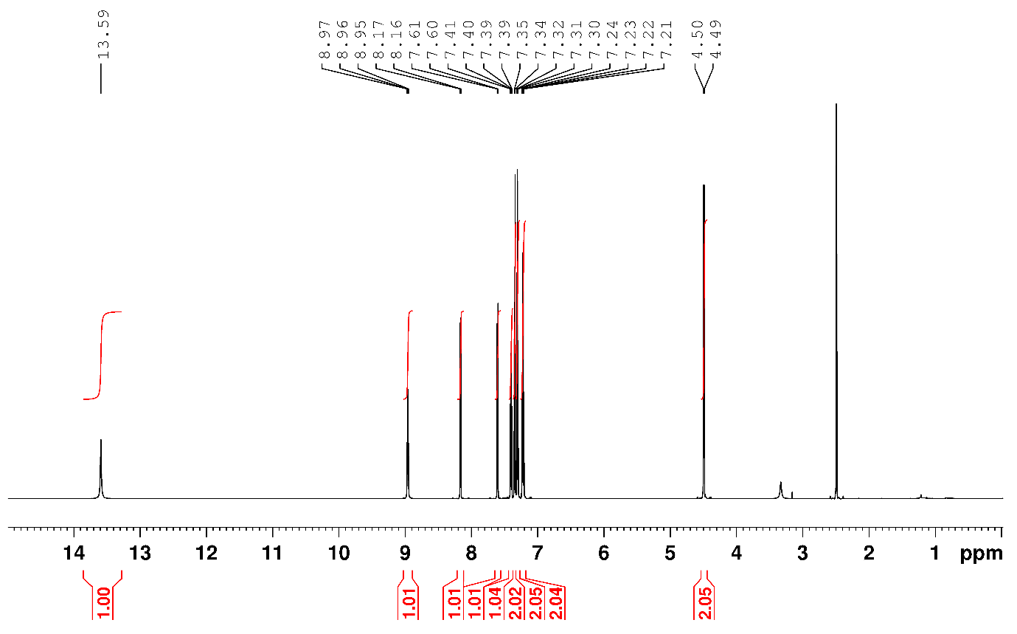
¹H NMR spectrum of 7 in DMSO-d₆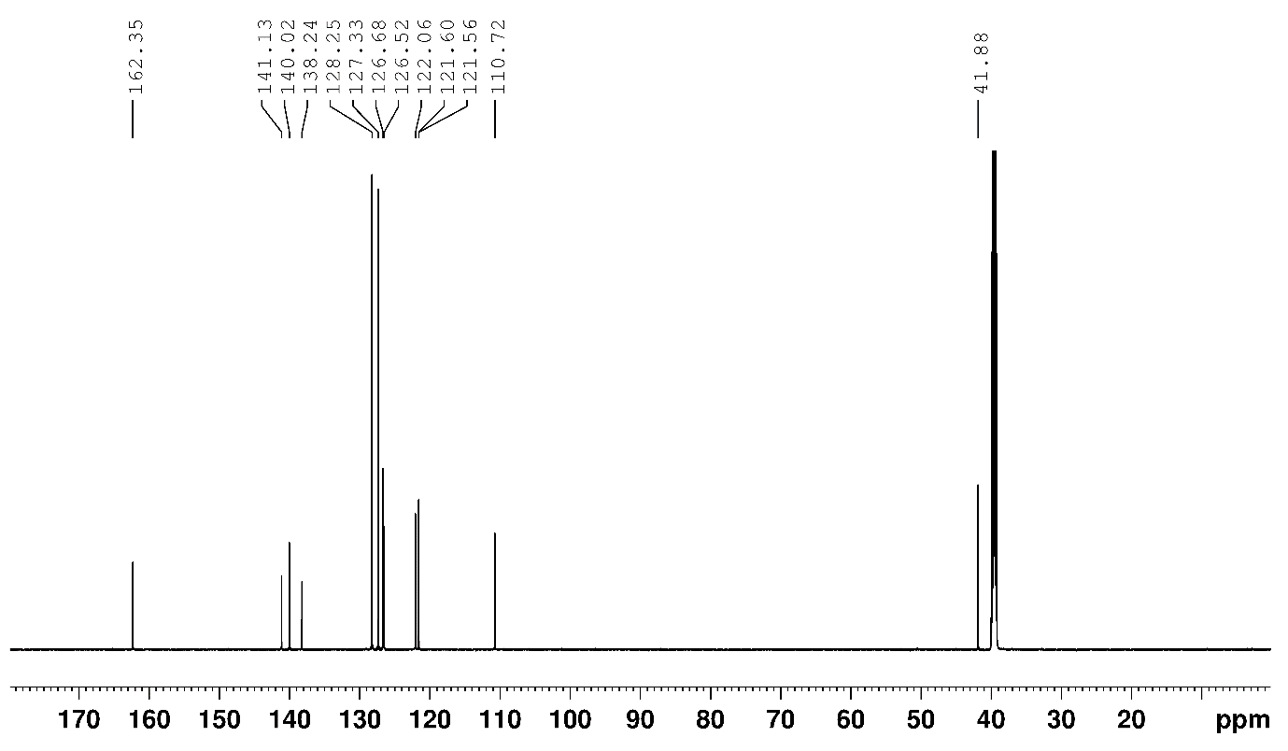
¹³C NMR spectrum of 7 in DMSO-d₆.

tert-butyl 4-(quinolin-8-ylcarbamoyl)piperidine-1-carboxylate
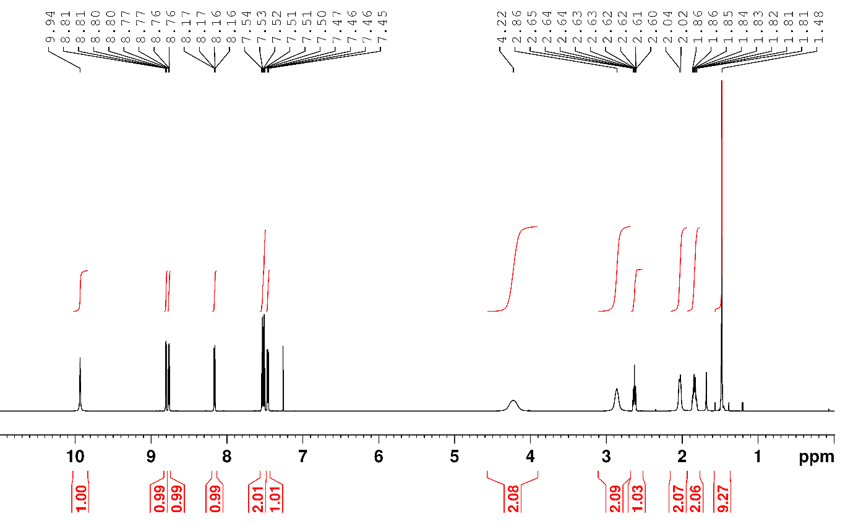
¹H NMR spectrum of 8 in CDCl₃
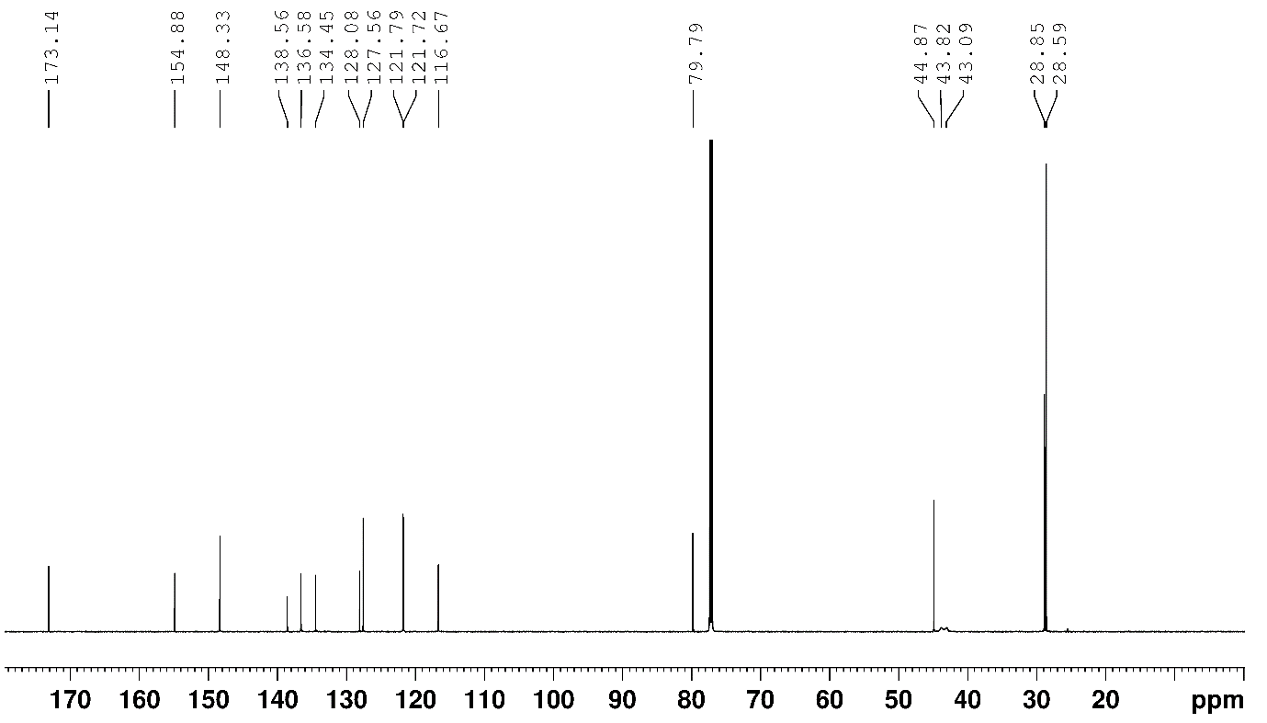
¹³C NMR spectrum of 8 in CDCl₃
N-(2-(dimethylamino)ethyl)-2-phenylacetamide
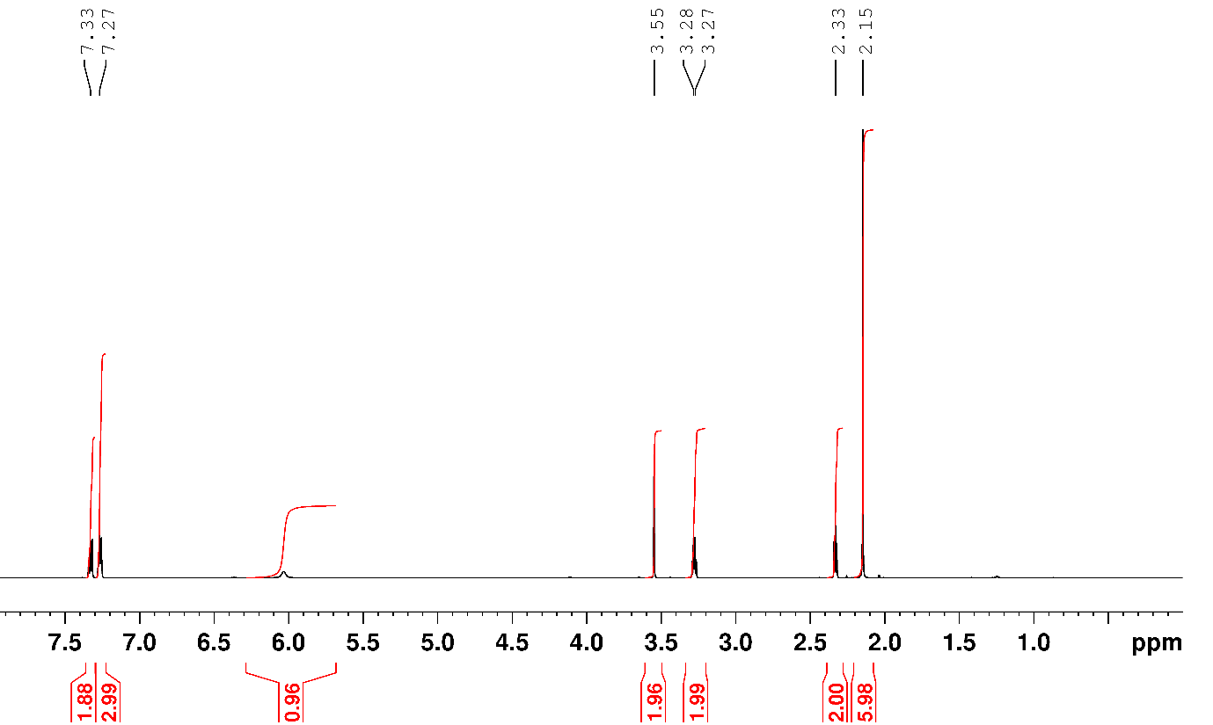
¹H NMR spectrum of 9 in CDCl₃
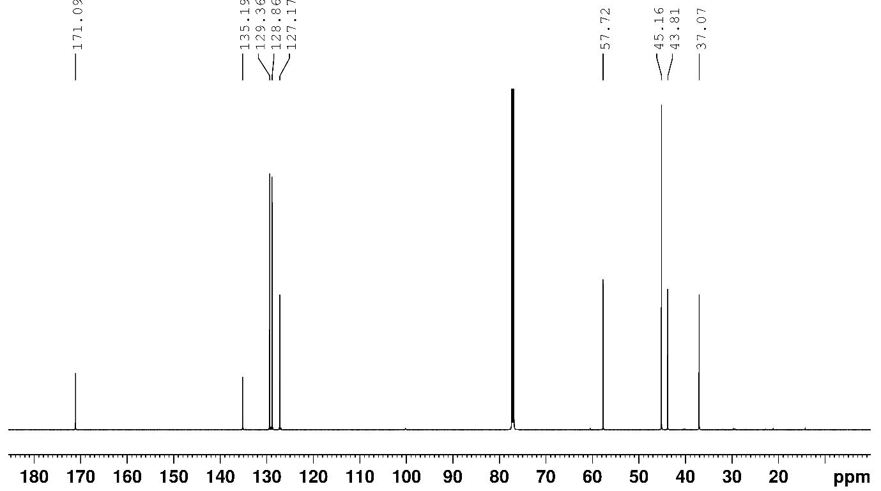
¹³C NMR spectrum of 9 in CDCl₃.

2-phenyl-N-(1H-pyrazol-3-yl)acetamide
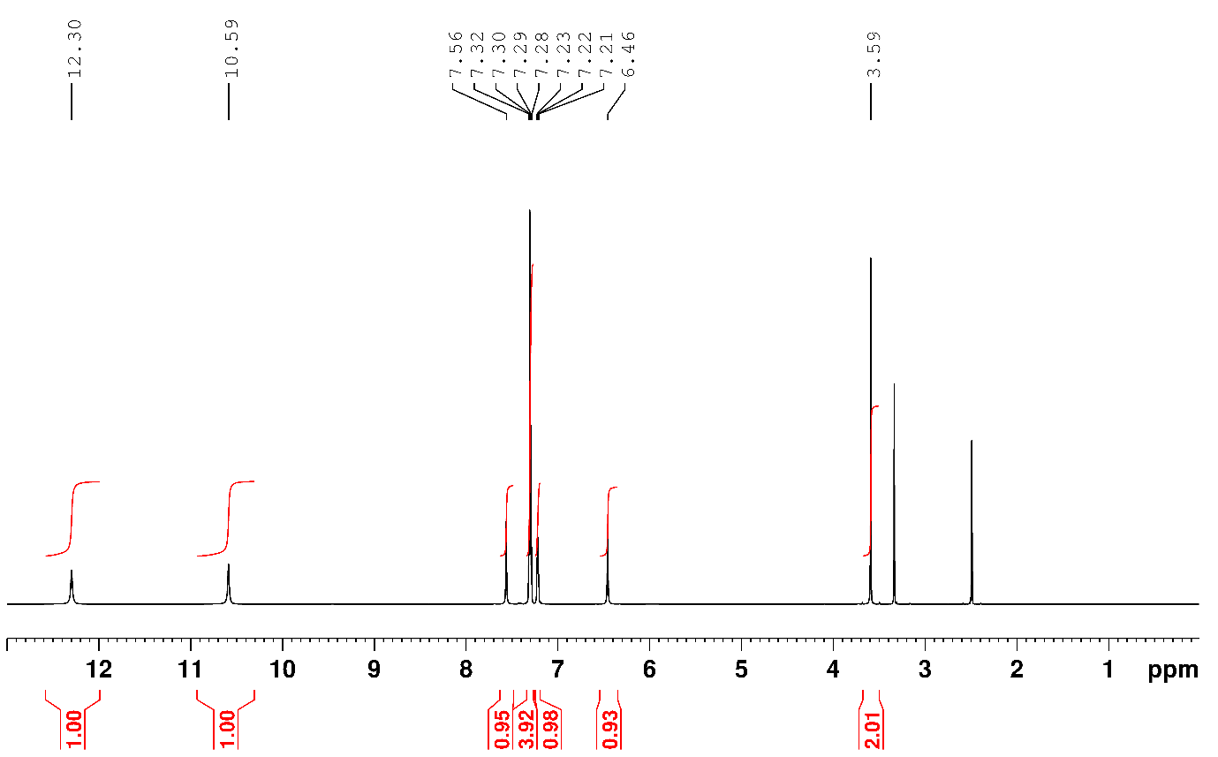
¹H NMR spectrum of 10 in DMSO-d₆
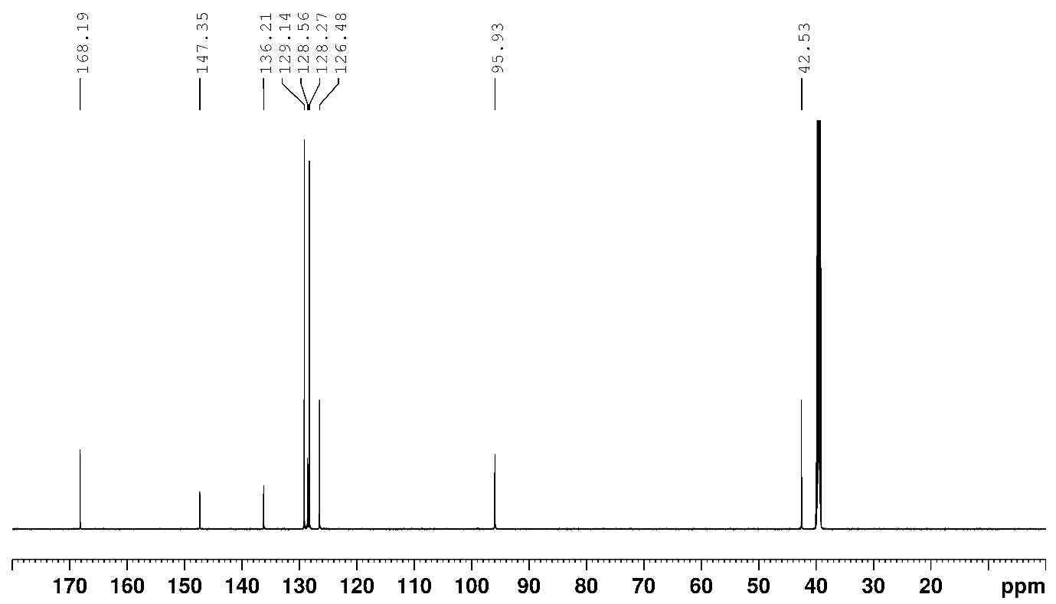
¹³C NMR spectrum of 10 in DMSO-d₆

N-Phenylpicolinamide
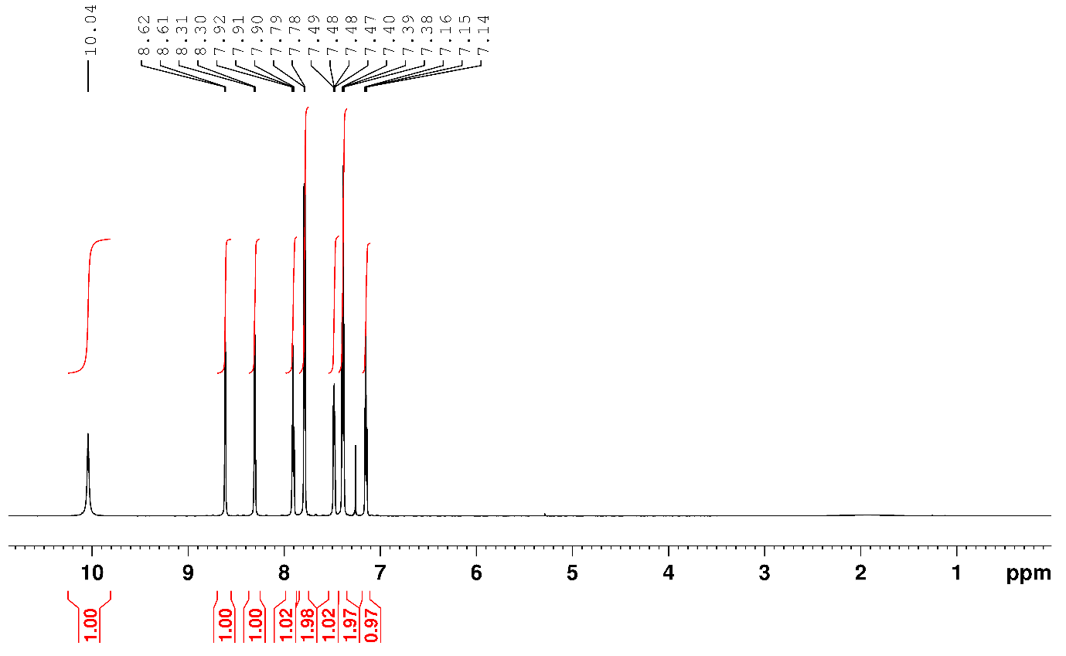
¹H NMR spectrum of 11 in CDCl₃
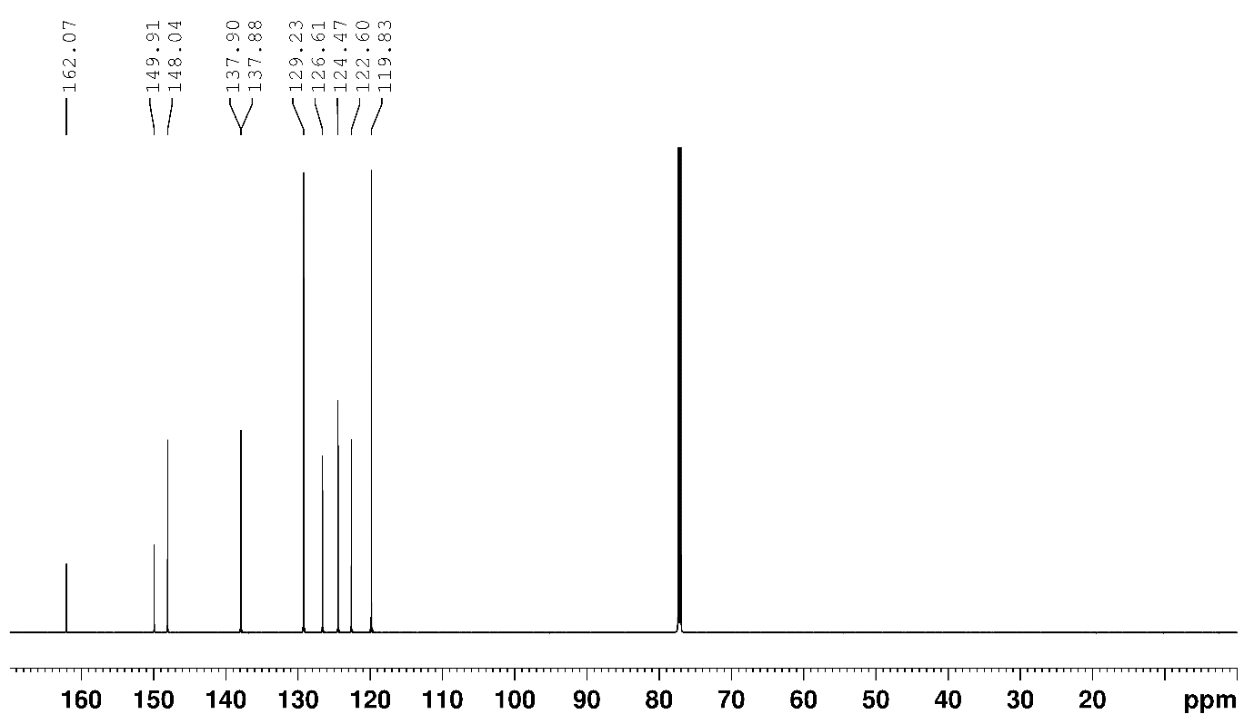
¹³C NMR spectrum of 11 in CDCl₃
N-(3-bromophenyl)-1H-pyrazole-3-carboxamide
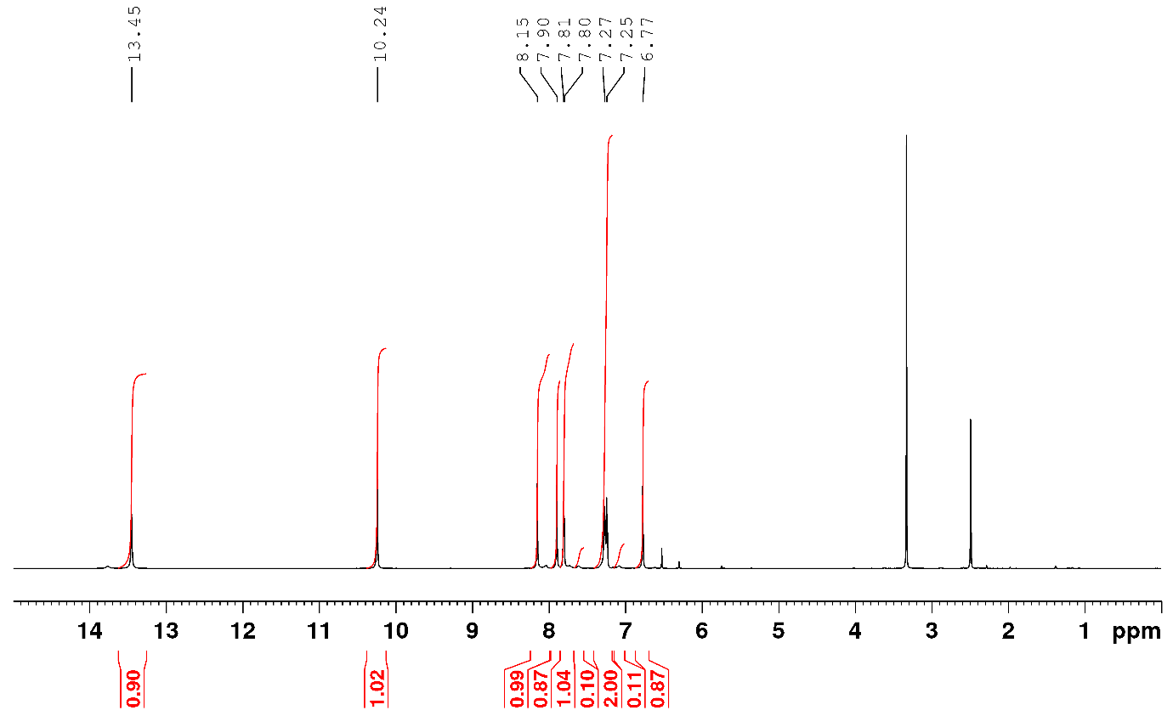
¹H NMR spectrum of 12 in DMSO-d₆
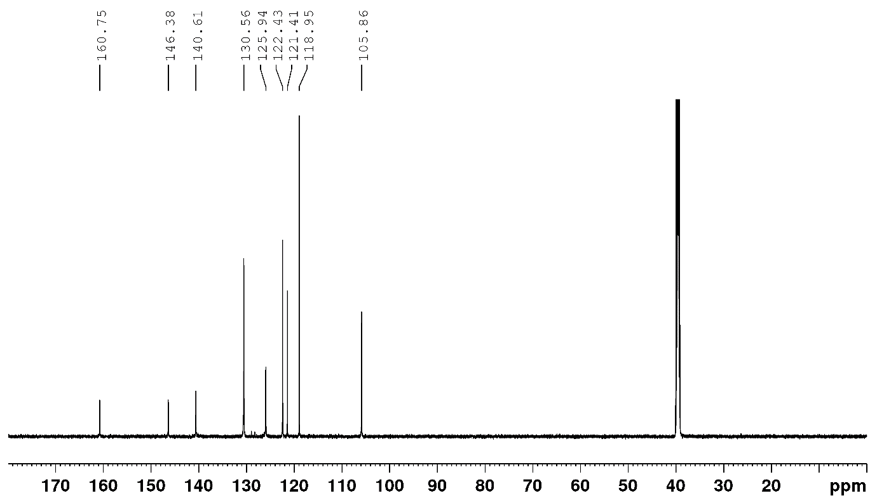
¹³C NMR spectrum of 12 in DMSO-d₆.

N-benzylpicolinamide
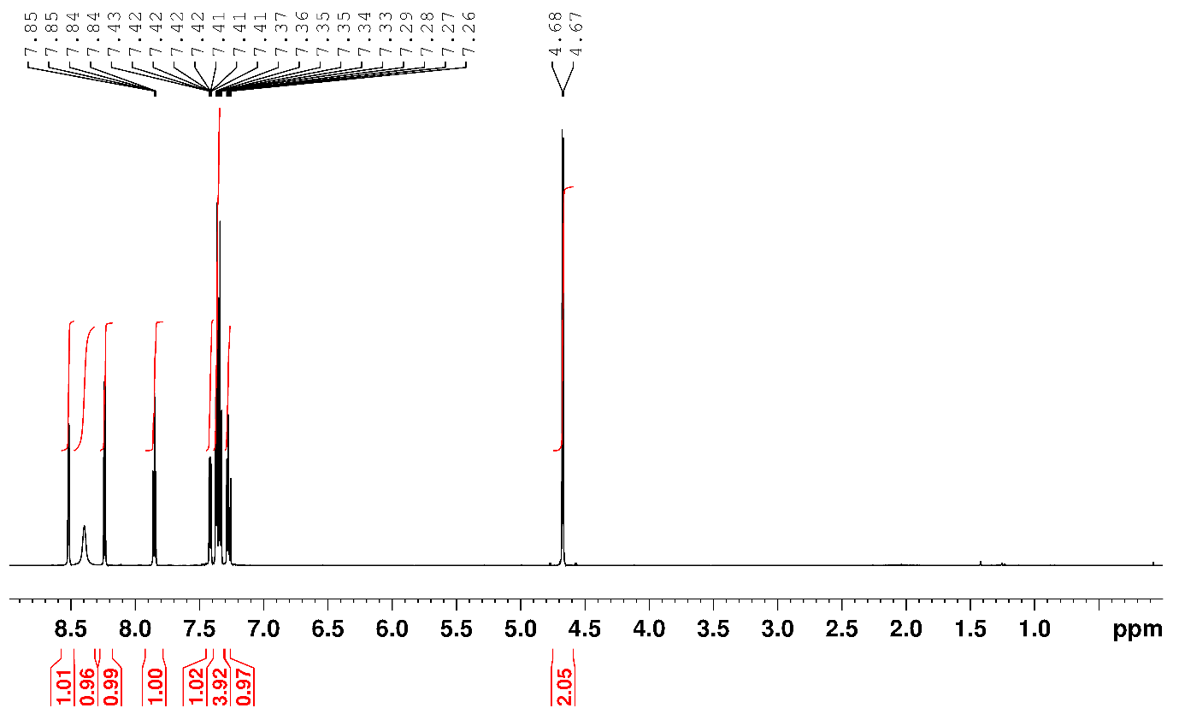
¹H NMR spectrum of 13 in CDCl₃
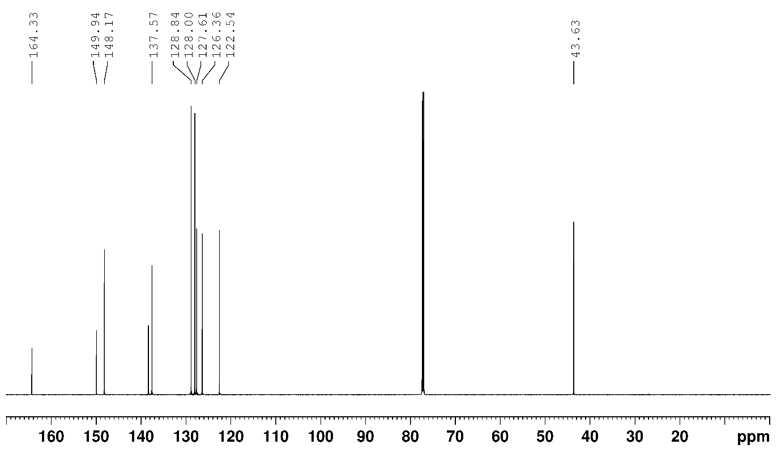
¹³C NMR spectrum of 13 in CDCl₃

N-benzyl-2-(2-chlorophenyl)-2-hydroxyacetamide
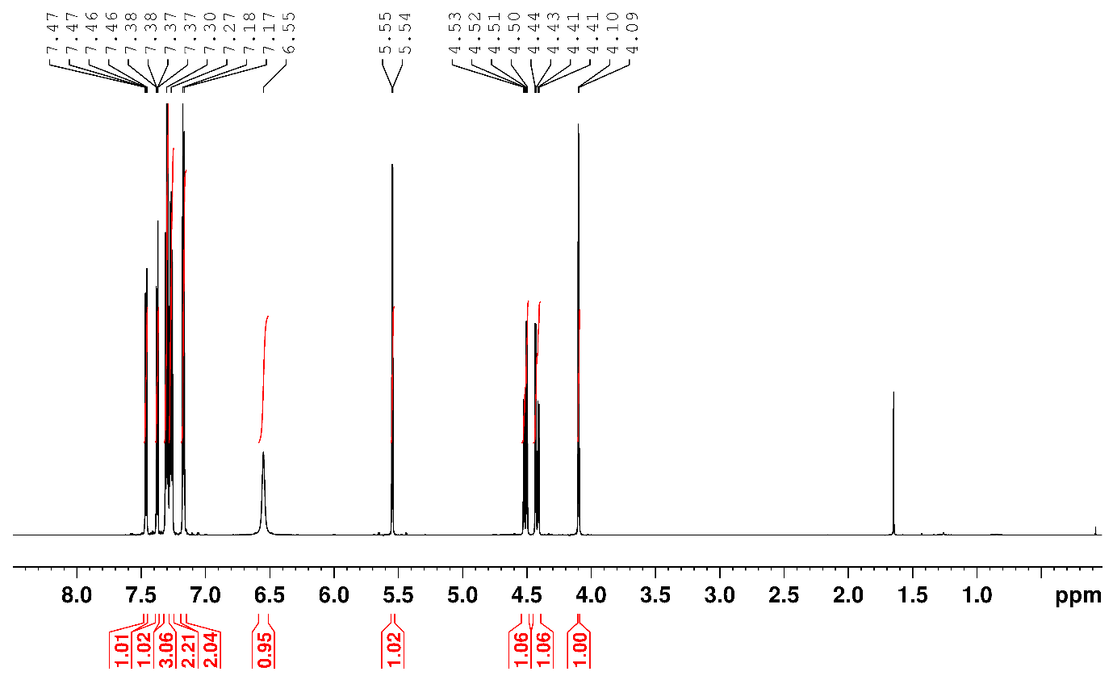
¹H NMR spectrum of 14 in CDCl₃
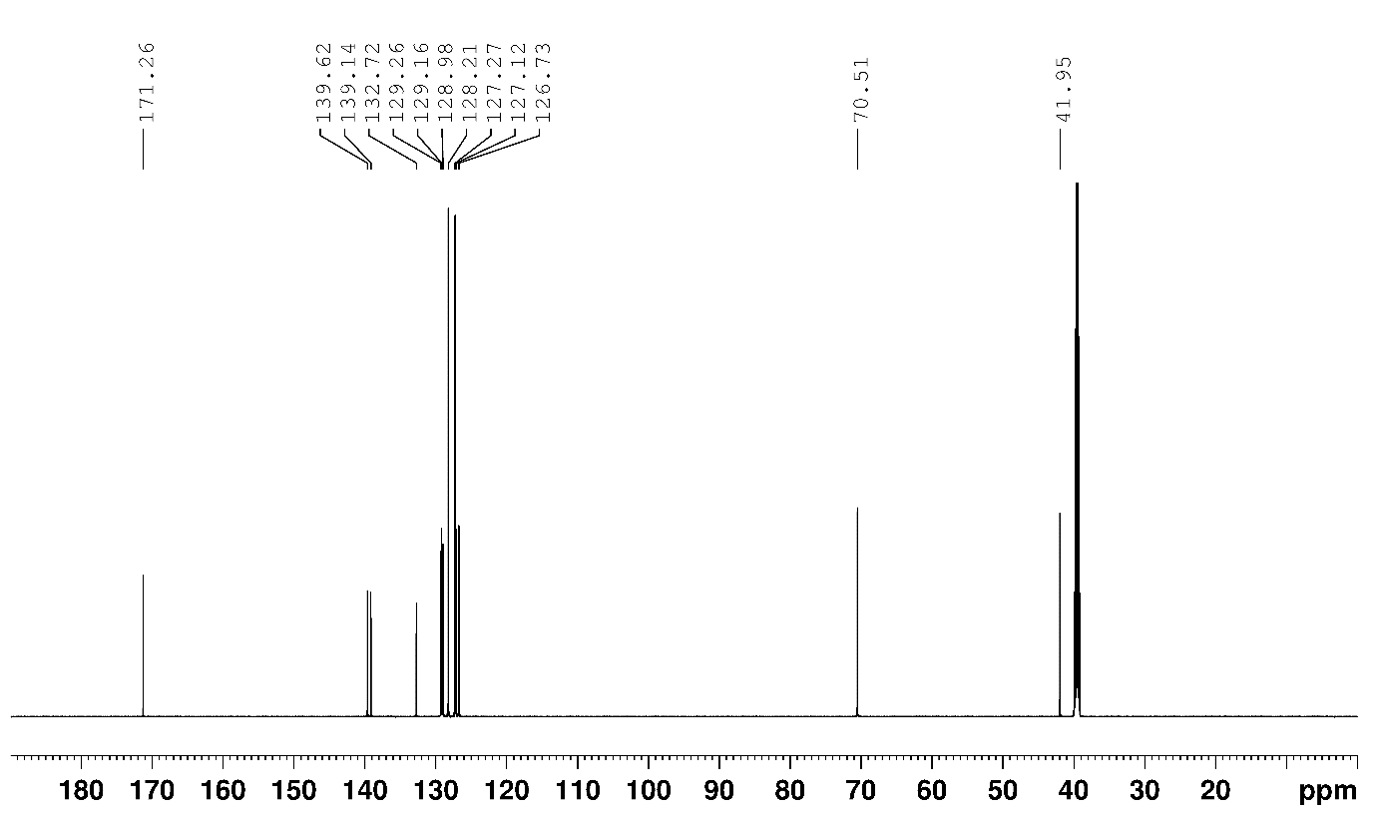
¹³C NMR spectrum of 14 in DMSO-d₆.
N-cyclohexylpicolinamide
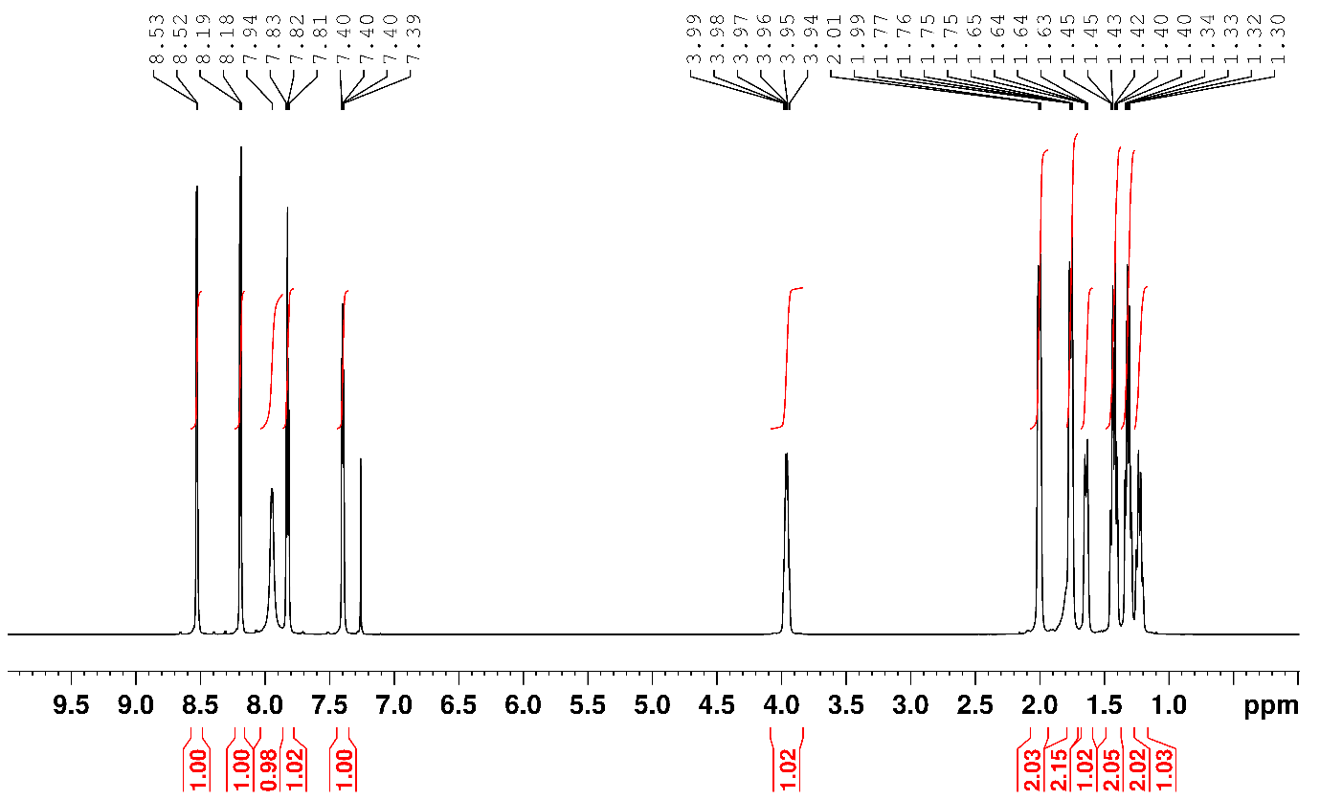
¹H NMR spectrum of 15 in CDCl₃
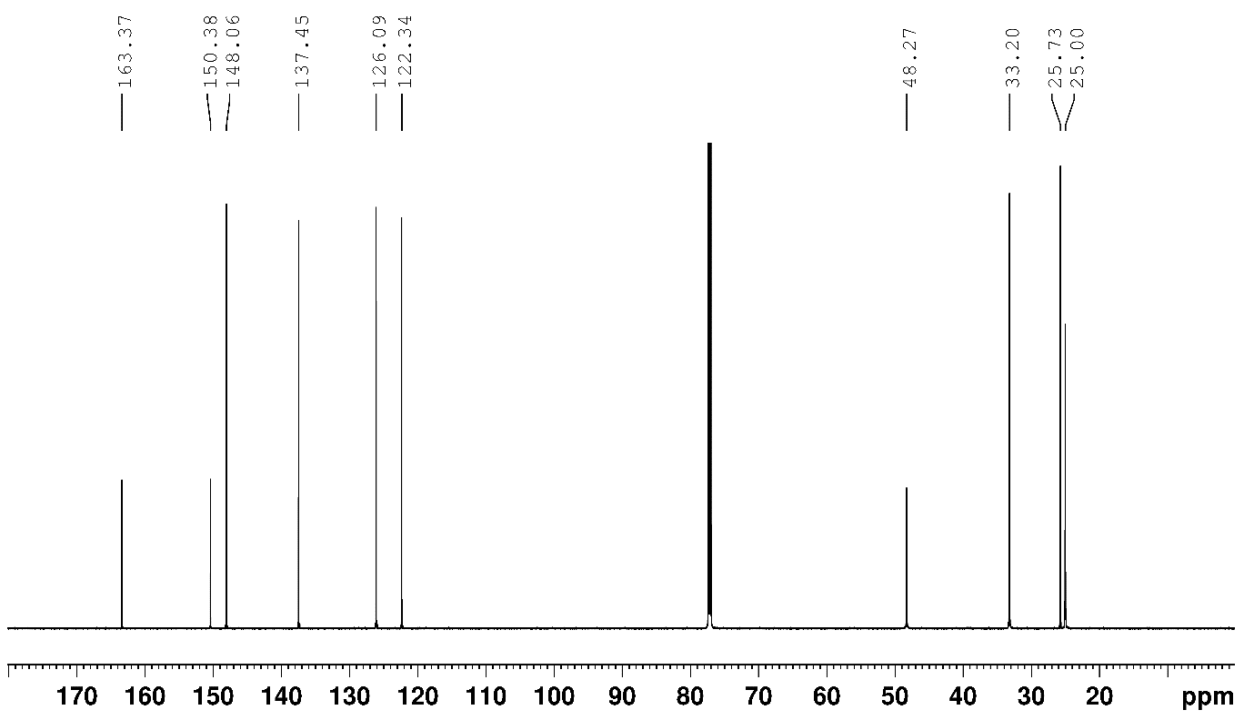
¹³C NMR spectrum of 15 in CDCl₃.

N-benzyl-1H-pyrazole-3-carboxamide
¹H NMR spectrum of 16 in DMSO.
¹³C NMR spectrum of 16 in DMSO.
N-(2-(dimethylamino)phenyl)-2-phenylacetamide
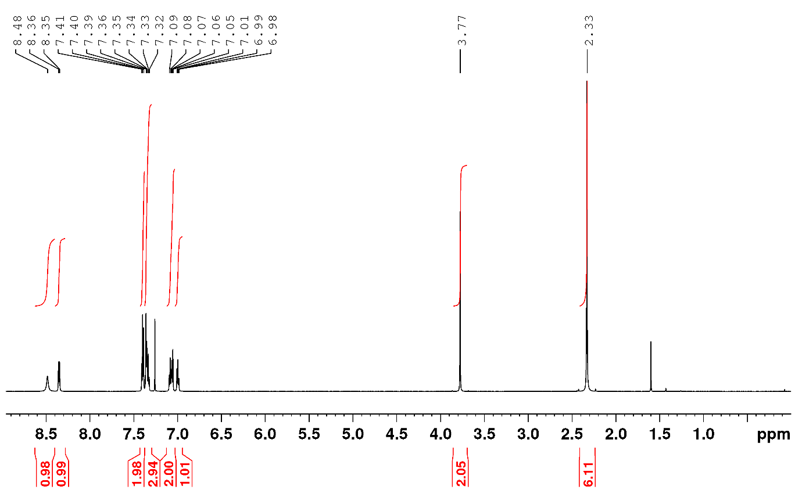
¹H NMR spectrum of 17 in CDCl₃
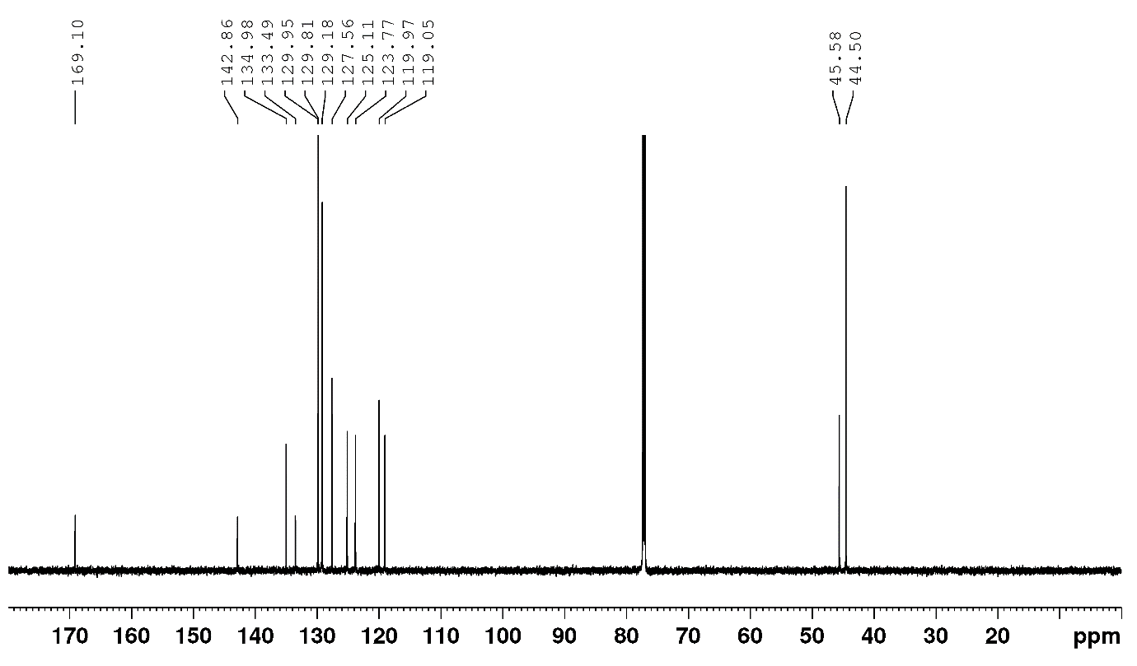
¹³C NMR spectrum of 17 in CDCl₃
2-(3-fluorophenyl)-N-(pyridin-3-yl)acetamide
Figure SX: ¹H NMR spectrum of 18 in CDCl₃
Figure SX: ¹³C NMR spectrum of 18 in CDCl₃.
tert-Butyl 4-(pyridin-3-ylcarbamoyl)piperidine-1-carboxylate
Figure SX: ¹H NMR spectrum of 19 in CDCl₃
Figure SX: ¹³C NMR spectrum of 19 in CDCl₃.

N-(3,5-bis(trifluoromethyl)phenyl)-5-bromofuran-2-carboxamide
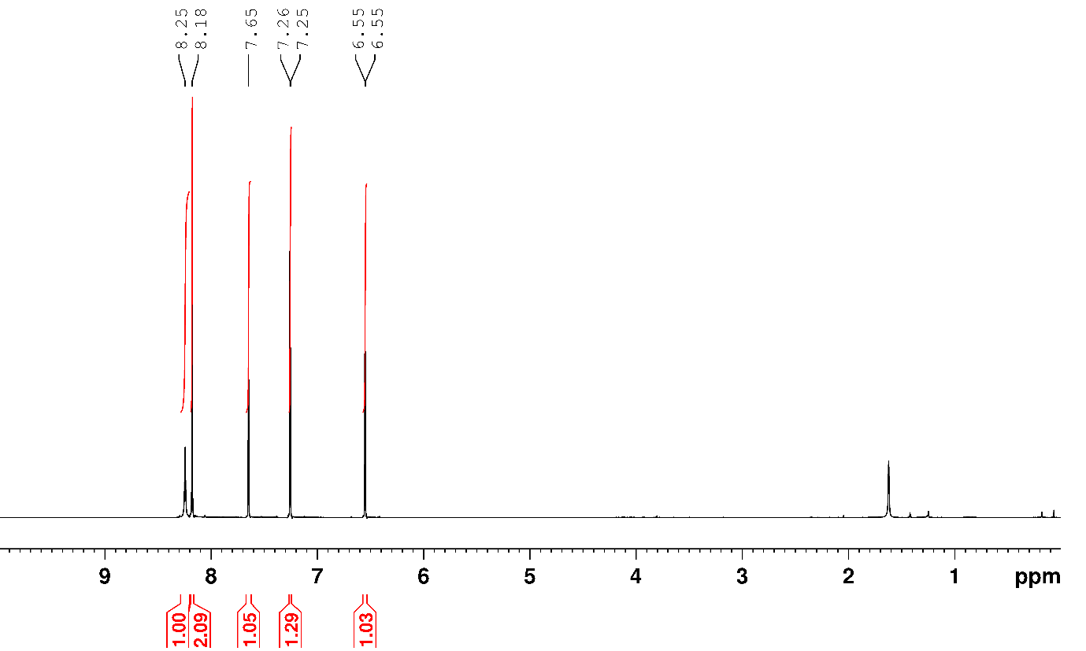
¹H NMR spectrum of 20 in CDCl₃
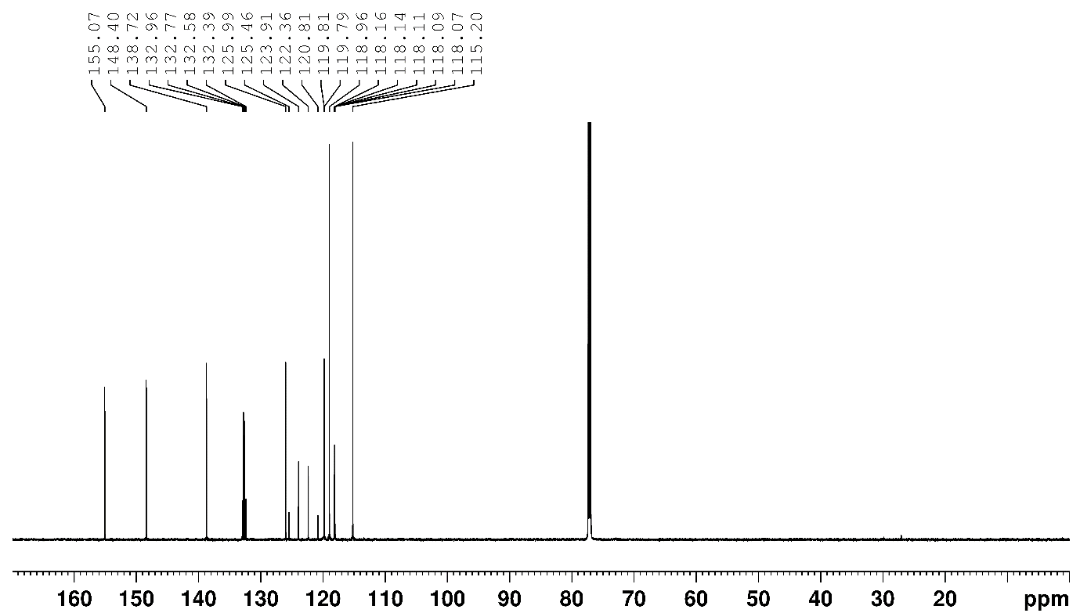
¹³C NMR spectrum of 20 in CDCl₃
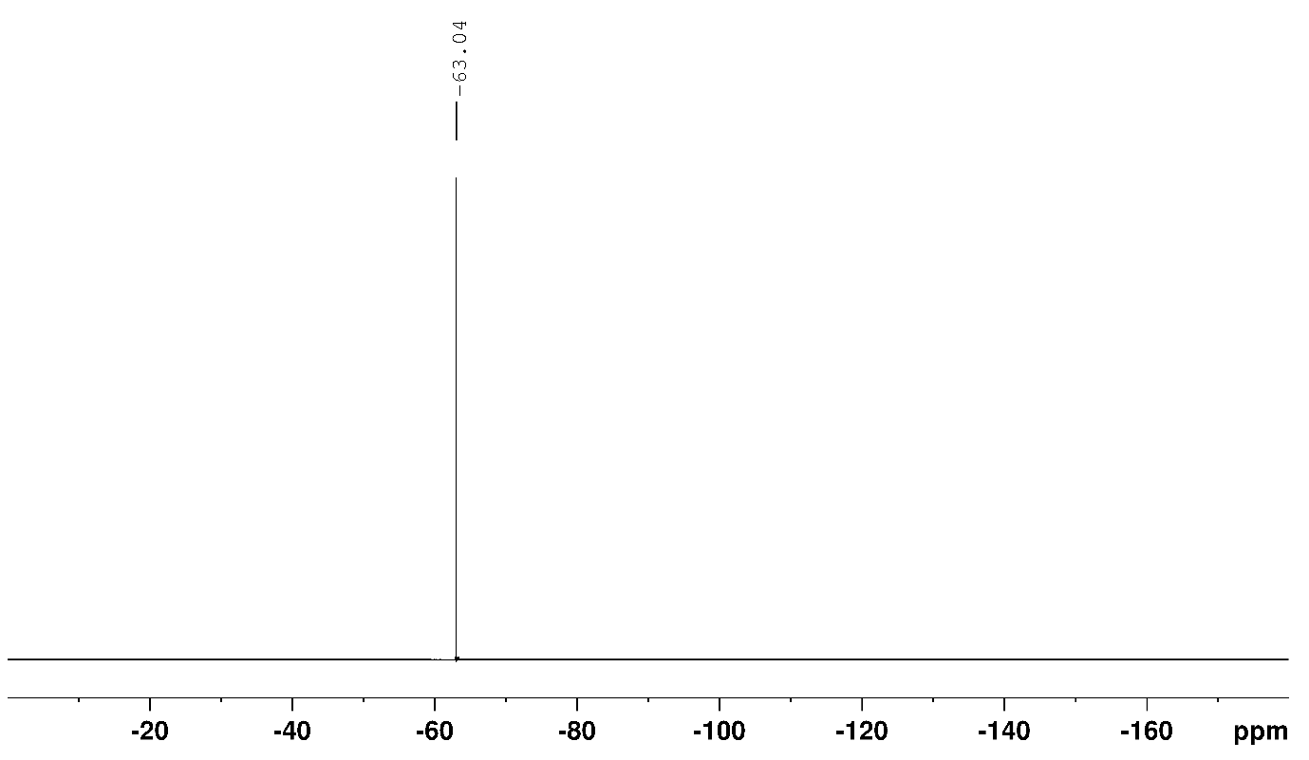
¹⁹F NMR spectrum of 20 in CDCl₃

N-(3-bromophenyl)benzamide
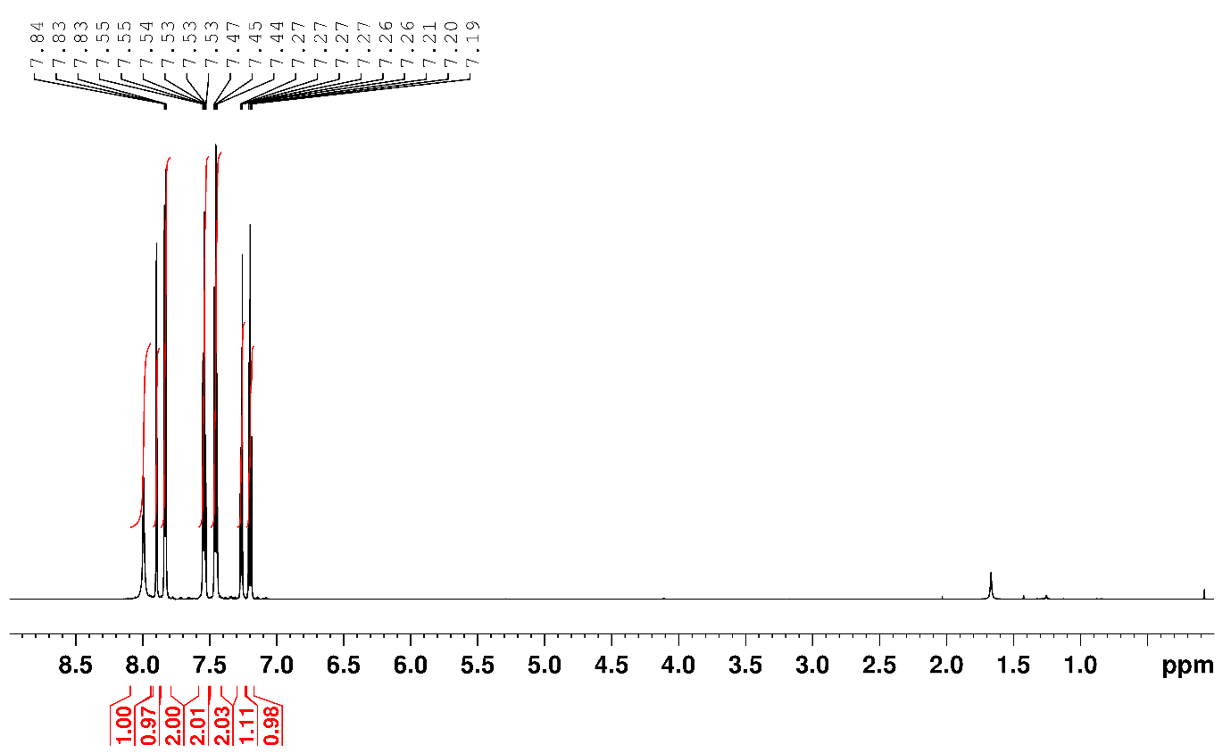
¹H NMR spectrum of 21 in CDCl₃
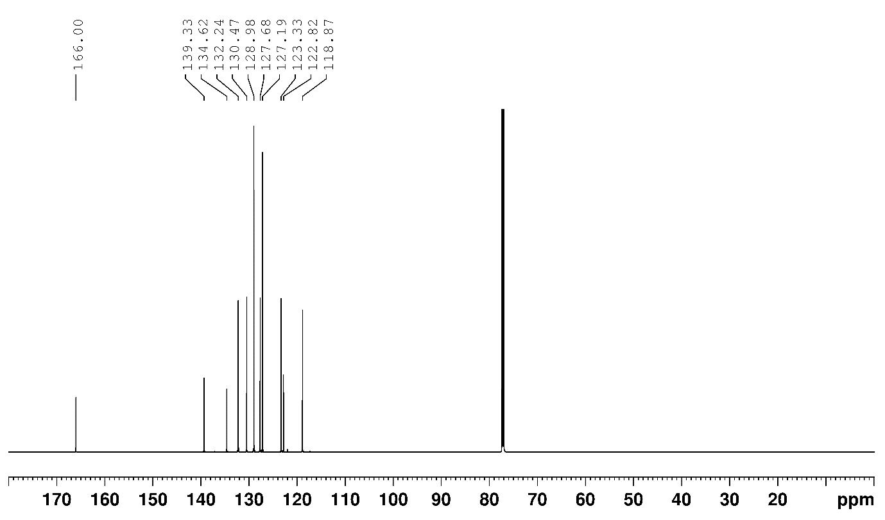
¹³C NMR spectrum of 21 in CDCl₃
N-(3,5-bis(trifluoromethyl)phenyl)-2-phenylacetamide
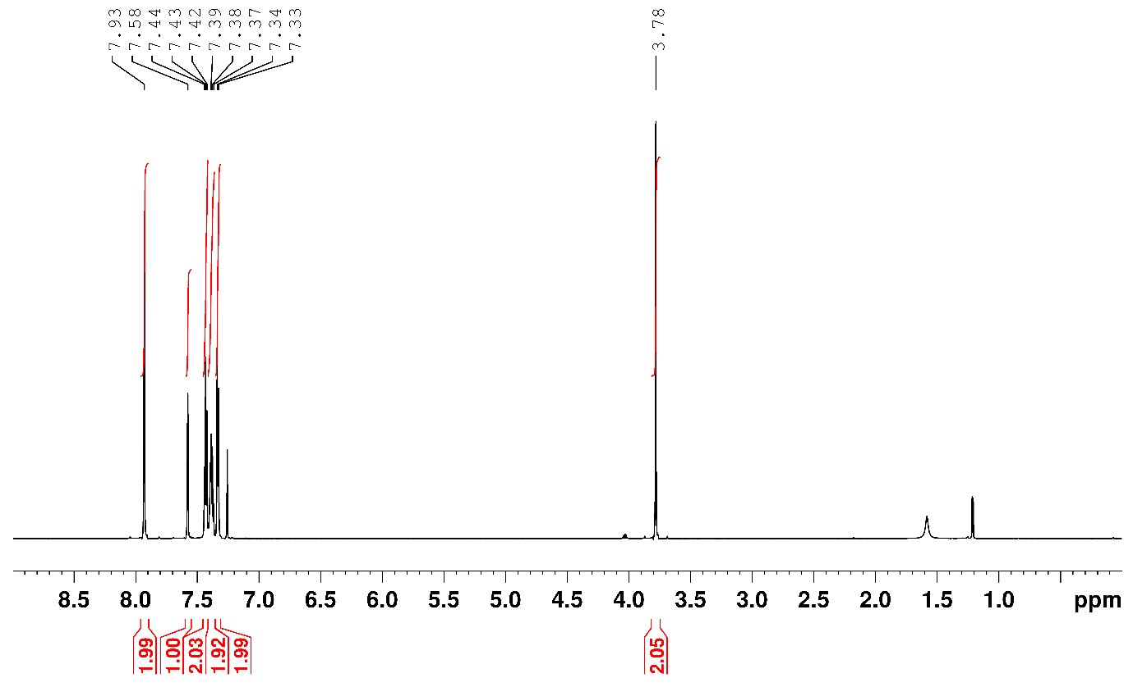
¹H NMR spectrum of 22 in CDCl₃
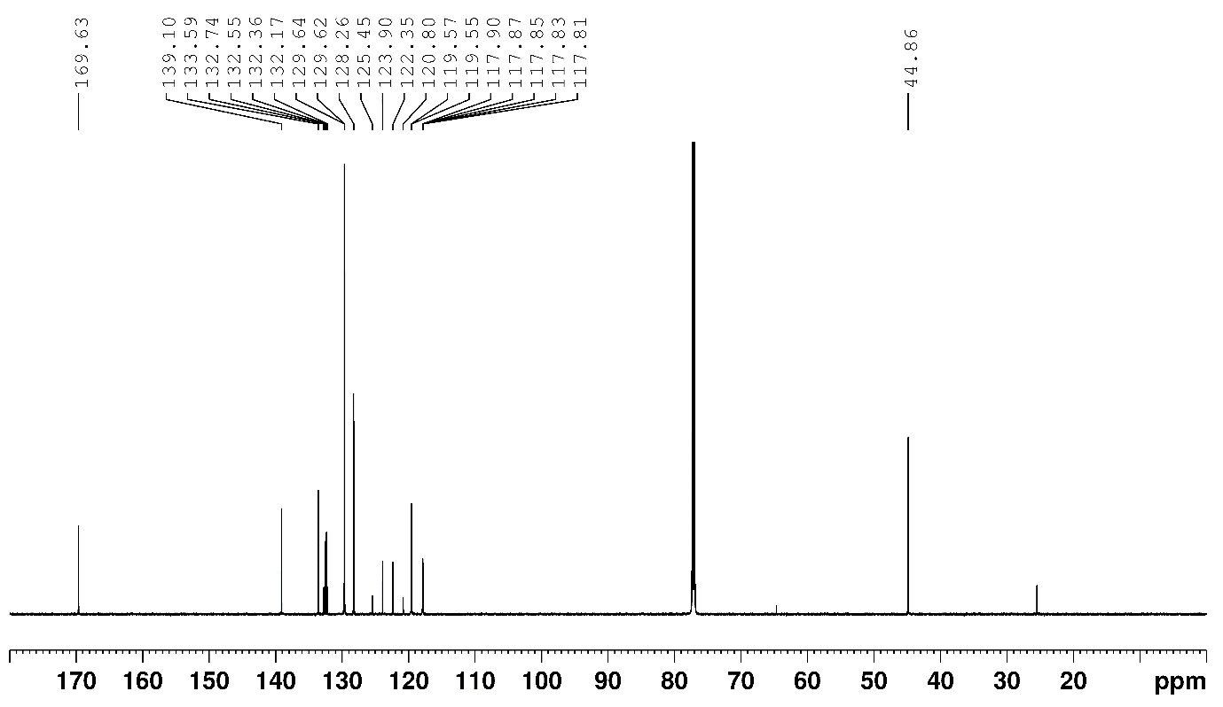
¹³C NMR spectrum of 22 in CDCl₃
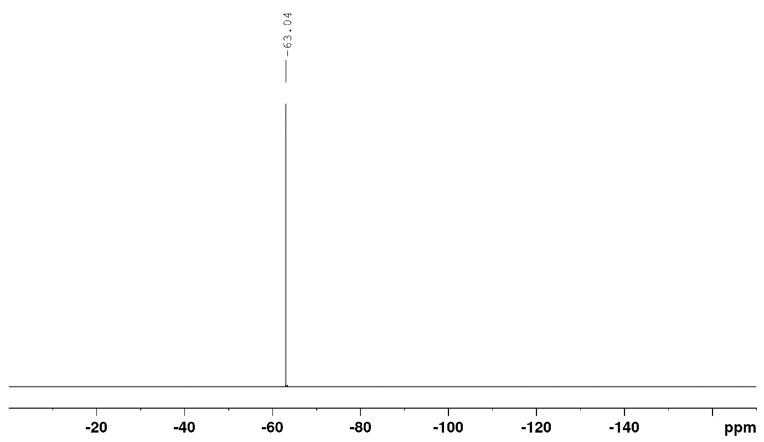
¹⁹F NMR spectrum of 22 in CDCl₃

N-allyl-N-phenyl,2-phenylacetamide
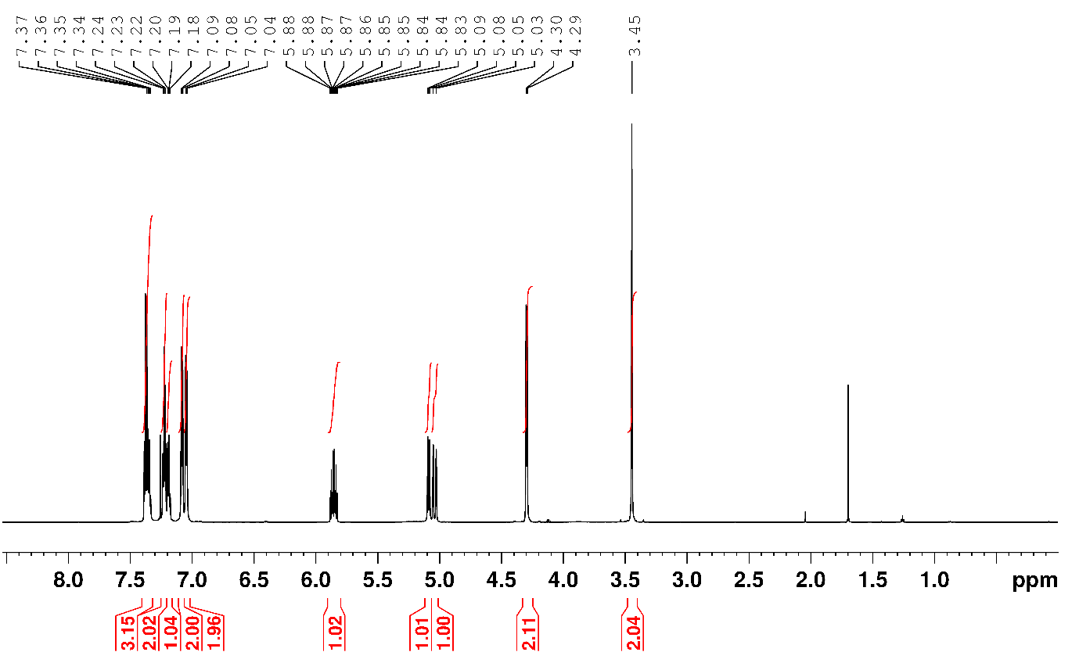
¹H NMR spectrum of 23 in CDCl₃
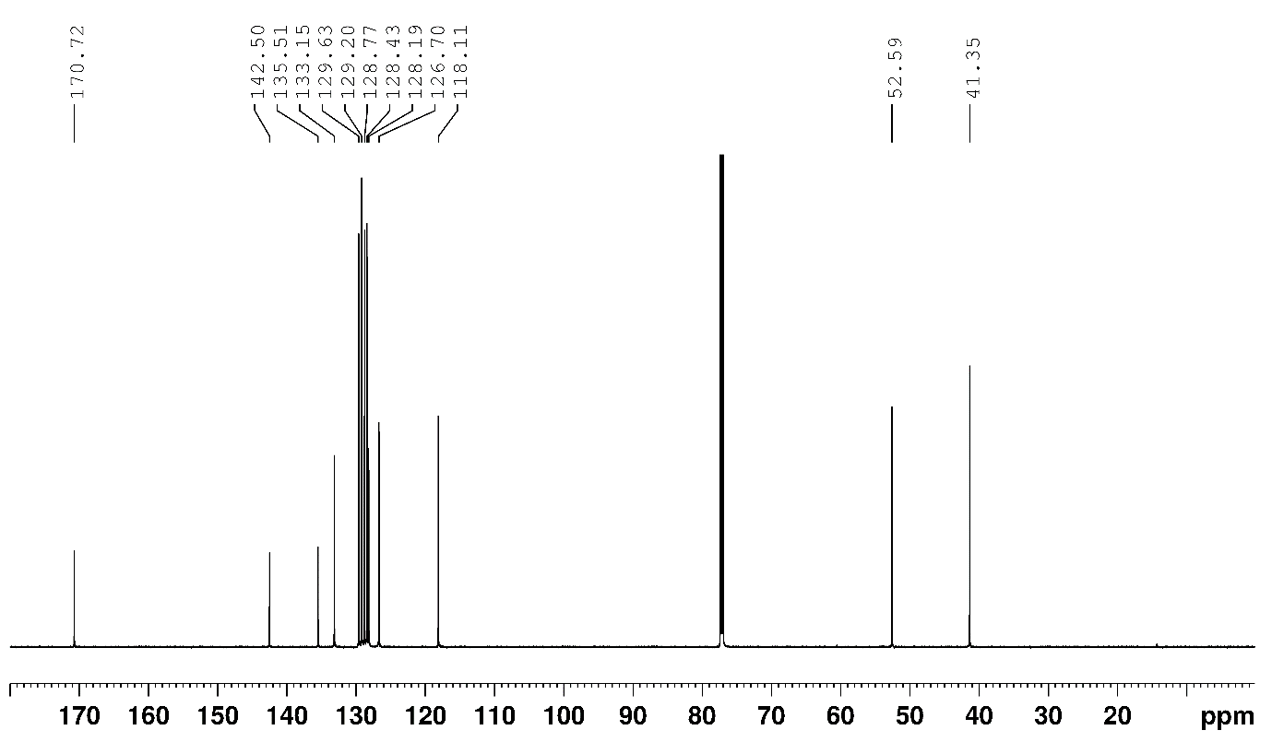
¹³C NMR spectrum of 23 in CDCl₃
N-Methyl-N-phenylbenzamide
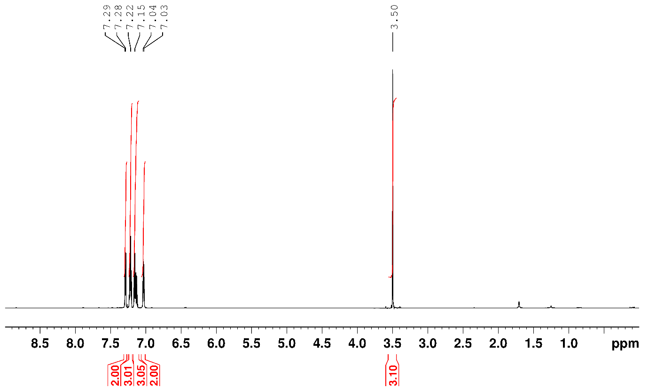
¹H NMR spectrum of 24 in CDCl₃
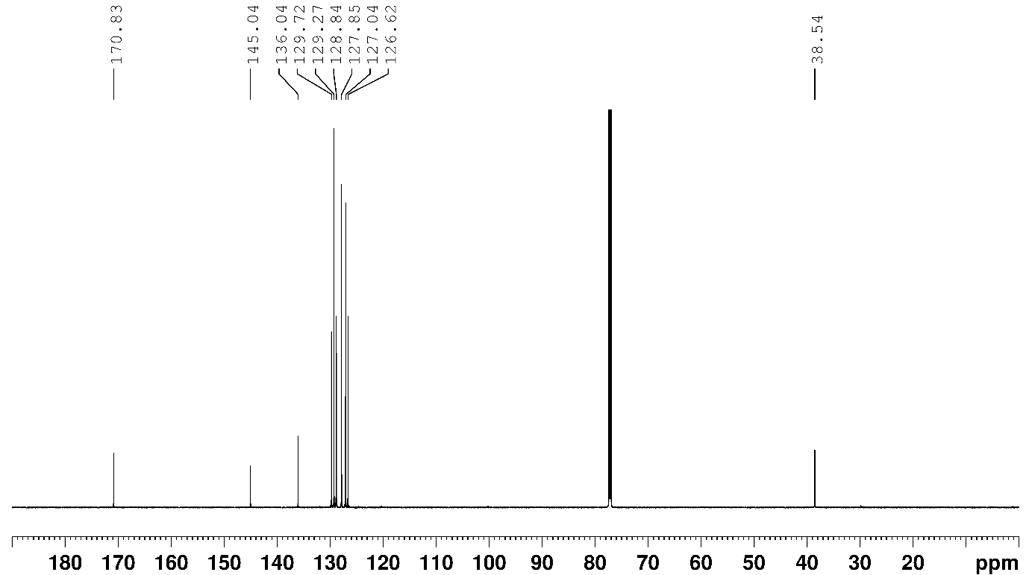
¹³C NMR spectrum of 24 in CDCl₃

N-cyclohexylcyclopropanecarboxamide
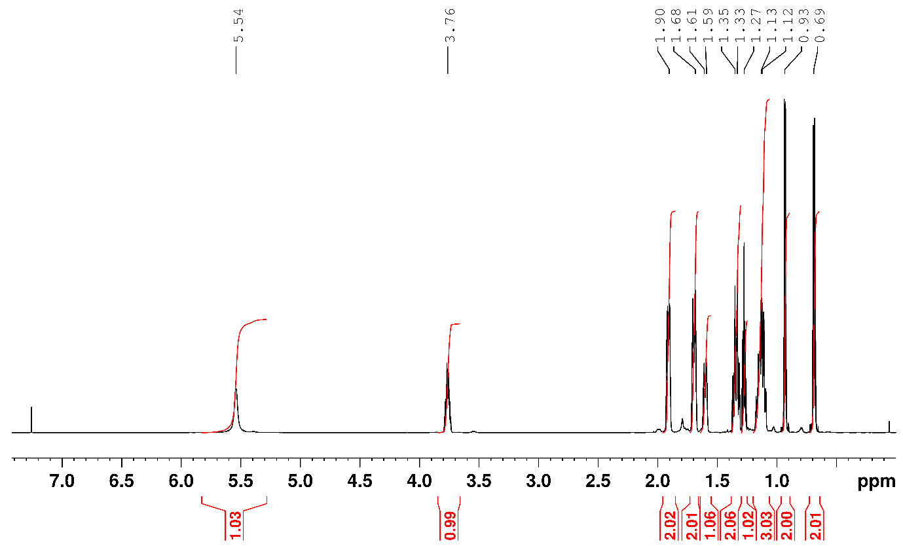
¹H NMR spectrum of 25 in CDCl₃
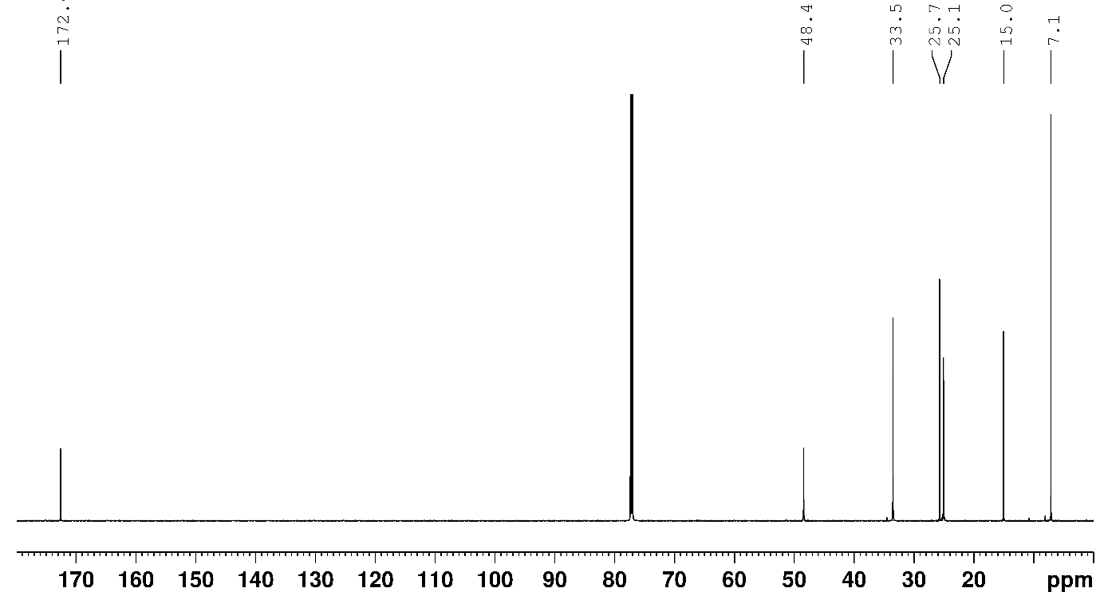
¹³C NMR spectrum of 25 in CDCl₃.

N-(adamantan-1-yl)-2-phenylacetamide
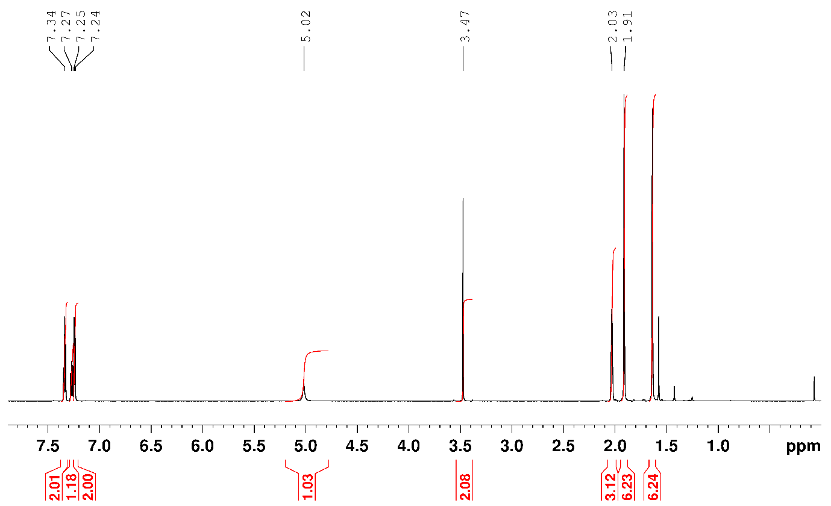
¹H NMR spectrum of 26 in CDCl₃
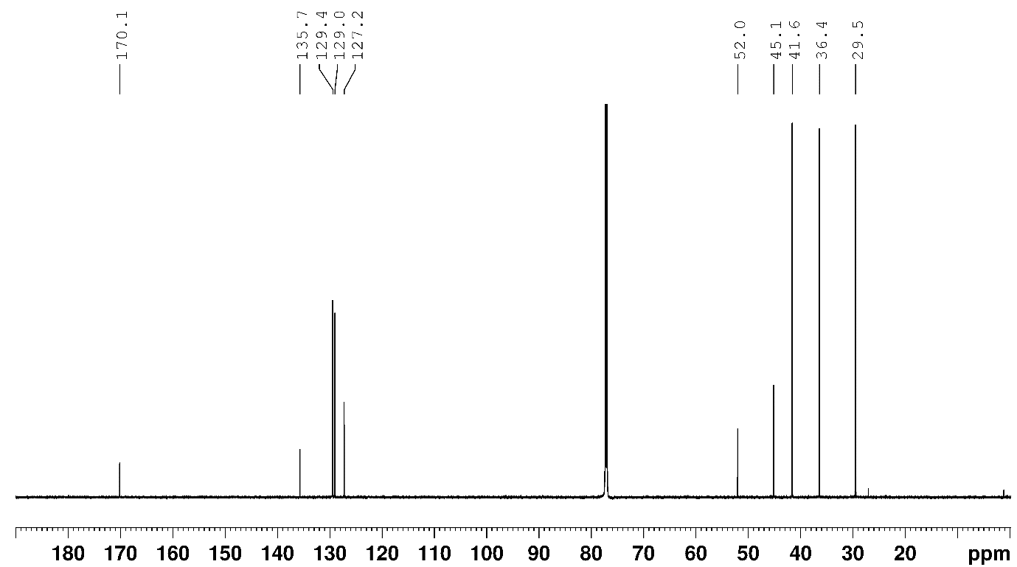
¹³C NMR spectrum of 26 in CDCl₃.

(S)-N-(1-phenylethyl)pivalamide
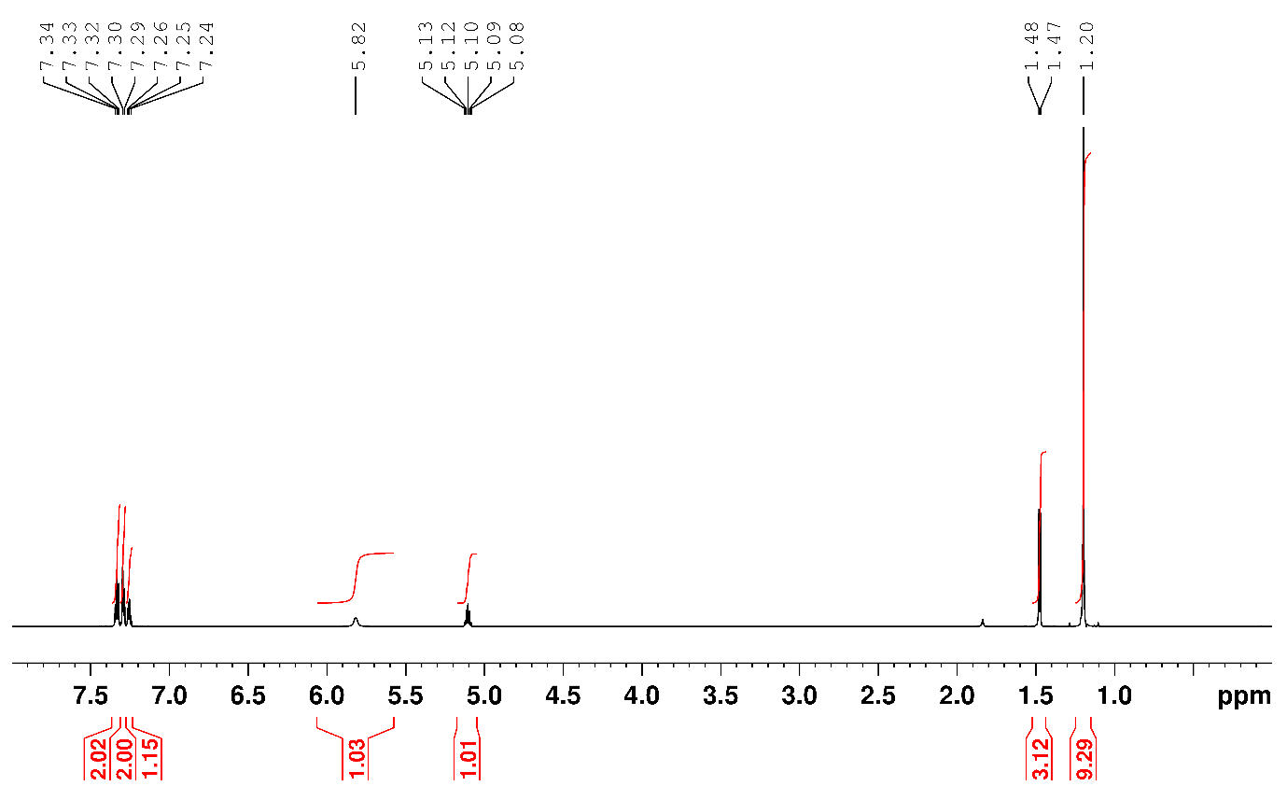
¹H NMR spectrum of 27 in CDCl₃
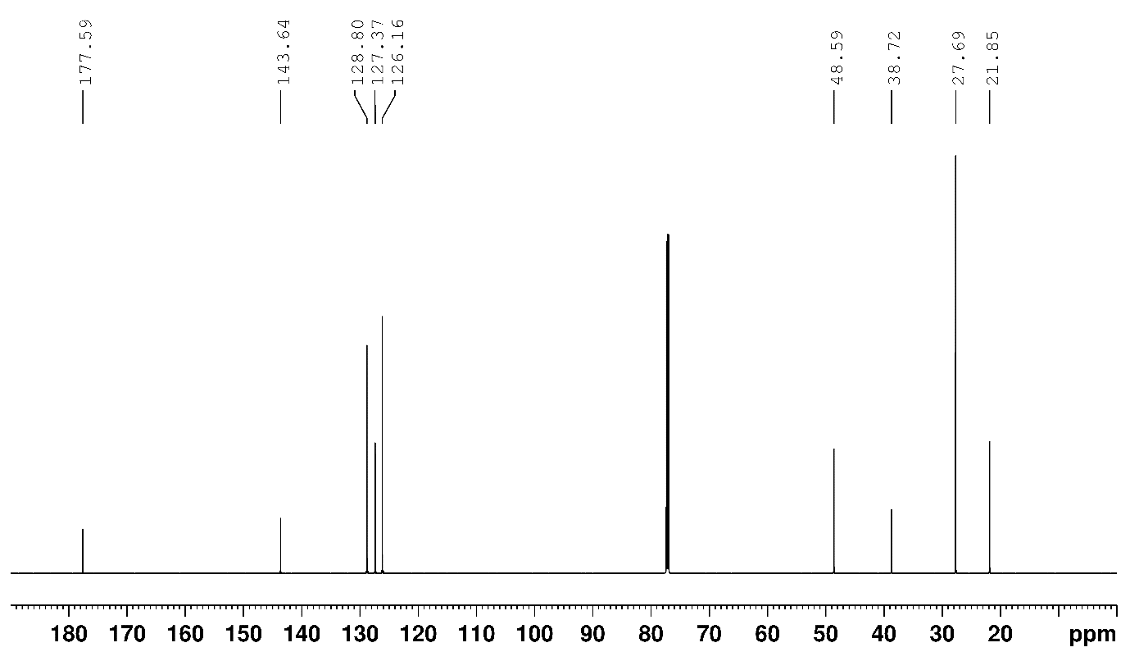
¹³C NMR spectrum of 27 in CDCl₃.
tert-butyl-(R)-2-(benzylcarbamoyl)pyrrolidine-1-carboxylate
¹H NMR spectrum of 28 in DMSO.
¹³C NMR spectrum of 28 in DMSO

tert-butyl (S)-2-(naphthalen-1-ylcarbamoyl)pyrrolidine-1-carboxylate
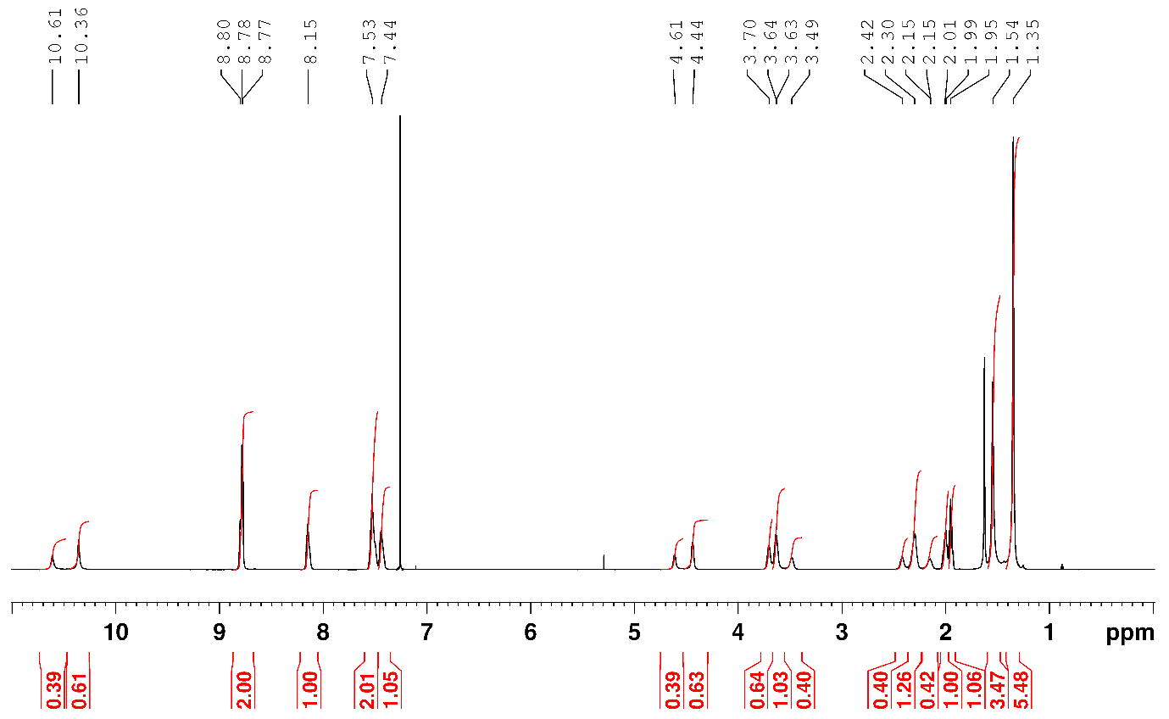
¹H NMR spectrum of 29 in CDCl₃
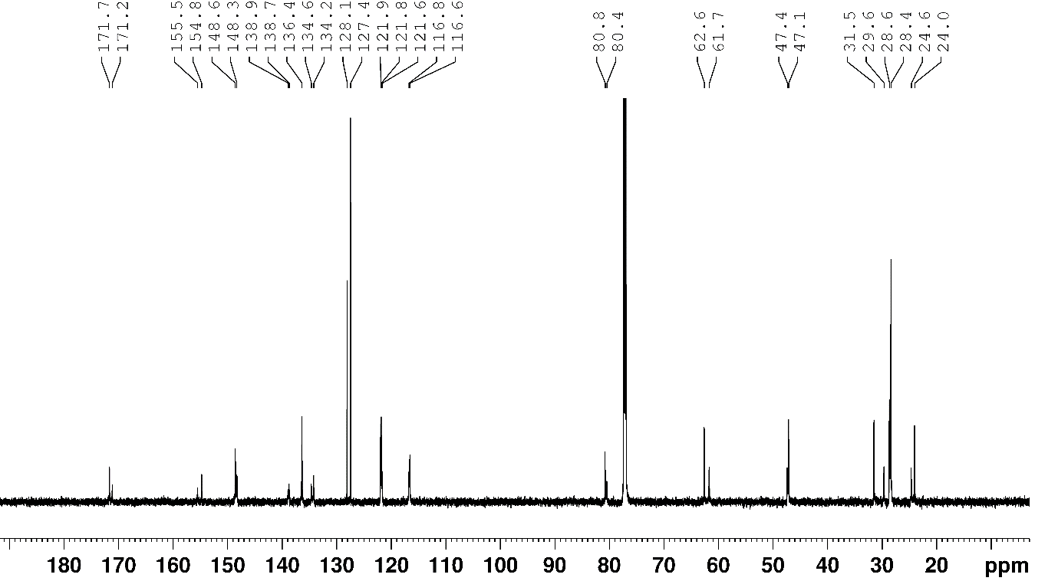
¹³C NMR spectrum of 29 in CDCl₃
N-(pyridin-2-yl)-2-(thiophen-3-yl)acetamide
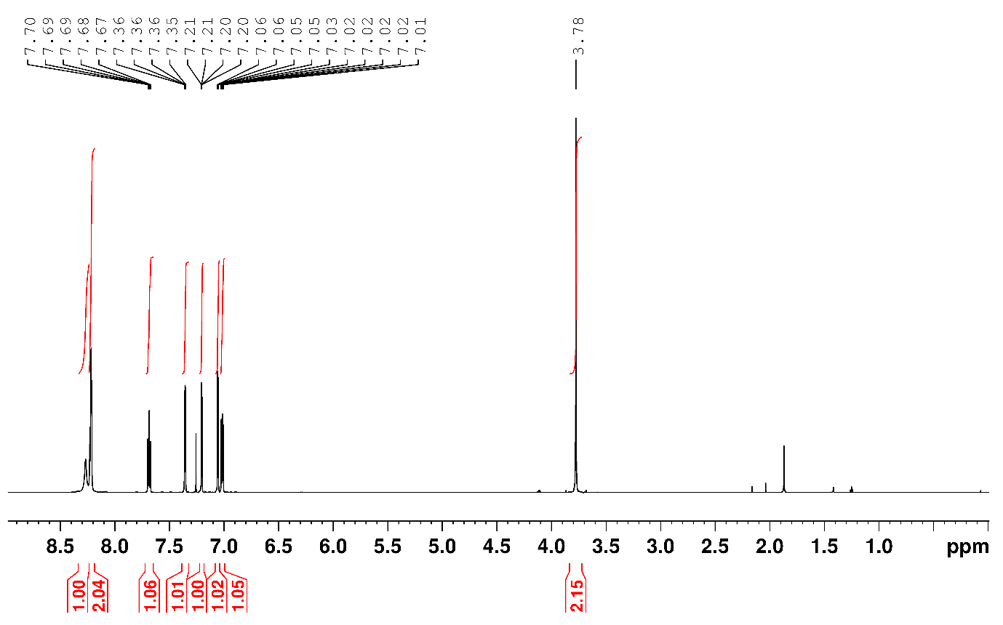
¹H NMR spectrum of 30 in CDCl₃
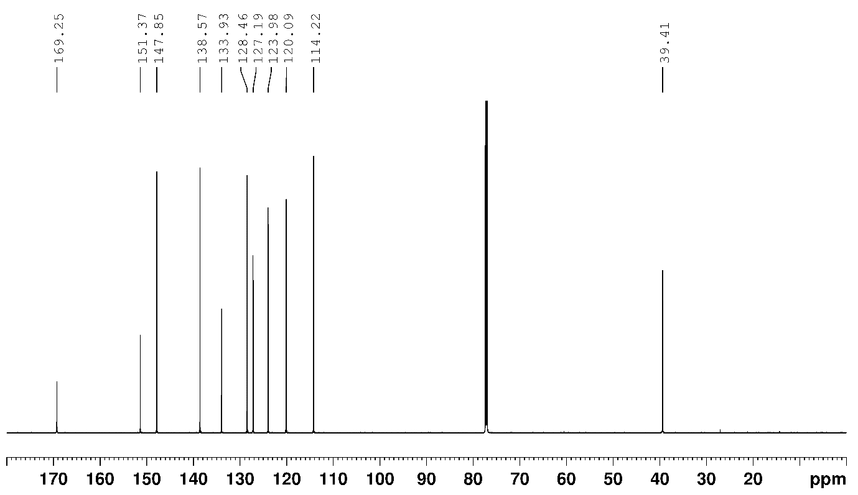
¹³C NMR spectrum of 30 in CDCl₃.

tert-butyl 4-(pyridin-2-ylcarbamoyl)piperidine-1-carboxylate
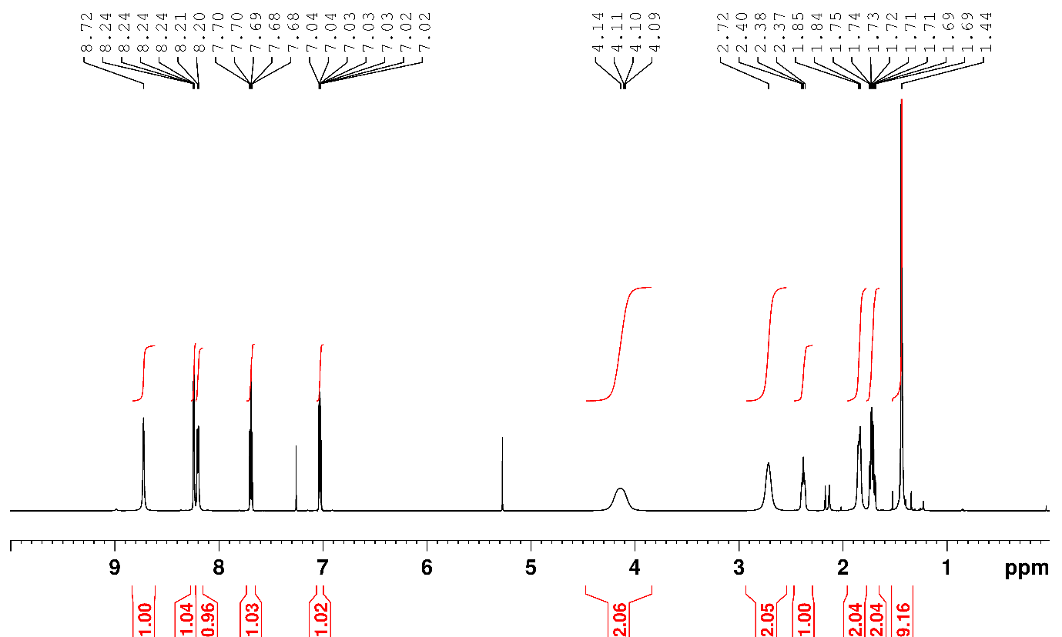
¹H NMR spectrum of 31 in CDCl₃.
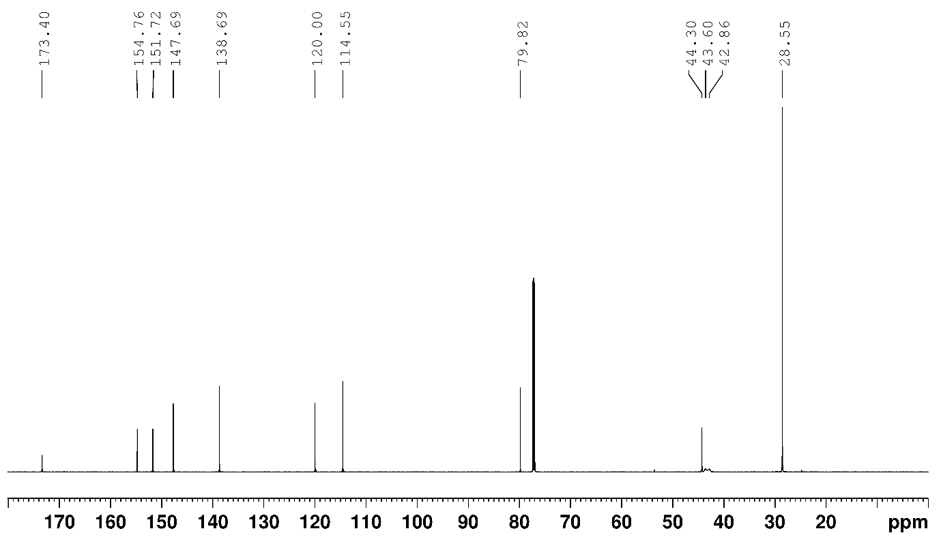
¹³C NMR spectrum of 31 in CDCl₃.
N-(pyridin-2-yl)pivalamide
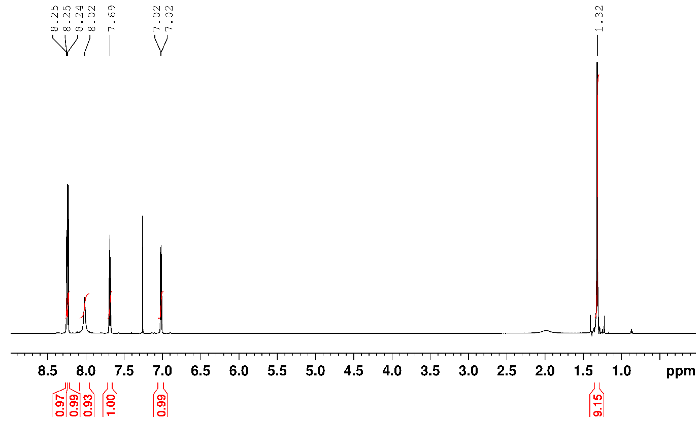
¹H NMR spectrum of 32 in CDCl₃
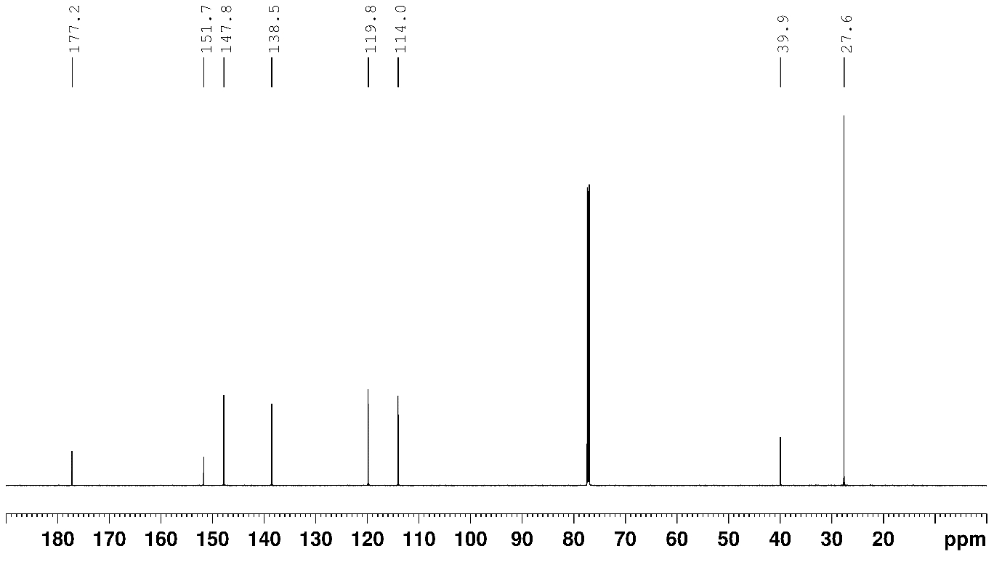
¹³C NMR spectrum of 32 in CDCl₃

N-(pyridin-2-yl)benzamide
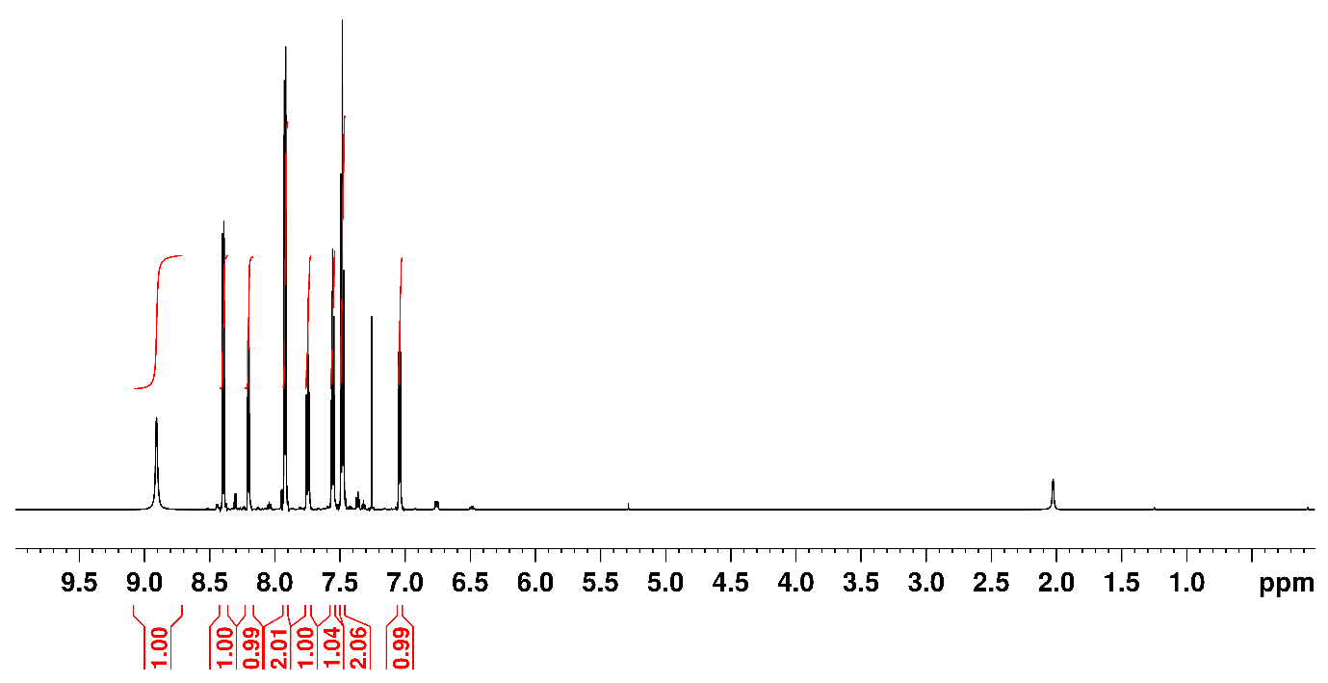
¹H NMR spectrum of 33 in CDCl₃
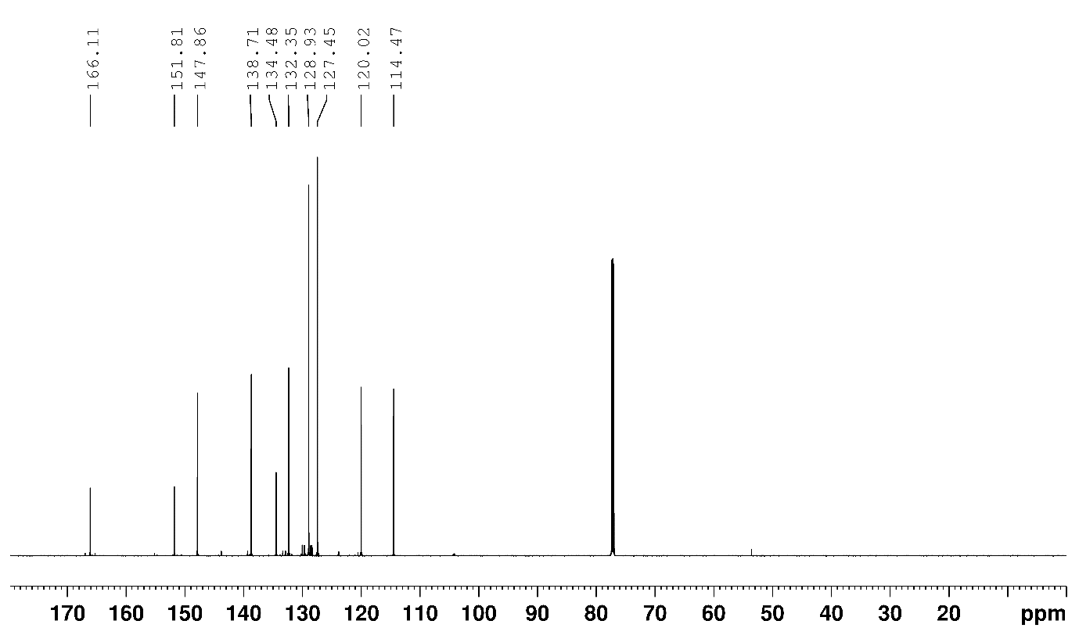
¹³C NMR spectrum of 33 in CDCl₃

N-(pyridin-2-yl)picolinamide
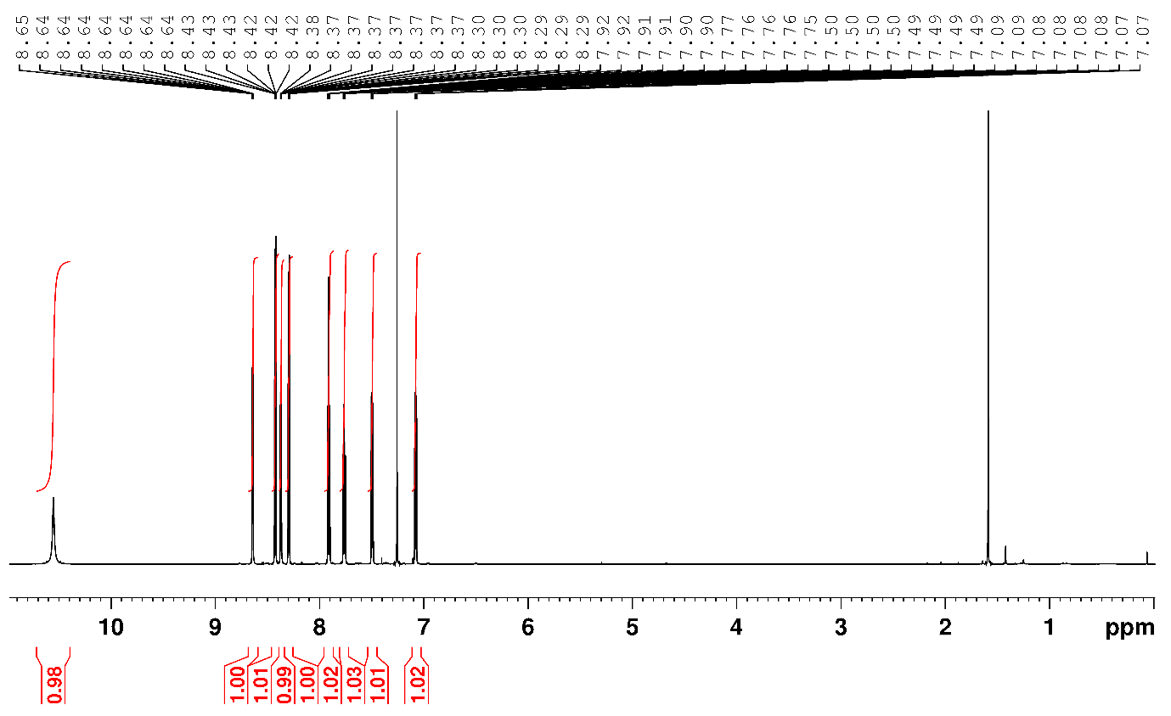
¹H NMR spectrum of 34 in CDCl₃
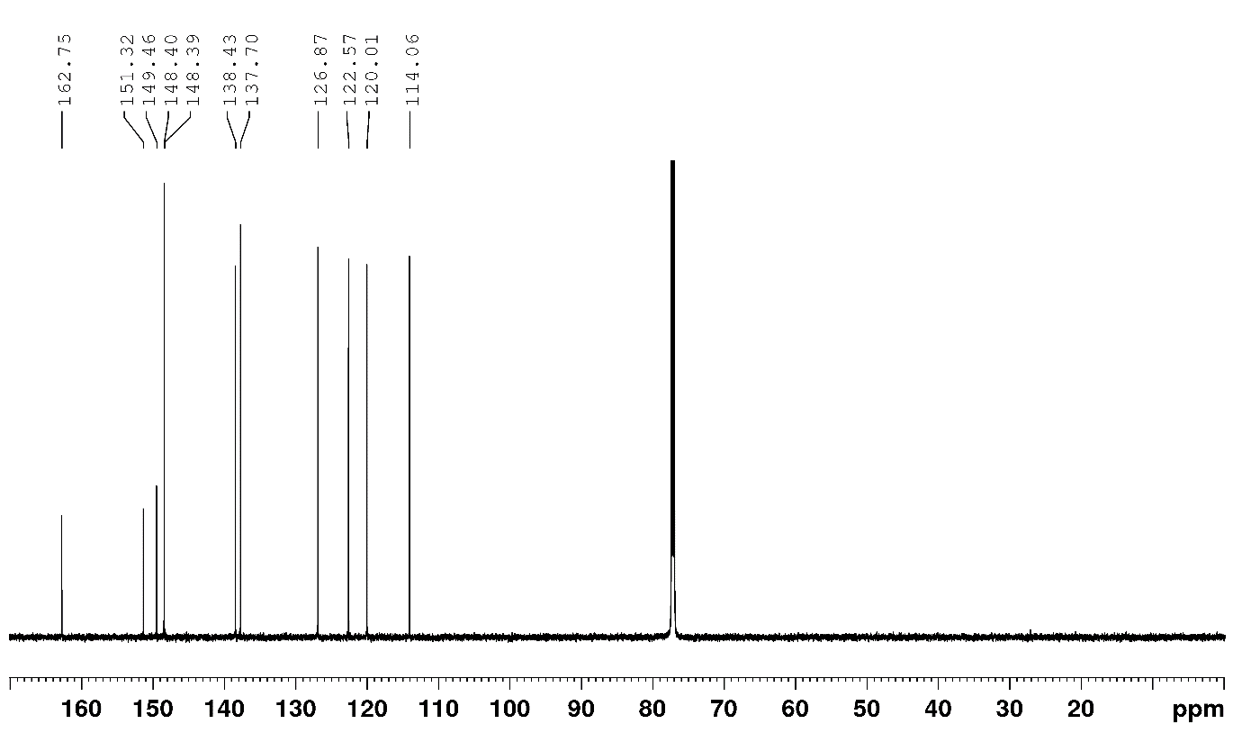
¹³C NMR spectrum of 34 in CDCl₃.
N-(pyridin-2-yl)-1H-indazole-3-carboxamide
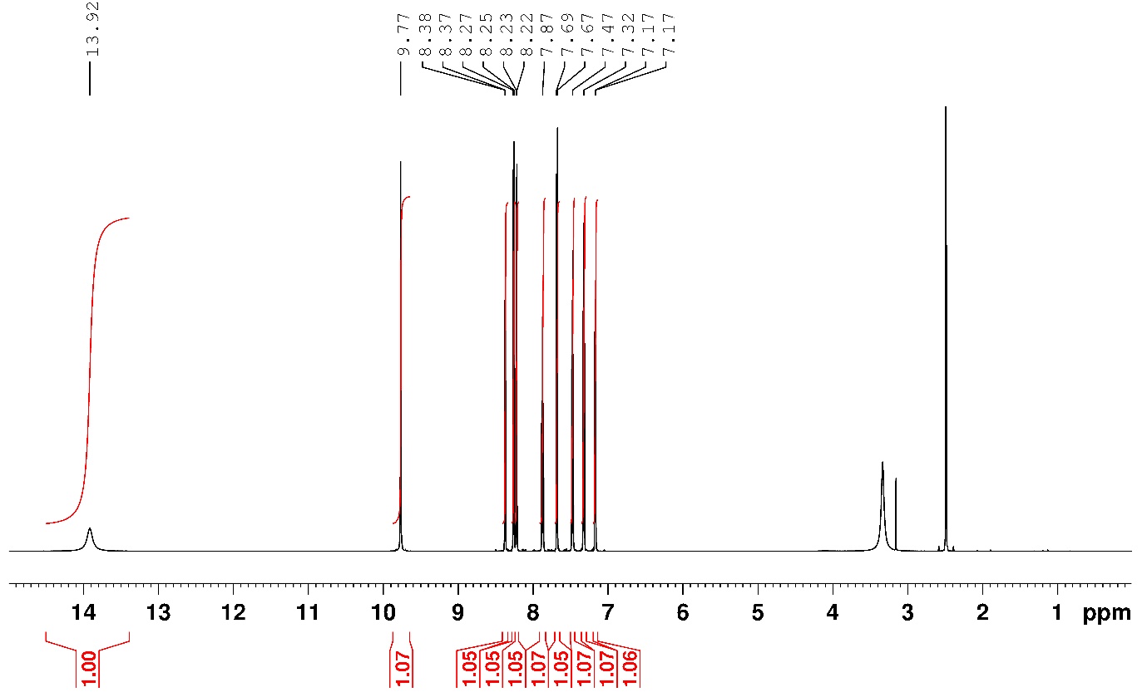
¹H NMR spectrum of 35 in DMSO – d₆
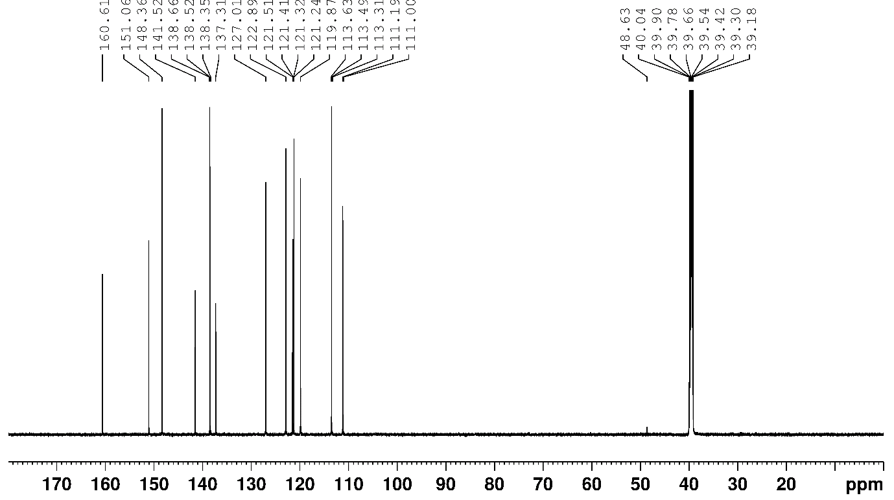
¹³C NMR spectrum of 35 in DMSO – d₆.

Chiral HPLC traces
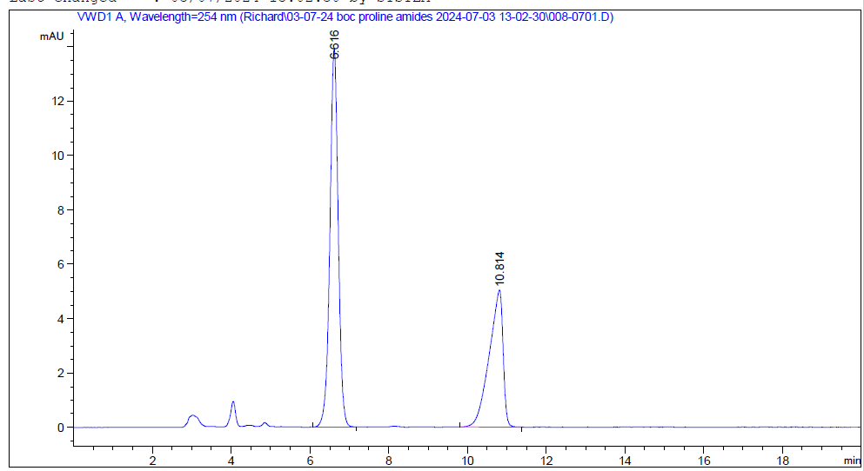
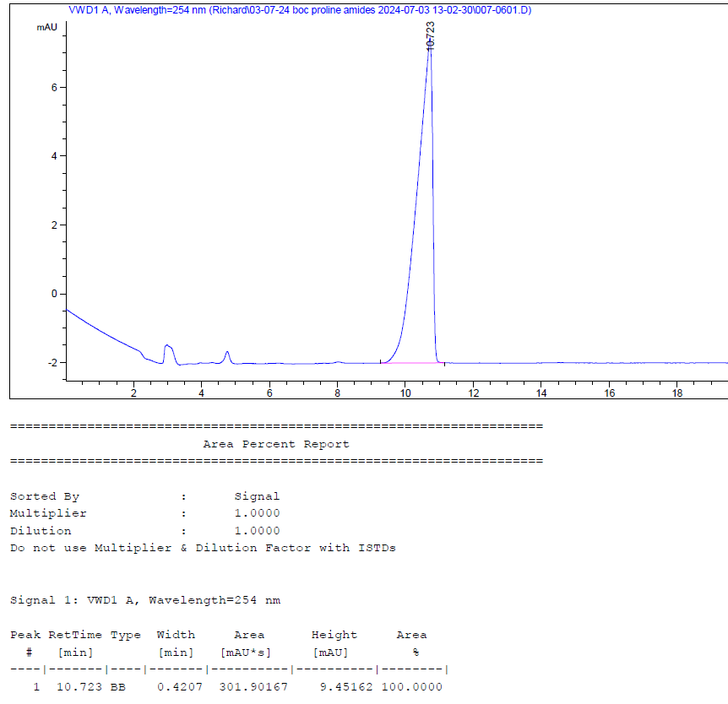
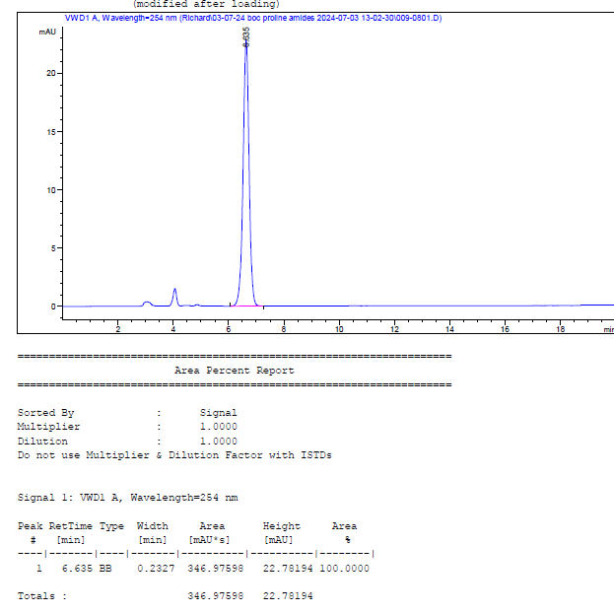

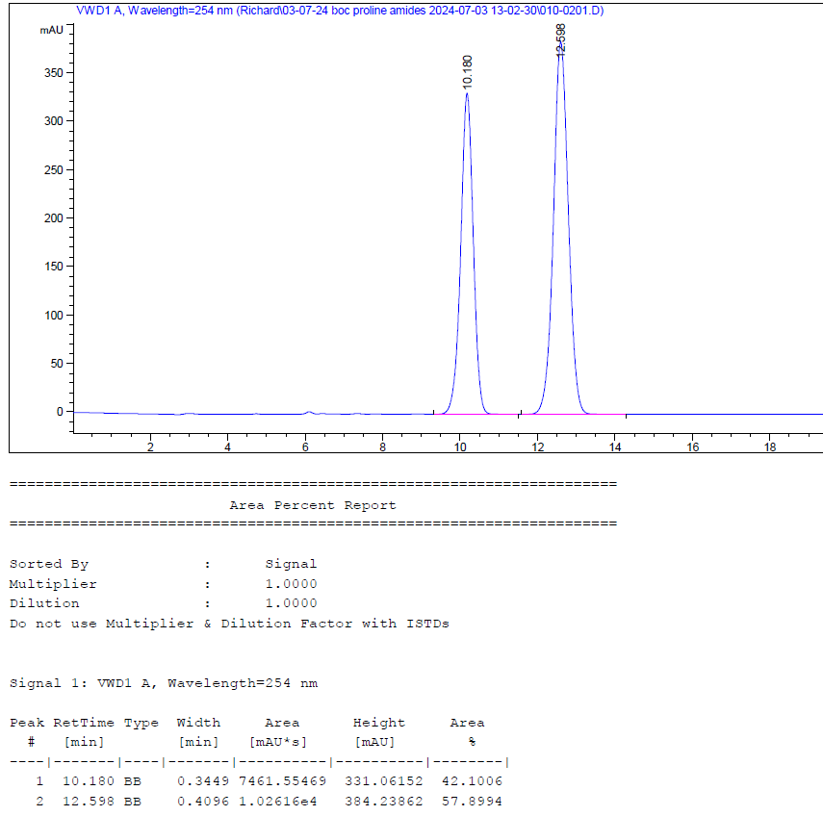

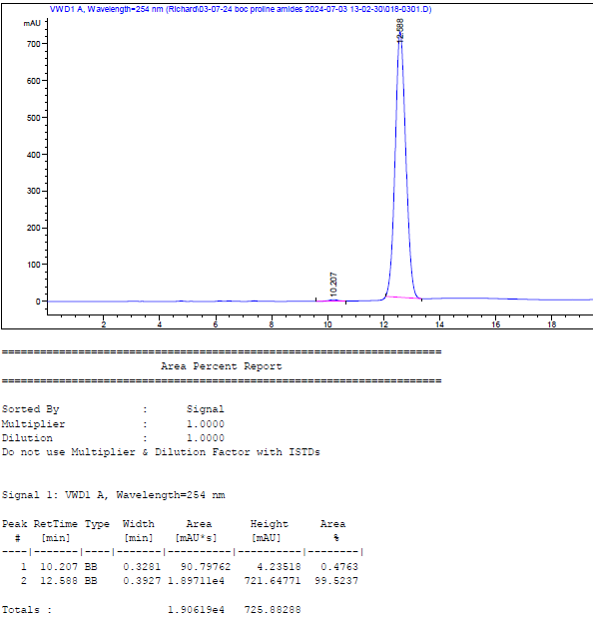

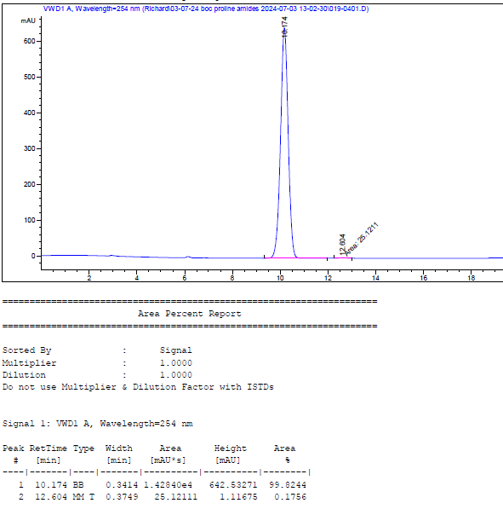

Single crystal x-ray diffraction studies
The diffraction data was collected on a four-circle Agilent SuperNova (Dual Source) single crystal X-ray diffractometer using a micro-focus CuK_{α} X-ray beam (λ = 1.54184 Å) and a HyPix-Arc 100° hybrid pixel array detector. The sample temperatures were controlled with an Oxford Instruments cryojet. The data were processed using the CrysAlis^{Pro} software²⁶.
The crystal structure was solved with the SHELXT programme²⁷, used within the Olex2 software suite²⁸, and refined by least squares on the basis of F² with the SHELXL²⁹ programme using the ShelXle graphical user interface³⁰. All non-hydrogen atoms were refined anisotropically by the full-matrix least-squares method. Hydrogen atoms associated with carbon atoms were refined isotropically [U_{iso}(H) = 1.2U_{eq}(C)] in geometrically constrained positions. The positions of hydrogen atoms affiliated with the amino group were located in the difference Fourier map and refined isotopically [U_{iso}(H) = 1.5U_{eq}(N)] using the DFIX and DANG commands in SHELXL.
Relevant crystallographic information and refinement parameters are shown in the table below.
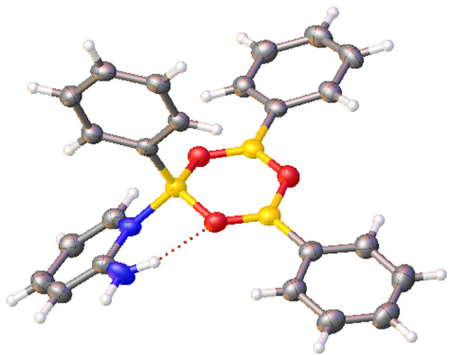

Crystallographic information and details of refinement parameters.
empirical formula | C₂₃H₂₁B₃N₂O₃
M_{r} / g mol⁻¹ | 405.85
crystal system | orthorhombic
space group | Pbca
a / Å | 6.81856(4)
b / Å | 18.79523(11)
c / Å | 32.85532(19)
α / ° | 90
β / ° | 90
γ / ° | 90
V / Å³ | 4210.62(4)
Z | 8
ρ_{calc} / g cm⁻³ | 1.280
T / K | 150.0(1)
μ / mm⁻¹ | 0.657
F(000) | 1696
crystal size / mm³ | 0.23 × 0.12 × 0.04
radiation | CuK_{α} (λ = 1.54184 Å)
2θ range for data collection / ° | 9.410−133.180
index ranges | −8 ≤ h ≤ 8  −22 ≤ k ≤ 22  −39 ≤ l ≤ 39
number of collected reflections | 94888
unique reflections | 3713
number of unique reflections | 3408 [I > 2σ(I)]
R_{int} | 0.0349
R(F), F > 2σ(F) | 0.0306
wR(F²), F > 2σ(F) | 0.0804
R(F), all data | 0.0333
wR(F²), all data | 0.0824
Δ_{r} (max., min.) e Å⁻³ | 0.165/−0.180
CCDC deposition number | 2391496

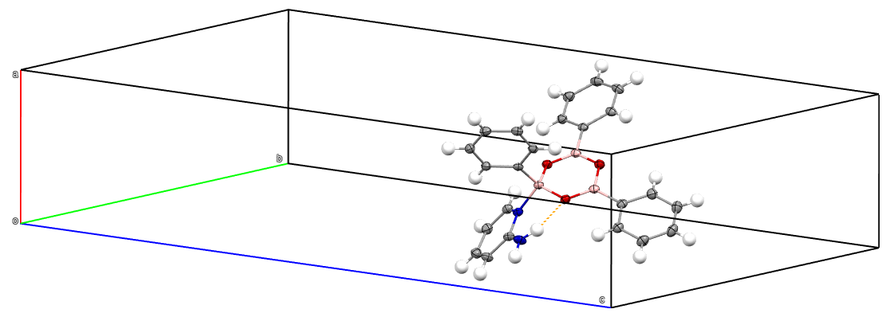
The asymmetric unit. The thermal ellipsoids are drawn at the 50% probability level. Colour scheme: carbon – grey, nitrogen – blue, oxygen – red, boron – pink.

Computational methods

Co-ordinate files can be found at Imperial College Research Data Repository, DOI: 10.14469/hpc/12218

References
1. M. T. Sabatini, L. T. Boulton and T. D. Sheppard, Sci. Adv., 2017, 3, e1701028.
2. H. S. Lee, X. Q. Yang, C. L. Xiang, J. McBreen and L. S. Choi, J. Electrochem. Soc., 1998, 145, 2813.
3. T. Maki, K. Ishihara and H. Yamamoto, Org. Lett., 2006, 8, 1431-1434.
4. T. Colclough, W. Gerrard and M. F. Lappert, J. Chem. Soc., 1956, DOI: 10.1039/JR9560003006, 3006-3010.
5. T. T. T. Nguyen, V. D. Duong, T. N. N. Pham, Q. T. Duong and T. B. Nguyen, Org. Biomol. Chem., 2022, 20, 8054-8058.
6. W.-H. Rao, B.-B. Zhan, K. Chen, P.-X. Ling, Z.-Z. Zhang and B.-F. Shi, Org. Lett., 2015, 17, 3552-3555.
7. A.-S. Piticari, D. Antermite, J. I. Higham, J. H. Moore, M. P. Webster and J. A. Bull, Adv. Synth. Catal., 2022, 364, 1488-1497.
8. V. Karaluka, R. M. Lanigan, P. M. Murray, M. Badland and T. D. Sheppard, Org. Biomol. Chem., 2015, 13, 10888-10894.
9. C. Li and H.-L. Qin, Org. Lett., 2019, 21, 4495-4499.
10. Á. M. Martínez, N. Rodríguez, R. Gómez Arrayás and J. C. Carretero, Chem. Commun., 2014, 50, 6105-6107.
11. S. B. Salunke, N. S. Babu and C.-T. Chen, Adv. Synth. Catal., 2011, 353, 1234-1240.
12. C. E. Coomber, V. Laserna, L. T. Martin, P. D. Smith, H. C. Hailes, M. J. Porter and T. D. Sheppard, Org. Biomol. Chem., 2019, 17, 6465-6469.
13. M. Kissane, S. E. Lawrence and A. R. Maguire, Org. Biomol. Chem., 2010, 8, 2735-2748.
14. E. Qu, S. Li, J. Bai, Y. Zheng and W. Li, Org. Lett., 2022, 24, 58-63.
15. J. d. M. Muñoz, J. Alcázar, A. de la Hoz, Á. Díaz-Ortiz and S.-A. Alonso de Diego, Green Chem., 2012, 14, 1335-1341.
16. J. Britton, J. M. Chalker and C. L. Raston, Chem. Eur. J., 2015, 21, 10660-10665.
17. A. R. Bayguzina, A. R. Lutfullina and R. I. Khusnutdinov, Russ. J. Org. Chem., 2018, 54, 1127-1133.
18. D. C. Braddock, J. J. Davies and P. D. Lickiss, Org. Lett., 2022, 24, 1175-1179.
19. J. Kumar, A. K. Singh, A. Gupta and S. Bhadra, J. Org. Chem., 2022, 87, 6330-6335.
20. S. J. Underwood and C. J. Douglas, Org. Lett., 2023, 25, 146-151.
21. W. I. Nicholson, F. Barreteau, J. A. Leitch, R. Payne, I. Priestley, E. Godineau, C. Battilocchio and D. L. Browne, Angew. Chem. Int. Ed., 2021, 60, 21868-21874.
22. Y. Zhao, L. Xu, J. Zhang, M. Zhang, J. Lu, R. He, J. Xi, R. Zhuang, J. Li and Y. Zhou, Biorg. Med. Chem., 2021, 29, 115867.
23. C. L. Allen, A. R. Chhatwal and J. M. J. Williams, Chem. Commun., 2012, 48, 666-668.
24. B. V. Subba Reddy, K. Bhavani, A. Raju and J. S. Yadav, Tetrahedron: Asymmetry, 2011, 22, 881-886.
25. S. Kayser, J. C. Hansen, M. Staudt, A. Moroz, Y. Larsen, P. Temperini, F. Yi, J. T. Syrenne, N. Krogsgaard-Larsen, S. Iliadis, B. Nielsen, K. B. Hansen, D. S. Pickering and L. Bunch, ACS Chemical Neuroscience, 2020, 11, 674-701.
26. CrysAllisPro 1.171.42.60a, Rigaku, 2022.
27. G. Sheldrick, Acta. Cryst. A, 2015, 71, 3-8.
28. O. V. Dolomanov, L. J. Bourhis, R. J. Gildea, J. A. K. Howard and H. Puschmann, J. Appl. Crystallogr., 2009, 42, 339-341.
29. G. Sheldrick, Acta. Cryst. C, 2015, 71, 3-8.
30. C. B. Hubschle, G. M. Sheldrick and B. Dittrich, J. Appl. Crystallogr., 2011, 44, 1281-1284.

